**UNIVERSITY OF ECONOMICS AND LAW**

**FACULTY OF INFORMATION SYSTEMS**

**FINAL PROJECT REPORT**

**TOPIC**

**BUILDING BUSINESS INTELLIGENCE SOLUTION FOR PURCHASING MODULE FOR ADVENTURE WORKS CYCLES COMPANY**

*Course:* BUSINESS INTELLIGENCE AND

DECISION SUPPORT SYSTEMS

*CourseID:* 243MI3301

*Lecturer:* Le Ba Thien, MSc.

Group 9

*Ho Chi Minh City, June, 2025*

MEMBERS OF GROUP 9

|  |  |  |  |  |
| --- | --- | --- | --- | --- |
| **No** | **Full Name** | **Student code** | **Roles** | **Completion Level** |
| **1** | Luong Chi Trung | K224060818 | Leader | 100% |
| **2** | Le Thanh Quy Hai | K224060780 | Member | 100% |
| **3** | Cao Phan Trung Hieu | K224060784 | Member | 100% |
| **4** | Tran Đuc Luong | K224060793 | Member | 100% |
| **5** | Nguyen Van Tai | K224060809 | Member | 100% |

# ACKNOWLEDGE

The successful completion of this project would not have been possible without the valuable support and guidance we received from various individuals and institutions. We are especially thankful to MSc. Le Ba Thien, lecturer at the Faculty of Information Systems, University of Economics and Law – VNU HCM, whose dedicated mentorship and thoughtful advice played a vital role in shaping our work. His continuous support helped us overcome many challenges throughout the development of the project.

We would also like to express our sincere appreciation to the authors and researchers whose academic work served as key references in our analysis. Their contributions provided essential insights and theoretical foundations, enabling us to better understand the subject and formulate meaningful conclusions. While we strived to ensure the highest quality in our efforts, we acknowledge that some imperfections may remain. Therefore, we respectfully welcome all constructive feedback and criticism to further improve our work and deepen our learning.

We are truly grateful for the opportunity to conduct this research and for the support received along the way. This experience has been invaluable in enhancing our skills and knowledge, and we look forward to future opportunities for growth.

*Sincerely,*

*Group 9*

*Ho Chi Minh City, June, 2025*

# COMMITMENT

We hereby declare that this project was independently conducted by our team under the supervision of MSc. Le Ba Thien, and fully reflects our own efforts in researching, designing, and implementing the proposed solution. The process involved building a data-driven system based on reliable sources and prior studies, aiming to generate valuable insights and support informed decision-making.

# TABLE OF CONTENT

ACKNOWLEDGE ii

COMMITMENT iii

TABLE OF CONTENT iv

LIST OF TABLES viii

LIST OF FIGURES x

ABSTRACT xiv

CHAPTER 1. OVERVIEW OF THESIS 1

1.1. Overview of the Bicycle Industry, AdventureWorks Cycles Company, and the Business Case 1

1.1.1. Overview of the Global Bicycle Retail Industry 1

1.1.2. Overview of Adventure Works Cycles Company and the Business Case 4

1.2. Objectives 5

1.2.1. General Objective 5

1.2.2. Specific Objectives 6

1.3. Subject and research scope of the project 6

1.4. Tools used 7

1.5. Research implications 8

1.5.1. Project Value 8

1.5.2. Desired Outcomes 9

1.5.3. Project Execution and Deliverables 9

1.6. Structure of the report 10

CHAPTER 2. THEORETICAL BASIS 12

2.1. Overview of BI 12

2.1.1. BI Models and Solutions 12

2.1.2. Benefits of BI in Business 13

2.1.3. BI Solution Implementation Process 15

2.2. Overview of ETL 18

2.3. Data warehouse and data marmart 20

2.3.1. Data warehouse 20

2.3.2. Data Mart 23

2.4. KPIs 24

2.5. OLAP technique and MDX language for analyzing multi-dimension data 25

2.5.1. OLAP technique 25

2.5.2. MDX language 27

2.6. Power BI 28

2.6.1. Definition of Power BI 28

2.6.2. Core Components of Power BI 29

2.6.3. How Power BI Works 31

2.6.3.1. Data Connection 31

2.6.3.2. Data Cleaning and Transformation 32

2.6.3.3. Data Visualization 32

2.6.3.4. Publishing and Sharing 32

CHAPTER 3: USER REQUIREMENTS ANALYSIS AND DATA DESCRIPTION 34

3.1. Purchasing Department 34

3.1.1. Purchasing Department at AdventureWorks 34

3.1.2. Organizational Structure 35

3.1.3. Purchasing Process 38

3.2. Key Performance Indicators (KPIs) 40

3.2.1. Return Rate 41

3.2.2. Received Rate 41

3.2.3. Order Quantity 42

3.2.4. Average Lead Time 42

3.3. Business Intelligence Capabilities for Procurement Decision Support 42

3.3.1. Strategic Needs for BI in Procurement 42

3.3.2. Core Analytical Scenarios 43

3.3.3. Role-Based Interaction with BI System 44

3.3.4. Types of Intelligence Required 45

3.3.5. Detailed Business Requirements 46

3.4. Data Preparation 48

3.4.1. Data Sources 48

3.4.2. Detailed Description of Data Source 49

3.4.3. Data Understanding 80

3.4.4. Data Analysis 80

CHAPTER 4: BUILDING DATA WAREHOUSE AND INTEGRATING DATA 90

4.1. Design Data Warehouse 90

4.1.1. Bus Matrix 90

4.1.2. Master Data and Transaction Data 91

4.1.3. Data Model 93

4.1.3.1 Data Model overview 93

4.1.3.2. Fact and Dimension tables 97

4.1.4. Data Warehouse building 106

4.2. ETL Process 107

4.2.1. Rationale for Selecting the ETL Strategy and Data Integration Framework 107

4.2.2 Detailed Operational Process of the System 110

4.2.3. Practical execution of SSIS process 111

CHAPTER 5. DATA ANALYSIS AND VISUALIZATION 136

5.1. Data analytics with SSAS technology 136

5.1.1. Building the cube 136

5.1.2. Analysis with SSAS 137

5.2. Building the KPIs system 139

5.3. Introduction to the structure of the reporting system 145

5.3.1. Report highlights 145

5.3.2. Overall insight of dashboards 146

5.4. Analyze and visualize data with Power BI 147

5.4.1. Transform and load data 147

5.4.2. Creating model relationship 149

5.4.3. Business analytics 150

5.4.3.1. Home page 150

5.4.3.2. Overview Dashboard 150

5.4.3.3. Inventory Dashboard 153

5.4.3.4. Vendor Dashboard 155

5.4.3.5. Delivery Dashboard 158

5.4.3.6. Employee Dashboard 161

5.4.3.7. Product Dashboard 163

5.4.3.8. Solution 167

5.5. Discuss and evaluate the results of data analysis and visualization 169

5.6. Cloud-Based Deployment Model 170

CHAPTER 6. CONCLUSION 174

6.1. Summary of findings 174

6.2. Limitations 174

6.3. Future works 175

6.4. Conclusion 176

REFERENCES 178

APPENDIX: GROUP WORK ACTIVITY REPORT 179

# LIST OF TABLES

**Table 3.1.** Business Requirements 46

**Table 3.2.** Column of Purchasing.PurchaseOrderHeader 50

**Table 3.3.** Relation of Purchasing.PurchaseOrderHeader 51

**Table 3.4.** Column of Purchasing.PurchaseOrderDetail 53

**Table 3.5** Relation of Purchasing.PurchaseOrderDetail 54

**Table 3.6.** Column of Purchasing.Vendor 55

**Table 3.7.** Relation of Purchasing.Vendor 57

**Table 3.8.** Column of Purchasing.ProductVendor 58

**Table 3.9.** Relation of Purchasing.ProductVendor 59

**Table 3.10.** Column of Purchasing.ShipMethod 60

**Table 3.11.** Relation of Purchasing.ShipMethod 61

**Table 3.12.** Column of Production.Product 62

**Table 3.13.** Relation of Production.Product 65

**Table 3.14.** Column of Production.ProductInventory 66

**Table 3.15.** Relation of Production.ProductInventory 67

**Table 3.16.** Column of Production.ProductCategory 68

**Table 3.17.** Relation of Production.ProductCategory 68

**Table 3.18.** Column of Production.ProductSubCategory 69

**Table 3.19.** Relation of Production.ProductSubCategory 70

**Table 3.20.** Column of Production.Location 71

**Table 3.21.** Relation of Production.Location 72

**Table 3.22.** Column of HumanResources.Employee 73

**Table 3.23.** Relation of HumanResources.Employee 75

**Table 3.24.** Column of Person.Person 75

**Table 3.25.** Relation of Person.Person 77

**Table 4.1.** Bus matrix 90

**Table 4.2**. Master data 91

**Table 4.3.** Transaction data 92

**Table 4.4.** Description of Galaxy data warehouse model 95

**Table 4.5.** Data Warehouse Table Descriptions 97

**Table 4.6.** DimVendor table 97

**Table 4.7.** DimProduct table 99

**Table 4.8.** DimEmployee table 100

**Table 4.9.** DimTime table 101

**Table 4.10.** DimShipMethod table 102

**Table 4.11.** FactPurchaseOrders table 103

**Table 4.12.** FactInventory table 105

**Table 4.13.** Description of Variables Used in the ETL Package 112

# LIST OF FIGURES

**Figure 1.1.** Bicycle Market Size 2025 - 2030 (Source: Mordor Intelligence) 1

**Figure 1.2.** Global Bicycle Market: Market Share by Type Segment (2024) (Source: Mordor Intelligence) 2

**Figure 1.3.** Bicycle Market: Forecasted Five-Year Growth Rate, By Region (Source: Mordor Intelligence) 3

**Figure 1.4.** Adventure Works Cycles (Source: Word Press) 4

**Figure 2.1.** Modern BI Models and Solutions (Source: Authors, 2025) 12

**Figure 2.2.** Steps in ETL Process (Source: Microsoft Learn) 18

**Figure 2.3.** Diagram of a data mart and how it works (Source: Velog) 24

**Figure 2.4** Online Analytical Processing (Source: GeeksforGeeks) 26

**Figure 2.5.** Power BI (Source: Adtimin) 29

**Figure 2.6.** Power BI Data Integration and Visualization Flow (Source: CRMVIET) 31

**Figure 3.1.** Purchasing Department (Source: Authors, 2025) 37

**Figure 3.2.** Product table Description (Source: Authors, 2025) 81

**Figure 3.3.** Product Statistical tables (Source: Authors, 2025) 82

**Figure 3.4.** Summary charts of product attributes and manufacturing statistics. (Source: Authors, 2025) 82

**Figure 3.5.** Product Inventory table Description (Source: Authors, 2025) 83

**Figure 3.6.** The data distribution of the ProductInventory table (Source: Authors, 2025) 83

**Figure 3.7.** Product Subcategory table Description (Source: Authors, 2025) 84

**Figure 3.8.** Product Category table Description (Source: Authors, 2025) 84

**Figure 3.9.** ProductVendor table Description (Source: Authors, 2025) 85

**Figure 3.11.** Location table Description (Source: Authors, 2025) 86

**Figure 3.12.** PurchaseOrderHeader table Description (Source: Author 2025) 86

**Figure 3.13.** The data distribution of the ProductOrderHeader table (Source: Author 2025) 86

**Figure 3.14.** PurchaseOderDetail table Description (Source: Author 2025) 87

**Figure 3.15.** The data distribution of the ProductOrderDetail table (Source: Authors, 2025) 87

**Figure 3.16.** Employee table Description (Source: Authors, 2025) 88

**Figure 3.17.** The data distribution of the Employee table (Source: Authors, 2025) 89

**Figure 4.1.** Purchasing data warehouse model 107

**Figure 4.2.** System and Custom Variables in the ETL Package – DimEmployee 112

**Figure 4.3.** Standard Control Flow for ETL of Dimension Tables 113

**Figure 4.4.** Task for Logging ETL Status 115

**Figure 4.5.** OnError Event – DimEmployee 116

**Figure 4.6.** Script Task – Log Error & Failure Status 117

**Figure 4.7.** Data Flow for ETL of DimEmployee using SCD Techniques 117

**Figure 4.8.** Detailed Data Flow for ETL of DimProduct Using SCD 119

**Figure 4.9.** Detailed Data Flow for ETL of DimShipMethod Using SCD 121

**Figure 4.10.** Detailed Data Flow for ETL of DimVendor Using SCD 122

**Figure 4.11.** Control Flow for Loading Data into FactInventory 124

**Figure 4.12.** Data Flow for Populating FactInventory 125

**Figure 4.13.** Control Flow for Loading Data into FactPurchaseOrders 126

**Figure 4.14.** Data Flow for Populating FactPurchaseOrders 127

**Figure 4.15.** ETL Completion 128

**Figure 4.16.** DimEmployee Result 129

**Figure 4.19.** DimProduct result 131

**Figure 4.20.** DimShipMethod result 131

**Figure 4.21** FactInventory result 132

**Figure 4.22.** FactPurchaseOrders result 132

**Figure 4.23.** ETL Load Log 132

**Figure 4.24.** Deployed ETL Packages in SSIS Catalog 133

**Figure 4.25.** Purchasing_DW Job Configuration in SSMS 134

**Figure 4.26.** Purchasing_DW Job Execution Success Log 135

**Figure 4.27.** ETL Result Log 135

**Figure 5.1**. SSAS cube 137

**Figure 5.2.** GrowthRate of Order Quantity 2011- 2014 137

**Figure 5.3.** Top 10 Vendor by Line Total 138

**Figure 5.4.** Annual Top 20 Vendors by OrderQty 138

**Figure 5.5.** ReceivedRate Calculation in SSAS 140

**Figure 5.6.** Setting up the ReceivedRate KPI in SSAS 141

**Figure 5.7.** ReceivedRate KPI by Supplier 141

**Figure 5.8.** ReceivedRate KPI by Year 142

**Figure 5.9.** ReturnRate Calculation in SSAS 143

**Figure 5.10.** ReturnRate KPI by Supplier 144

**Figure 5.11.** ReturnRate KPI by Supplier and by Year 145

**Figure 5.12:** Import SQL Server database 148

**Figure 5.13.** Model relationship 149

**Figure 5.14**. Home Page 150

**Figure 5.16.** Inventory Dashboard 153

**Figure 5.17.** Vendor Dashboard Overview 155

**Figure 5.18.** Delivery Dashboard 158

**Figure 5.19.** Employee Dashboard 161

**Figure 5.20.** Product Dashboard 164

**Figure 5.21.** Solution Page 167

**Figure 5.22.** Activating a Personal Gateway in Power BI Service 171

**Figure 5.23.** Successful publishing of a report from Power BI Desktop to Power BI Service 172

**Figure 5.24.** Data source configuration in the On-premises Gateway 172

**Figure 5.25.** Schedule Refresh configuration in Power BI Service 173

ABSTRACT

This project presents the design and implementation of a Business Intelligence (BI) solution focused on the Purchasing Module of the AdventureWorks database. Using Microsoft’s BI ecosystem—SQL Server Integration Services (SSIS), SQL Server Analysis Services (SSAS), and Power BI—the team developed a data warehouse to streamline the extraction, transformation, and loading (ETL) of purchasing data. The solution includes a multidimensional cube for advanced analytics and visual dashboards that provide insights into supplier performance, purchasing trends, and key procurement indicators. This integrated system supports data-driven decision-making and enhances operational visibility in the procurement process.

# CHAPTER 1. OVERVIEW OF THESIS

## 1.1. Overview of the Bicycle Industry, AdventureWorks Cycles Company, and the Business Case

### 1.1.1. Overview of the Global Bicycle Retail Industry

The bicycle industry has seen strong and steady growth due to global trends such as environmental awareness, health consciousness, and a shift towards sustainable transportation. Bicycles serve not only as eco-friendly means of transportation but also as a popular form of fitness and recreation, driving consistent market expansion.

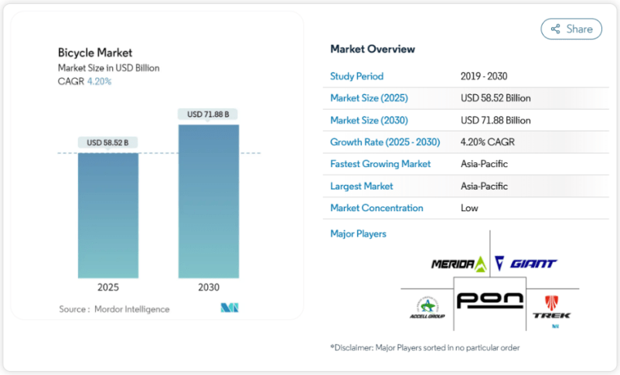

**Figure 1.1.** Bicycle Market Size 2025 - 2030 (Source: Mordor Intelligence)

According to a report by Mordor Intelligence, the global bicycle market is expected to grow from USD 58.52 billion in 2025 to USD 71.88 billion by 2030, driven by a CAGR of 4.20% (Figure 1.1). This growth is supported by rising environmental awareness, technological innovation, and strong government support. Manufacturers are leveraging AI to improve product development and supply chain efficiency, while the adoption of smart technologies has given rise to connected bicycles with GPS, mobile integration, and performance tracking. The electric bike segment, in particular, is seeing advancements in battery and power-assist systems. At the same time, infrastructure investments are accelerating, with countries like the Netherlands and France committing billions to cycling facilities. Product innovation remains strong, with brands introducing models tailored to specific user needs, such as Giant’s Voya E+ and PakYak E+ in Germany. The retail landscape is also evolving, combining physical stores and online platforms with added services like repairs and rentals. Incentive programs, such as the Netherlands’ policy of reimbursing cyclists USD 0.22 per kilometer, further stimulate demand and reinforce the market’s positive outlook.

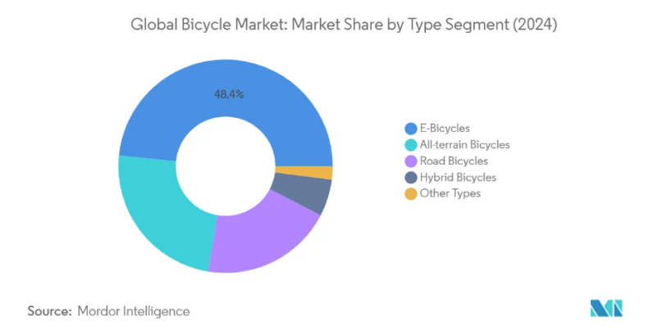

**Figure 1.2.** Global Bicycle Market: Market Share by Type Segment (2024) (Source: Mordor Intelligence)

As illustrated in Figure 1.2, e-bicycles hold the largest market share in the global bicycle market, accounting for 48.4% in 2024. This dominance reflects the growing consumer demand for convenient, eco-friendly mobility solutions and the increasing adoption of electric bikes in urban and recreational settings. The strong presence of all-terrain and road bicycles further indicates a diversified market catering to various lifestyle and sporting needs.

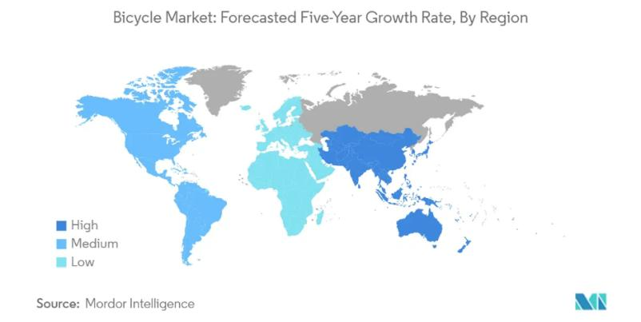

**Figure 1.3.** Bicycle Market: Forecasted Five-Year Growth Rate, By Region (Source: Mordor Intelligence)

Figure 1.3 illustrates the forecasted five-year growth rate of the global bicycle market by region, highlighting clear differences across geographic areas. Notably, countries in the Asia-Pacific region such as China, India, Vietnam, and Australia are expected to experience high growth rates. This trend is largely driven by rapid urbanization, growing environmental awareness, and government initiatives supporting green transportation. In Southeast Asia, demand for bicycles is rising significantly due to persistent traffic congestion and the cost-effectiveness of bicycles for daily commuting. In contrast, several regions in Africa, the Middle East, and parts of Europe are projected to see only moderate or low growth, possibly due to market saturation or economic conditions that are less favorable for shifting transportation habits. Meanwhile, countries in the Americas, including the United States and Brazil, fall into the medium growth category, where investments in cycling infrastructure and public health awareness continue to support market expansion. These regional disparities emphasize the need for businesses in the bicycle industry to tailor their investment and market entry strategies to each specific region. According to a report by Mordor Intelligence, this approach is essential for maximizing opportunities and minimizing risks in the global market.

The global bicycle market presents a fragmented and highly competitive landscape, with a wide mix of global corporations and strong regional manufacturers. While large players benefit from scale and brand reach, many smaller or localized companies gain market share through region-specific designs, agile operations, and strong dealer networks. The industry is undergoing steady consolidation, especially through acquisitions in the electric bicycle segment, as companies seek to expand their product offerings and enter new markets. A strong emphasis is being placed on sustainability, with manufacturers adopting eco-friendly materials and production practices to meet environmental standards. Meanwhile, digital transformation continues to shape the market through the development of smart bicycles and direct-to-consumer channels. New business models like subscriptions and urban mobility services also create opportunities for innovative companies to grow. In this environment, success increasingly depends on a company's ability to adapt to shifting consumer preferences, comply with safety and environmental regulations, and manage supply chains effectively. (Source: Mordor Intelligence)

### 1.1.2. Overview of Adventure Works Cycles Company and the Business Case



**Figure 1.4.** Adventure Works Cycles (Source: Word Press)

Adventure Works Cycles is a simulated multinational company specializing in the manufacturing and distribution of bicycles and related products. Alongside its core product line of bicycles made from various materials, the company also offers accessories, spare parts, and cycling apparel. A significant portion of these products is procured from third-party suppliers, which makes the company not only a manufacturer but also a reseller.

The company serves both individual customers and retail bike stores through online channels and wholesale distribution. Although it does not operate physical storefronts, Adventure Works relies on digital platforms and business-to-business sales to reach the market.

The Purchasing Department plays a vital role in ensuring the availability of materials and resale products. It oversees the procurement of components needed for bicycle production as well as finished goods sourced for resale, such as helmets, water bottles, and clothing. The available data within the AdventureWorks database contains comprehensive records of purchase orders, vendors, product categories, and transaction histories—providing a strong foundation for analysis.

This project is centered on building a Business Intelligence (BI) solution tailored to the Purchasing module. Tools such as SQL Server Integration Services (SSIS), SQL Server Analysis Services (SSAS), and interactive data visualizations are used to extract, transform, analyze, and present meaningful insights.

By analyzing purchasing trends, supplier performance, and cost patterns, the BI solution is expected to support the department in improving procurement strategies, reducing delays, and managing supplier relationships more effectively. The ultimate goal is to turn raw purchasing data into actionable insights that contribute to better decisions and higher operational efficiency.

To achieve this, our team initiated the project titled "Business Intelligence-Based Procurement Optimization for Adventure Works Cycles", focusing on data-driven improvements that support the company’s growth and competitiveness.

## 1.2. Objectives

### 1.2.1. General Objective

The main goal of this project is to develop a Business Intelligence (BI) solution for the Purchasing Department at AdventureWorks Company. This involves researching and applying SSIS and SSAS techniques to build a data warehouse, leveraging OLAP methods and MDX language for data analysis, and utilizing Power BI to visualize the results. The proposed BI system is expected to provide purchasing staff and company executives with a comprehensive view of the procurement process, enabling them to identify unresolved issues and make better-informed decisions that enhance operational efficiency.

### 1.2.2. Specific Objectives

Use the AdventureWorks database as a sample database to conduct a comprehensive analysis, understand the data structure and quality, and gain insights into the purchasing process.

Analyze the purchasing workflow and develop a KPI system to effectively evaluate performance.

Propose a suitable data warehouse design that aligns with business requirements and ensures efficient data management.

Develop a new and appropriate data warehouse tailored to the needs of the purchasing subsystem.

Implement the ETL process to optimally integrate source data into the data warehouse.

Apply SSAS to convert raw data into meaningful and actionable business insights.

Use MDX (Multidimensional Expressions) to query data from OLAP cubes to support detailed data analysis.

Build a reporting and visualization system using Power BI to deliver an overall view of inventory status and purchasing trends within the company.

## 1.3. Subject and research scope of the project

Subject: Developing a Business Intelligence solution for the Purchasing Department of AdventureWorks Company.

Scope: The project scope includes processing and analyzing data from the Purchasing Department in the AdventureWorks dataset, constructing a centralized data warehouse through the ETL process, conducting descriptive data analysis using OLAP cubes, and developing interactive dashboards to visualize sales performance, customer segmentation, and key business metrics. The dataset used in this project includes purchasing data collected between April 16, 2011 and September 22, 2014, providing a sufficient historical range for analyzing procurement trends and supplier performance.

## 1.4. Tools used

SQL Server Management Studio (SSMS): SSMS is a powerful database management tool developed by Microsoft, used for managing, configuring, and querying SQL Server databases. In this project, we used SSMS to explore the structure of the original data, execute queries for validation, and assist in preparing the source data for the data warehouse.

SQL Server Integration Services (SSIS): SSIS is a specialized tool for handling ETL (Extract, Transform, Load) processes. It was used to design automated workflows that extracted data from transactional (OLTP) systems, transformed and standardized it—including the implementation of Slowly Changing Dimensions (SCD Type 1 and Type 2)—and loaded it into the centralized data warehouse.

SQL Server Analysis Services (SSAS): SSAS is a tool for building OLAP (Online Analytical Processing) cubes, which allow for multidimensional data analysis. In the project, SSAS was used to create analytical cubes that enabled quick retrieval of KPIs such as Received Rate, Return Rate, and Order Quantity across dimensions like time, vendor, and product.

Microsoft Power BI: Power BI is a robust data visualization platform used to create interactive reports and dashboards. We utilized Power BI to present the analysis results through intuitive visuals, making it easier for end users—such as purchasing managers—to monitor key metrics and make timely decisions.

Python: Python, known for its flexibility and efficiency, was used to support data processing tasks such as data cleaning, anomaly detection, and automation of certain preprocessing steps before loading data into the main BI system.

## 1.5. Research implications

### 1.5.1. Project Value

Throughout the project implementation, our team gained several valuable experiences and insights, including:

*Understanding how to build and operate a data warehouse system:* From designing data models and identifying fact and dimension tables to integrating and managing data from multiple sources.

*Becoming familiar with and applying Business Intelligence (BI) tools:* Including SSIS for ETL processes, SSAS for building analytical cubes, and Power BI for data visualization.

*Grasping the mindset required to implement a complete BI solution:* Not only technical aspects but also understanding how to define problems, gather user requirements, build KPIs, and design practical solutions.

*Learning how to evaluate and measure performance through KPIs:* By building indicators such as Received Rate, Return Rate, Order Quantity, etc., and understanding the practical significance of each.

*Enhancing analytical thinking and problem-solving skills:* Through data handling, error detection, ETL optimization, and drawing meaningful insights to support decision-making.

*Developing teamwork and professional communication skills:* gained through task delegation, technical collaboration, and presenting the final report to instructors.

### 1.5.2. Desired Outcomes

With a solid technological foundation and an appropriate implementation methodology, the project aims to deliver in-depth analytical reports that help the company uncover hidden insights and translate them into actionable recommendations. These outcomes are expected to provide management with a clearer understanding of customer segments and support the development of strategies for customer retention, growth, and market expansion.

The project also seeks to improve performance measurement capabilities through standardized KPIs, allowing the business to identify consumer trends promptly and respond effectively to market fluctuations. Most importantly, by offering a multi-dimensional analytical perspective, the project enables the company to discover and capitalize on emerging business opportunities, while optimizing operational processes and long-term strategic planning.

### 1.5.3. Project Execution and Deliverables

*Step 1: Planning*

The first phase focuses on gathering and defining requirements from the Purchasing Department. This includes outlining the purchasing workflow, identifying key business needs, and developing a system of Key Performance Indicators (KPIs). Functional requirements are also clarified to ensure the BI solution aligns with operational demands.

*Step 2: Data Preparation*

Raw data from OLTP (Online Transaction Processing) systems is collected and transformed into a Purchasing Data Mart. Exploratory Data Analysis (EDA) is conducted to understand data characteristics and design a suitable structure for the upcoming processing. The objective is to organize data effectively to support the ETL process.

*Step 3: ETL Processing*

In this step, data is extracted, transformed, and loaded into a centralized Data Warehouse. Key tasks include updating existing records (using Slowly Changing Dimensions types 1 and 2) and inserting new ones. Lookup tables are applied for data matching and validation to ensure accuracy before analysis. After this phase, the data is ready for in-depth analytics.

*Step 4: Data Analytics*

Processed data is analyzed using OLAP cubes built with SQL Server Analysis Services (SSAS). A KPI system is also developed to monitor performance against predefined criteria. This provides a solid foundation for drawing insights and supporting decision-making.

*Step 5: Visualization and Reporting*

Analyzed data is visualized through dynamic, interactive reports built in Power BI. These reports are deployed on the Microsoft Fabric platform, making them easily accessible and scalable. As a result, stakeholders can quickly grasp essential information and make informed decisions.

## 1.6. Structure of the report

*Chapter 1: Introduction*

This chapter provides an overview of the bicycle market and introduces AdventureWorks—the primary subject of this study. It identifies existing issues within the purchasing process, analyzes the need for improvement, and proposes a solution based on Business Intelligence (BI) technologies. Additionally, the chapter outlines the research objectives, scope, target users, tools employed, and the practical significance of the proposed BI solution for the company.

*Chapter 2: Theoretical Foundation*

This chapter establishes the theoretical basis for implementing a BI solution in the purchasing department. It covers the concepts and benefits of Business Intelligence, the process of building a BI system, and detailed explanations of the ETL (Extract, Transform, Load) process. Furthermore, it introduces the use of Key Performance Indicators (KPIs) to measure performance, along with the fundamentals of MDX language, OLAP techniques, and Power BI as tools to support effective data analysis.

*Chapter 3: User Requirement Analysis and Data Description*

This chapter analyzes the business requirements of the purchasing department at AdventureWorks and develops a set of suitable KPIs accordingly. It also presents the data preparation steps, including data cleaning, data warehouse design, and data modeling. The chapter concludes with a detailed description of the ETL process implemented using SSIS, incorporating Slowly Changing Dimension (SCD) techniques to manage historical data changes effectively.

*Chapter 4: Data Analysis and Modeling*

This chapter explains how the team utilized SQL Server Analysis Services (SSAS) to build a data analysis model (cube) and applied MDX language to query the data warehouse. It continues with the development of KPIs and performs data analysis through dashboards in Power BI, allowing the team to derive insights, identify trends, and propose specific strategic recommendations for the business.

*Chapter 5: Conclusion*

This final chapter summarizes the key outcomes of the project and highlights the significance of the BI system in enhancing the purchasing department’s operations. The chapter also discusses the limitations encountered during the project and proposes future directions, such as integrating ERP systems or leveraging AI/ML technologies for demand forecasting.

# CHAPTER 2. THEORETICAL BASIS

## 2.1. Overview of BI

### 2.1.1. BI Models and Solutions

Business Intelligence is a collection of processes that includes business analysis, data mining, data visualization, data infrastructure and tools, along with best practices, to help businesses analyze their business information data. This process requires the collection, storage, analysis, and visualization of data from various sources within the organization.

**Figure 2.1.** Modern BI Models and Solutions (Source: Authors, 2025)

In this project, the system was designed based on the modern Business Intelligence (BI) architecture, which encompasses several key layers, including data sources, ETL processing, data warehousing, data modeling, and visualization. To meet the complex analytical requirements of the purchasing domain, we adopted the Galaxy Schema (also known as the Fact Constellation model) as the foundation for data organization.

This schema allows multiple fact tables to share common dimension tables, providing a flexible and scalable structure for multidimensional analysis. In our implementation, the data warehouse includes two main fact tables: one for recording purchasing transactions and another for capturing periodic inventory snapshots. Both fact tables are linked to shared dimensions such as product, vendor, employee, time, and location. The use of this schema facilitates integrated analysis across processes such as procurement and inventory management, while ensuring consistency in data interpretation.

The Galaxy Schema model proves to be well-suited for enterprise BI systems, especially when business processes are interconnected and require simultaneous monitoring across several analytical dimensions.

### 2.1.2. Benefits of BI in Business

Business Intelligence (BI) offers a range of significant benefits for businesses that choose to implement and leverage its capabilities. Below are insights into the advantages of BI in business operations:

*Informed, Data-Driven Decisions:* Business Intelligence (BI) enables timely and reliable decision-making by providing real-time, organized data. Instead of relying on intuition, managers use data insights to evaluate strategies, reallocate resources, and minimize risks. For example, a retailer can accurately forecast restocking needs by analyzing consumer trends, improving both efficiency and customer satisfaction.

*Improved customer satisfaction:*BI enables businesses to gain deeper insights into customer needs and behavior, allowing for personalized experiences and services. When organizations understand customer preferences and reactions, they can tailor messaging, products, or promotions to enhance satisfaction. Platforms like Netflix and Shopee leverage this capability effectively to improve user retention.

*Improved data access:*Modern BI systems integrate data from various sources and offer role-based access to users. Instead of relying on the IT department, business units can directly extract the information they need through intuitive dashboards, boosting responsiveness and reducing delays in data flow.

*Enhanced risk management:*BI supports risk mitigation by monitoring performance indicators and detecting anomalies. From finance to operations, BI systems can provide early warnings when a metric exceeds thresholds or deviates from norms. For example, banks use BI to identify suspicious transaction patterns and activate fraud prevention mechanisms.

*Cost savings:*BI offers in-depth visibility into financial operations, production costs, logistics, or marketing efficiency, enabling businesses to eliminate wasteful spending. By analyzing historical data and performance metrics, organizations can spot inefficiencies, streamline operations, or negotiate better supplier terms.

*Improved operational efficiency:*By analyzing workflows and measuring internal KPIs, BI helps identify non-value-adding steps or bottlenecks in processes. This enables process improvement, better workforce allocation, and automation of repetitive tasks, leading to smoother daily operations.

*Data visualization:*The ability to convert raw data into charts, interactive tables, and heatmaps makes trends and insights more accessible. Data visualization not only simplifies data interpretation but also improves internal communication by presenting complex information clearly and persuasively.

*Identifying market trends:*BI supports market trend analysis by processing customer and market data to uncover new patterns or shifts in behavior. Instead of reacting passively, businesses can proactively adjust product strategy, marketing direction, or market expansion plans—gaining a competitive edge.

*Better forecasting:*Forecasting powered by BI is based on historical data and statistical or machine learning models. This allows companies to plan more accurately for finance, procurement, production, or workforce needs, minimizing understocking or overcapacity during peak periods.

Business Intelligence offers substantial benefits to organizations by transforming raw operational data into meaningful insights that support timely and informed decision-making. In our project, BI was applied to empower the purchasing department of AdventureWorks with enhanced visibility and analytical capabilities.

Through the use of real-time dashboards and historical trend analysis, managers can now monitor procurement costs, order volumes, vendor performance, inventory availability, and stockout risks with greater accuracy. Instead of relying on intuition, decision-makers are equipped with data-driven insights to detect supply chain inefficiencies, assess supplier reliability, and identify replenishment needs. The integration of BI into daily operations enables more proactive management, better resource allocation, and strategic improvements across the procurement function.

By embedding BI into the purchasing workflow, the organization benefits from increased operational transparency, improved responsiveness, and a stronger foundation for long-term planning.

### 2.1.3. BI Solution Implementation Process

*Step 1: Define Business Requirements*

Implementing a BI system must start with clearly capturing the business requirements of the enterprise, especially from departments directly using data like Purchasing. In this step, the project team works closely with stakeholders to understand the information they need to track, the specific goals they aim to achieve through the BI system, and current difficulties in accessing data. Business expectations, risks, and priorities will be documented in a Business Requirements Document (BRD), forming the foundation for subsequent design steps.

*Step 2: Assess Current Environment:*

Once business requirements are clear, the project team needs to conduct a comprehensive assessment of the current state of the technology infrastructure and existing data systems. This includes reviewing input data sources, checking data quality and completeness, identifying existing analytical tools (if any), and understanding existing processing flows within the Purchasing department. This practical assessment helps identify strengths to leverage and data gaps or technical limitations to address when building the BI solution.

*Step 3: Conceptualize the BI Solution:*

Based on the gathered information and assessment, the implementation team will conceptualize the BI solution – specifically defining what the system needs to do and who it will serve. This phase focuses on identifying essential functions (such as data filtering, time-based analysis, drill-down, report exporting) and non-functional requirements (security, performance, scalability). These requirements will be clearly categorized and prioritized, forming a complete System Requirements Specification (SRS) as the basis for technical design.

*Step 4: Design the BI Solution Architecture:*

After defining the goals and required functions, the technical team will begin designing the overall architecture for the BI system. This design must clearly illustrate the data flow from extraction to presentation for end-users, including ETL/ELT processing architecture, data warehouse model, analytical tools, and reporting interfaces. The choice of data model (star schema, snowflake, or flat table) will also be decided at this step to ensure efficiency and maintainability.

*Step 5: Choose Deployment Strategy:*

At this stage, the business needs to decide how the BI solution will be deployed: on-premise, cloud-based, or a hybrid of both. This decision depends on budget, security requirements, infrastructure management capabilities, and long-term development direction. For example, if data is highly sensitive or subject to legal constraints, an on-premise deployment model may be more suitable; while businesses desiring flexibility and rapid scalability will prioritize cloud.

*Step 6: Select Appropriate Technologies:*

After determining the deployment strategy, the next step is selecting the technology stack to implement the system. This includes choosing ETL tools, data warehouse platforms, visualization software, and related supporting technologies like programming languages, integration APIs. Factors such as compatibility with existing systems, licensing costs, internal capabilities, and scalability will play crucial roles in the final decision.

*Step 7: Develop Detailed Implementation Plan:*

With the technical components defined, the project team will build a specific implementation plan, including timelines, task assignments, budget estimates, and risk management scenarios. A good strategy often starts with deploying a Minimum Viable Product (MVP) – focusing on critical functions first – before gradually expanding. Clearly defining priorities and resources at this step ensures the project deploys on schedule and achieves high efficiency.

*Step 8: Develop BI Components:*

This is the stage of realizing the system through building data processing pipelines, designing data models, developing reports, dashboards, and user interface components that interact with users. The technical team will connect data sources, write processing logic (ETL), build the Data Warehouse, and ensure the final data is presented clearly, visually, and is easy to use. Naming conventions, data testing procedures, and quality control methods are also established here.

*Step 9: Testing and User Training:*

Before the official deployment, the system needs comprehensive testing to ensure stability and accuracy. Testing focuses not only on technical functionality but also on data accuracy and user experience. Subsequently, the organization will conduct training for end-users – those who directly utilize data from the system – to ensure they can use BI effectively, understand reports clearly, and face no difficulties accessing data.

*Step 10: Official Deployment and Operation:*

The final phase is putting the BI system into actual operation. Data will be updated periodically, processing workflows are automated, and the system begins serving daily business activities. Simultaneously, the business needs to establish monitoring, maintenance, data update, and incident handling procedures. This is also when user feedback will be collected for continuous system improvement over time, ensuring BI becomes not just a technical tool but truly the organization's "data brain".

## 2.2. Overview of ETL

*ETL Process Concept*

ETL, an acronym for Extract, Transform, and Load, is a three-step data integration process that combines data from various sources into a unified and consistent data warehouse. This process consists of three main stages: extracting data from multiple sources, transforming the data to meet specific standards, and loading it into the target system, such as a data warehouse.

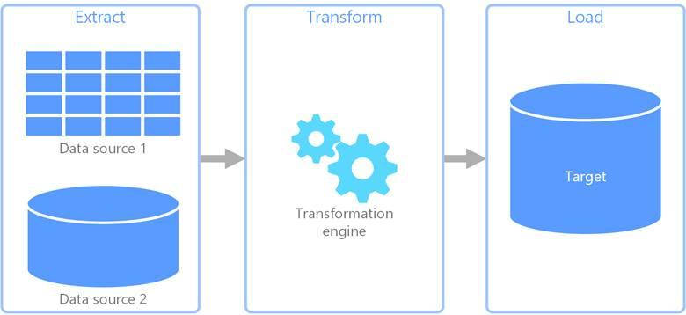

**Figure 2.2.** Steps in ETL Process (Source: Microsoft Learn)

Key Steps in the ETL Process:

*Extract (Data Extraction)*

The first stage in ETL is extracting data from source systems. The goal is to collect all necessary data while ensuring completeness and avoiding disruption to the source system's operations. Input data may come from:

* Relational databases (SQL Server, MySQL, PostgreSQL...)
* Non-relational databases (NoSQL like MongoDB, Cassandra)
* Raw files (CSV, Excel, JSON, XML)
* APIs from other systems (REST, SOAP)
* Cloud services (Google Cloud, AWS S3, Azure Blob)
* Legacy systems still in operation

Extraction can be performed in various modes: scheduled (batch), event-triggered, or real-time (streaming), depending on data freshness and speed requirements.

*Transform (Data Transformation)*

Once collected, data requires processing to become usable in the target system. This stage demands deep technical and business understanding. Typical operations include:

* Data cleansing: Removing missing, duplicate, or malformed data.
* Value standardization: Unifying date formats, measurement units, product codes.
* Format conversion: e.g., XML to JSON or relational tables.
* Applying business logic: Calculating profit margins, classifying customers by lifetime value, risk labeling based on behavior…
* Integrating data from multiple sources: e.g., joining transaction records with customer profiles.

This step converts raw data into meaningful information while restructuring it for analytical readiness. It also establishes a unified data format for future storage and utilization.

*Load (Data Loading)*

The final stage loads processed data into the target system. Depending on system scale and purpose, enterprises may choose these strategies:

* Full Load: Suitable for initial loads or small systems.
* Incremental Load: Only new or changed data (delta).
* Real-time Load: For systems requiring continuous updates (e.g., fraud detection, customer behavior tracking).
* Batch Processing: Periodic aggregation (hourly/daily/weekly).

Target systems are typically Data Warehouses (Snowflake, Amazon Redshift, Google BigQuery) or Data Lakes for more flexible, diverse data storage.

The Extract – Transform – Load (ETL) process serves as a vital component of any BI system, ensuring that data is accurate, reliable, and consistently structured. In this project, we used SQL Server Integration Services (SSIS) to develop automated ETL workflows that retrieve data from various operational sources, including purchase orders, product catalogs, vendor information, and employee assignments.

Once extracted, the data undergoes multiple transformation steps such as cleaning invalid values, mapping codes through lookup tables, enriching records with calculated fields like inventory status or date keys, and preparing historical tracking for dimension tables. For attributes that evolve over time—such as vendor ratings or addresses—the project implements Slowly Changing Dimensions, allowing us to preserve data history and support accurate time-based analysis.

After transformation, the processed data is loaded into the warehouse under the Galaxy Schema structure, where it becomes immediately accessible for analytical modeling in SSAS and visualization in Power BI. The ETL process, as implemented, is not only technically robust but also business-aware, aligning closely with procurement workflows and ensuring that the BI system remains dependable and relevant over time.

## 2.3. Data warehouse and data marmart

### 2.3.1. Data warehouse

A data warehouse (DW) is a digital storage system that connects and harmonizes large amounts of data from many different sources. Its purpose is to feed business intelligence (BI), reporting, and analytics, and support regulatory requirements – so companies can turn their data into insight and make smart, data-driven decisions. Data warehouses store current and historical data in one place and act as the single source of truth for an organization.

Data flows into a data warehouse from operational systems (like ERP and CRM), databases, and external sources such as partner systems, Internet of Things (IoT) devices, weather apps, and social media – usually on a regular cadence. The emergence of cloud computing has caused a shift in the landscape. In recent years, data storage locations have moved away from traditional on-premises infrastructure to multiple locations, including in private and public clouds. A typical data warehouse often includes the following elements:

* A [relational database](https://www.oracle.com/vn/database/what-is-a-relational-database/) to store and manage data
* An extraction, loading, and transformation (ELT) solution for preparing the data for analysis
* Statistical analysis, reporting, and data mining capabilities
* Client analysis tools for visualizing and presenting data to business users
* Other, more sophisticated analytical applications that generate actionable information by applying [data science](https://www.oracle.com/vn/what-is-data-science/) and artificial intelligence (AI) algorithms, or [graph](https://www.oracle.com/vn/autonomous-database/what-is-graph-database/) and spatial features that enable more kinds of analysis of data at scale.

*Benefits of a Data Warehouse*

Data warehouses offer the overarching and unique benefit of allowing organizations to analyze large amounts of variant data and extract significant value from it, as well as to keep a historical record.

Four unique characteristics (described by computer scientist William Inmon, who is considered the father of the data warehouse) allow data warehouses to deliver this overarching benefit. According to this definition, data warehouses are

* *Subject-oriented*: They can analyze data about a particular subject or functional area (such as sales).
* *Integrated:* Data warehouses create consistency among different data types from disparate sources.
* *Nonvolatile:* Once data is in a data warehouse, it’s stable and doesn’t change.
* *Time-variant:* Data warehouse analysis looks at change over time.

A well-designed data warehouse will perform queries very quickly, deliver high data throughput, and provide enough flexibility for end users to “slice and dice” or reduce the volume of data for closer examination to meet a variety of demands—whether at a high level or at a very fine, detailed level. The data warehouse serves as the functional foundation for middleware BI environments that provide end users with reports, dashboards, and other interfaces.

In data warehousing, a schema defines how data is logically organized and how the relationships between different tables are structured. Choosing the right schema design is crucial for ensuring efficient data storage, retrieval, and analysis. The most commonly used schemas in data warehouse design include:

* *Star Schema:* This is the simplest and most widely used schema. It consists of a central fact table connected directly to several denormalized dimension tables. The structure resembles a star, which makes it easy to understand and query. It’s ideal for straightforward reporting and quick data retrieval.
* *Snowflake Schema:* In this schema, dimension tables are normalized into multiple related tables, forming a structure that looks like a snowflake. While it reduces data redundancy and improves data integrity, it requires more complex queries due to additional joins.
* *Galaxy Schema (Fact Constellation Schema):* A more complex schema that involves multiple fact tables sharing dimension tables. It is used in large-scale data warehouses where different business processes (e.g., sales and inventory) are tracked simultaneously. It provides flexibility and supports more complex analysis.

These schemas serve different purposes depending on the business needs, query complexity, and data volume. Understanding their differences helps organizations design a data warehouse that balances performance, scalability, and maintainability.

### 2.3.2. Data Mart

A Data Mart is a type of data warehouse that contains data *specific* to a particular business line or department rather than an entire enterprise.

Because data marts contain a smaller subset of data, they enable a department or business line to discover more focused insights more quickly than is possible when working with the broader data warehouse data set.

For example, a marketing team might use a data mart to define ideal target demographics, while a product team might use one to analyze inventory patterns.

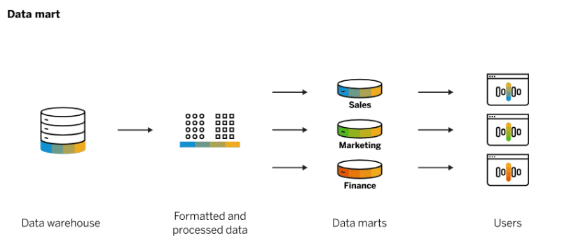

**Figure 2.3.** Diagram of a data mart and how it works (Source: Velog)

In our project, we built a data warehouse using the Galaxy Schema model, with data sourced from the AdventureWorks 2019 database. The main objective is to analyze the performance of the Purchasing Department, providing insights to support better decision-making and operational efficiency.

## 2.4. KPIs

A performance indicator or key performance indicator (KPI) is a type of performance measurement. KPIs evaluate the success of an organization or of a particular activity (such as projects, programs, products and other initiatives) in which it engages. KPIs provide a focus for strategic and operational improvement, create an analytical basis for decision making and help focus attention on what matters most.

Key performance indicators are used in business to judge performance and progress toward specific, measurable goals. As such, they provide owners and managers with an overview of how their business, or an aspect of their business, is performing at a certain point in time. They may be compared to:

* A predetermined benchmark
* Other competitors within the industry
* The performance of the business over time

Also referred to as key success indicators (KSIs), KPIs vary between companies and between industries, depending on performance criteria. For example, a software company striving to attain the fastest growth in its industry may consider year-over-year (YOY) revenue growth as its chief performance indicator. Conversely, a retail chain might place more value on same-store sales as the best KPI metric for gauging growth.

At the heart of KPIs lie data collection, storage, cleaning, and synthesizing. The KPI data is gathered and compared to the target that has been set. The results of that comparison are analyzed and used to draw conclusions about how well current systems or recent changes to those systems are working to achieve the department's or business's goals. This allows management to determine whether the current systems are effective and whether adjustments are needed to improve those outcomes and meet future goals.

The goal of KPIs is to communicate results succinctly to allow management to make more informed strategic decisions. They are often measured using analytics software and reporting tools.

As part of the project, the team designed and implemented a Key Performance Indicator (KPI) system to evaluate the operational effectiveness of the Purchasing Department at AdventureWorks, using data from the AdventureWorks 2019 sample database. The selected KPIs are practical and closely aligned with real-world procurement and supply chain processes. These KPIs were implemented within an OLAP cube using SQL Server Analysis Services (SSAS), with calculations written in MDX language. The results were visualized through interactive Power BI dashboards, enabling purchasing managers and team members to monitor performance trends, evaluate suppliers, and make timely, data-driven decisions. This KPI system plays a crucial role in improving procurement efficiency, enhancing supply chain visibility, and supporting strategic decision-making in a data-driven environment.

## 2.5. OLAP technique and MDX language for analyzing multi-dimension data

### 2.5.1. OLAP technique

OLAP (Online Analytical Processing) is an advanced data analysis technique that enables users to efficiently retrieve, process, and analyze data across multiple dimensions. It is a fundamental component of data warehouse systems, where data is structured into multidimensional formats to support in-depth analytical needs.



**Figure 2.4** Online Analytical Processing (Source: GeeksforGeeks)

At the core of OLAP lies the OLAP cube, a multidimensional structure that extends the traditional table format by incorporating multiple analytical dimensions such as time, product, vendor, etc. Each dimension can be broken down into various hierarchical levels (e.g., year → quarter → month). While OLAP cubes are theoretically capable of supporting unlimited dimensions (hypercube), in practice, designers implement only the necessary dimensions to optimize both analytical capability and system performance.

Among the OLAP architectures, MOLAP (Multidimensional OLAP) stands out as the most efficient and widely used. It pre-processes, aggregates, and stores data directly in physical cubes, allowing for extremely fast query response times. MOLAP supports a range of analytical operations, including:

* Drill-down: Navigating from summary data to more detailed levels within a hierarchy, allowing users to explore data granularity.
* Roll-up: The reverse of drill-down; it summarizes detailed data to higher-level aggregates to reveal broader trends.
* Slice: Refers to extracting a subset of the cube by fixing a single value from one dimension.
* Dice: Involves selecting a range of values across two or more dimensions.
* Pivot: Rotating the cube's perspective to view the data from different angles and uncover new relationships.

The key advantage of MOLAP lies in its speed and responsiveness. Since the data is already aggregated and indexed within the cube, complex queries and visualizations can be processed in near real time. This makes MOLAP highly suitable for Business Intelligence (BI) applications such as KPI analysis, interactive dashboards, and real-time decision support.

While ROLAP and HOLAP are also mentioned in OLAP theory:

* ROLAP queries relational databases directly without physical cubes, offering better scalability but slower performance.
* HOLAP combines MOLAP and ROLAP strengths but involves higher complexity and maintenance costs.

In this project, the team implemented MOLAP using SQL Server Analysis Services (SSAS) to build and analyze data cubes for the Purchasing Department of AdventureWorks. The use of MDX (Multidimensional Expressions) to query the cubes allows for flexible and accurate access to multidimensional insights, optimizing the overall BI effectiveness.

### 2.5.2. MDX language

First introduced in the late 1990s by Panorama Software and Microsoft, MDX (Multidimensional Expressions) has since evolved into a widely adopted query language, now considered a non-proprietary standard by many multidimensional database vendors. It was designed to facilitate the querying and analysis of data stored in OLAP cubes, using a syntax that is both powerful and user-friendly.

MDX is widely used in SQL Server Analysis Services (SSAS) and has the capability to generate multidimensional query results, including both axis data and cell data – which represent the intersection of selected dimensions. Compared to traditional SQL, which operates on two-dimensional tables, MDX enables analysis from multiple perspectives simultaneously, making it highly suitable for complex business intelligence requirements.

A basic MDX query typically consists of the following components:

* WITH clause: Allows the definition of calculated expressions or named sets that can be reused within the query. This improves logical handling and enhances query performance.
* SELECT clause: Specifies which dimension members will be displayed on the axes — usually ROWS and COLUMNS. Each axis contains a set of members to display results in a multidimensional format.
* FROM clause: Identifies the name of the cube to be queried. This cube serves as the data source, containing all preprocessed and structured multidimensional data.
* WHERE clause (also known as a slicer): Used to filter data by one or more specific members of a dimension. It restricts the analytical context without altering the axis layout. Note that the WHERE clause in MDX does not remove rows like in SQL; instead, it slices the data based on the selected dimension member.

By correctly applying and adhering to the role of each component in the query structure, MDX enables queries to be flexible, readable, and optimized for multidimensional data analysis. This structure not only reflects how data is organized within the cube but also ensures that users can retrieve information accurately and extend their analysis according to practical needs.

## 2.6. Power BI

### 2.6.1. Definition of Power BI

Power BI is a powerful data analytics and visualization platform developed by Microsoft. It allows users to connect to a wide range of data sources, process and model that data, and transform it into interactive reports and visual dashboards. This tool supports businesses in making data-driven decisions swiftly while also facilitating the digitalization of reporting and performance monitoring processes.

Thanks to its user-friendly interface and high level of interactivity, Power BI enables even non-technical users to easily build dynamic dashboards and explore data in real time. Its interactive features allow for flexible filtering, data slicing, and in-depth analysis, helping users uncover valuable insights to guide managerial and operational decisions.

Unlike traditional static reporting tools, Power BI offers a modern, interactive working environment. It is deeply integrated with Microsoft’s ecosystem—such as Excel, Azure, SharePoint, and Teams—as well as popular data platforms like SQL Server, Google Analytics, Salesforce, and SAP. Its high compatibility and ease of deployment have made Power BI a widely adopted solution across modern organizations, from analysts to executives.



**Figure 2.5.** Power BI (Source: Adtimin)

### 2.6.2. Core Components of Power BI

The Power BI ecosystem is built around three core components: Power BI Desktop, Power BI Service, and Power BI Mobile. Each plays a distinct role within the data analysis and visualization pipeline. In addition, Microsoft provides supporting tools to enhance the overall reporting workflow within business environments.

*Power BI Desktop* is a desktop application considered the central workspace for building reports. Users can:

* Connect to various data sources, including Excel, SQL Server, PostgreSQL, web APIs, and more.
* Perform ETL (Extract – Transform – Load) processes to clean and prepare data.
* Design data models by defining relationships between tables and creating calculated columns or measures using the DAX language.
* Generate interactive reports using charts, dashboards, KPIs, maps, and other visuals.

*Power BI Service (also known as Power BI Online)* is a web-based platform that allows users to publish their reports from Power BI Desktop to the cloud. Within this environment, users can:

* Store, present, and share reports in real time.
* Schedule data refreshes to ensure up-to-date information.
* Manage user access and distribute content securely across departments.

*Power BI Mobile* is an application available on Android and iOS devices. It provides quick access to dashboards and reports stored on Power BI Service, allowing users to monitor key metrics and make decisions anytime, anywhere. The mobile interface is optimized for touch interaction and supports data alerts when thresholds are breached.

In addition to these core components, Power BI includes several supplementary tools that complete the data analysis lifecycle:

* *Power BI Gateway* acts as a bridge between on-premises data sources and Power BI Service. It ensures continuous and secure synchronization of internal data to the cloud.
* *Power BI Report Server* is an on-premises deployment option designed for organizations with strict data security requirements or those not yet ready for cloud adoption. It enables storage and access to reports within a company’s local network.
* *Power Query and Power Pivot* are integrated tools within Power BI Desktop. Power Query facilitates data cleansing and transformation, while Power Pivot supports high-performance data modeling and advanced calculations using DAX.

### 2.6.3. How Power BI Works

The operation of Power BI can be described through four sequential phases, forming a closed-loop workflow for data analysis and visualization. Each phase plays a vital role in transforming raw data into meaningful insights that support decision-making.

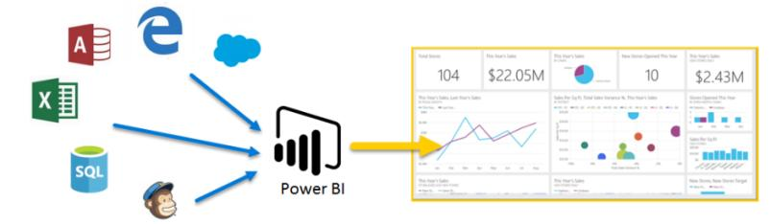

**Figure 2.6.** Power BI Data Integration and Visualization Flow (Source: CRMVIET)

#### 2.6.3.1. Data Connection

The first stage in the Power BI data workflow involves establishing connections to data sources. Power BI supports a wide variety of connectors—over one hundred in total—ranging from simple file-based inputs such as Excel and CSV to more advanced relational database systems like SQL Server, Oracle, and PostgreSQL. In addition, it offers seamless integration with various cloud-based platforms including Google Analytics, Salesforce, Azure, and Dynamics 365, as well as Microsoft’s own enterprise tools such as SQL Server Analysis Services (SSAS) and SQL Server Integration Services (SSIS). Power BI can directly query analytical models built in SSAS or consume output data that has been processed and prepared through SSIS ETL packages.

Thanks to this high level of interoperability, Power BI serves as an effective solution for unifying data from fragmented systems, laying a strong foundation for analysis, visualization, and data-driven decision-making.

#### 2.6.3.2. Data Cleaning and Transformation

Once data is connected, it typically requires cleaning and transformation before it becomes usable. Power BI leverages the Power Query Editor to facilitate data preparation in an intuitive, code-free environment.

Users can eliminate invalid records, normalize data formats, split or merge columns, convert data types, and define relationships between tables. This step is crucial in ensuring data consistency and accuracy, which directly affects the reliability of analytical results.

#### 2.6.3.3. Data Visualization

Cleaned data is then used to design reports. Power BI offers an extensive library of visualization options, including bar charts, line graphs, pie charts, geographic maps, waterfall charts, combo charts, and KPI indicators.

Users can create visually appealing and interactive dashboards through simple drag-and-drop actions. Notably, features such as *drill-down analysis* and *dynamic filtering* allow users to explore data hierarchically and extract insights based on specific contexts, all within the report interface.

#### 2.6.3.4. Publishing and Sharing

Once completed, reports can be published to the Power BI Service platform. This is a cloud-based workspace where reports are stored, synchronized, and made accessible to end users.

Power BI Service supports *scheduled data refresh*, ensuring that reports reflect the most recent data available. A robust permission system allows for precise control over who can view, edit, or export reports. Furthermore, Power BI reports can be *embedded* into internal platforms like SharePoint, Microsoft Teams, or corporate websites—broadening accessibility while maintaining data governance.

# 

# CHAPTER 3: USER REQUIREMENTS ANALYSIS AND DATA DESCRIPTION

This chapter comprehensively presents the process of building a Business Intelligence (BI) solution for the Purchasing Department at AdventureWorks. It begins with an analysis of the roles, organizational structure, and specific operational processes of the Purchasing Department – the foundation for clearly defining business requirements, key performance indicators (KPIs), and necessary system functionalities. Based on this foundation, the chapter continues by discussing BI use cases and analysis types suitable for needs such as cost tracking, supplier performance management, and order management. The data preparation and understanding process is carried out through data source analysis and the construction of a specialized Data Mart, leading to the design of a star-schema data warehouse with fact and dimension tables. Finally, the chapter describes the ETL process with data integration strategies, Slowly Changing Dimension (SCD) handling, and execution using SSIS tools, ensuring data is transformed and loaded into the analytical system stably, consistently, and efficiently.

## 3.1. Purchasing Department

### 3.1.1. Purchasing Department at AdventureWorks

In the context of modern industrialization, the Purchasing Department at AdventureWorks plays an essential role in ensuring a stable, efficient, and production-requirement-aligned input supply chain. As a large-scale manufacturing enterprise specializing in sports equipment, mechanical components, and bicycles, AdventureWorks heavily relies on the availability, quality, and cost of externally sourced raw materials and components. Therefore, the Purchasing Department does not merely perform ordering functions but also acts as a strategic hub helping to control input risks, optimize costs, and enhance the overall competitiveness of the enterprise.

Firstly, the Purchasing Department is responsible for planning and coordinating supply activities aligned with the company's production plans and development strategies. Purchasing decisions must be based on analysis of actual demand, storage capacity, market trends, and raw material price fluctuations. The goal is not only to "purchase enough" but also to "purchase correctly": the right type, right quality, right time, and right supplier. This requires the purchasing team to maintain a reliable supplier network while constantly updating market trends to flexibly adjust purchasing policies.

Furthermore, the Purchasing Department acts as a bridge in building sustainable partnerships with strategic suppliers. Instead of a short-term transactional approach, AdventureWorks' modern purchasing model focuses on long-term collaboration, where both parties share information, improve quality, and develop products. In some cases, the Purchasing Department participates in new product design by coordinating with the R&D department to source better-quality or lower-cost alternative materials.

From an internal control perspective, the Purchasing Department is also the frontline in ensuring compliance with the company's financial policies, business ethics, and sustainability standards. Supplier selection is not based solely on cost factors but also requires evaluation of production capacity, social responsibility, environmental commitments, and compliance with international laws – especially within the increasingly complex globalized supply chain context.

In summary, the Purchasing Department at AdventureWorks holds a core role in ensuring continuity, efficiency, and quality for production activities – from supply chain strategy planning, cost control, and partner development to risk management. Organizing this function well not only helps the enterprise avoid production disruptions but also creates a sustainable competitive advantage in the market.

### 3.1.2. Organizational Structure

The operational structure of AdventureWorks' Purchasing Department is built upon the dynamic interaction of three core roles: the *Purchasing Manager*, the *Buyer*, and the *Purchasing Assistant***.** While each of these positions functions within a distinct scope of responsibilities, their collaboration forms the backbone of an efficient and responsive procurement process that aligns with organizational goals in cost control, supply assurance, and inventory stability.

At the strategic level, the *Purchasing Manager* serves as the architect of the company's procurement framework. This role is not confined to approving large-scale purchasing plans but extends to shaping long-term supplier strategies, assessing market conditions, and ensuring procurement activities align with broader financial and operational targets. The Purchasing Manager must constantly evaluate sourcing risks, supplier reliability, and total cost structures to optimize supply continuity while minimizing exposure to market volatility. As such, this role requires not only a macro-level view of supplier ecosystems and contract lifecycles but also timely insights into how purchasing decisions impact inventory flow, working capital, and production schedules. From a solution standpoint, the Purchasing Manager expects a system that enables centralized oversight of procurement activities, facilitates contract governance, and provides alignment between strategic sourcing decisions and actual purchasing execution.

In contrast, the *Buyer* operates at the tactical and executional level of the procurement function. Their primary responsibility lies in translating purchasing plans or inventory replenishment needs into actionable transactions with suppliers. The role demands a high degree of operational responsiveness, as Buyers are directly involved in managing the purchase order lifecycle—from issuance and confirmation to follow-up and exception handling. This includes resolving discrepancies in delivery times, quantities, or item specifications, often under time-sensitive conditions. Furthermore, since Buyers serve as the primary liaison between the organization and its suppliers on a day-to-day basis, they require complete visibility over supplier performance, delivery histories, and open orders. An effective solution must therefore empower Buyers to act swiftly and decisively by providing real-time order status, streamlined supplier communications, and proactive alerts when deviations occur. The ability to adapt rapidly to unexpected changes is critical to maintaining service levels across the supply chain.

Supporting both strategic and operational functions is the *Purchasing Assistant*, whose role centers on maintaining equilibrium between inventory availability and financial efficiency. The Purchasing Assistant ensures that stock levels are sufficient to meet demand without incurring unnecessary holding costs or risking stockouts. This involves continuous monitoring of inventory movements, trend analysis based on consumption patterns, and forecasting future demand to generate accurate replenishment proposals. Given the fast-moving nature of production and sales cycles, this role requires both precision and foresight. The Purchasing Assistant's input is vital in initiating timely purchasing actions and avoiding disruptions caused by misaligned stock levels. Accordingly, any purchasing solution must integrate tightly with inventory data, enabling the Controller to make data-informed proposals and collaborate seamlessly with Buyers on restocking decisions.

**Figure 3.1.** Purchasing Department (Source: Authors, 2025)

The interdependence among these three roles illustrates the importance of a cohesive and well-integrated solution that supports both strategic control and operational agility. The Purchasing Manager sets the direction, the Buyer executes in the field, and the Purchasing Assistant ensures the rhythm between consumption and supply is maintained. A robust solution must bridge these perspectives—offering clarity, consistency, and coordination across all levels of the purchasing hierarchy. In doing so, it not only enhances internal collaboration but also strengthens the organization's ability to respond effectively to external supply chain dynamics.

### 3.1.3. Purchasing Process

The purchasing process is not merely a material ordering activity but a coordinated system between multiple departments and functions to ensure every purchasing decision stems from actual needs and is controlled for quality, price, timing, and budget.

*Step 1: Identify Purchase Need*

Purchasing activities originate from actual internal enterprise needs. The Purchasing Assistant directly monitors and analyzes inventory data, periodic material consumption levels, or abnormal signals from the production system. Additionally, specialized departments can submit purchase proposals for specific materials or equipment.

* Input: Actual inventory data, consumption history, production plan, or purchase proposals from relevant departments.
* Output: Preliminary list of purchase needs, serving as the basis for creating a Purchase Requisition.

*Step 2: Initiate and Approve Purchase Requisition (PR)*

Based on the analysis from the previous step, the Purchasing Assistant or the requester creates a Purchase Requisition. This form must clearly state the purpose, type, quantity of materials, requesting unit, and required delivery time. The request is then sent to the Purchasing Manager for approval according to authorization.

* Input: Clearly defined purchase need, supporting data from the inventory system or production plan.
* Output: Approved Purchase Requisition (validated PR), ready to move to the order creation step.

*Step 3: Supplier Selection and Purchase Order (PO) Creation*

The Buyer is responsible for receiving the approved PR, then proceeding to search, evaluate, and select suppliers. Selection criteria may include: price, delivery time, payment terms, past reliability, and product technical standards. After identifying a suitable supplier, the Buyer creates a Purchase Order.

* Input: Approved PR, list of potential suppliers, and quotation data.
* Output: Purchase Order (PO) with detailed information: product, quantity, price, delivery deadline, and transaction terms.

*Step 4: Purchase Order Approval and Supplier Dispatch*

The created order undergoes final approval. The Purchasing Manager reviews the validity of the PO based on budget, price level, transaction volume, and internal regulations. For large orders, multi-level sign-off or leadership approval may be required.

* Input: Purchase Order from Buyer and system approval data.
* Output: Confirmed PO sent to the supplier.

*Step 5: Goods Delivery and Receipt*

The supplier delivers goods according to the PO. The warehouse department, together with the Buyer, checks and receives the goods. The inspection includes comparing the actual received quantity with the PO, assessing material quality, and recording packaging condition. If the goods meet requirements, a Receiving Report is created.

* Input: Confirmed PO, goods from the supplier, delivery information.
* Output: Goods Receipt Report (Receiving Report), updating the quantity into the inventory system.

*Step 6: Invoice Matching and Payment Processing*

After delivery is completed, the supplier sends an invoice. The accounting department matches the invoice, PO, and Receiving Report to ensure information consistency (three-way matching process). If there are no discrepancies, payment is processed according to the agreed terms.

* Input: Supplier invoice, confirmed PO, Receiving Report.
* Output: Payment approval, payment order, and recording of supplier liability.

*Step 7: Bookkeeping and Data Storage*

After payment is completed, the purchasing process continues with post-audit activities to ensure the entire transaction is accurately recorded in the accounting system. Data is also stored for future management, analysis, and internal audit purposes. The accounting department will perform cost recognition entries, update liability accounts, reconcile balances, and allocate purchasing costs to the correct cost objects such as production departments, projects, or overhead costs. Simultaneously, data related to orders, suppliers, invoices, and payment status will be stored in the data management system (data warehouse) to ensure traceability, aggregation, and analysis capabilities.

* Input: Executed payment information, approved invoice, PO data, and Receiving Report.
* Output: Cost and liability recognition in the accounting system, updated purchasing cost reports, stored procurement data for future analysis and auditing.

## 3.2. Key Performance Indicators (KPIs)

The purchasing department uses the following key performance indicators (KPIs) to monitor and improve procurement efficiency. These indicators offer quantitative insights into the purchasing process, supplier quality, and supply chain responsiveness.

### 3.2.1. Return Rate

*Monitoring Purpose:* To evaluate supplier product quality and the effectiveness of quality control during the procurement process.

*Definition:* Return Rate measures the proportion of products that were ordered but not stocked, due to technical issues, defects, or quality failures.

*Formula:* Return Rate = (Received Quantity − Stocked Quantity) / Received Quantity

*Indicator Interpretation:* The lower the Return Rate, the better. A high rate indicates supplier issues or inadequate inspection procedures.

*Data Sources:*

* Purchasing.PurchaseOrderDetail
* Purchasing.PurchaseOrderHeader

### 3.2.2. Received Rate

*Monitoring Purpose:* To assess the reliability of suppliers in delivering the full ordered quantities.

*Definition:* Received Rate indicates the proportion of products actually received compared to the total quantity ordered.

*Formula:* Received Rate = Received Quantity / Order Quantity

*Indicator Interpretation:* A high rate reflects supplier reliability. A low rate may indicate supply issues, partial deliveries, or delivery delays.

*Data Sources:*

* Purchasing.PurchaseOrderDetail
* Purchasing.PurchaseOrderHeader

### 3.2.3. Order Quantity

*Monitoring Purpose:* To track the volume of goods ordered over specific periods, which supports procurement planning and inventory control.

*Definition:* This KPI sums up the quantity of all products purchased within a defined period (e.g., by day, month, or year).

*Formula:* OrderQty

*Indicator Interpretation:* This indicator helps analyze demand trends, forecast future purchasing needs, and avoid overstocking.

Data Sources:

* Purchasing.PurchaseOrderDetail
* Purchasing.PurchaseOrderHeader

### 3.2.4. Average Lead Time

*Monitoring Purpose:* To evaluate the responsiveness of the supply chain based on how long it takes to receive goods after ordering.

*Definition:* Average Lead Time is the average number of days from the order date to the receipt date.

*Formula:* Average Lead Time

*Indicator Interpretation:* Shorter lead times suggest a more agile supply chain. Longer durations may lead to stockouts or disrupt production planning.

*Data Source:* Purchasing.ProductVendor

## 3.3. Business Intelligence Capabilities for Procurement Decision Support

### 3.3.1. Strategic Needs for BI in Procurement

The procurement function plays a critical role in ensuring business continuity, especially in manufacturing-oriented enterprises like AdventureWorks. In recent years, the complexity of sourcing networks, global vendor relationships, and real-time inventory demands have increased pressure on purchasing departments to not only operate efficiently but also make strategic, data-driven decisions. Traditional tools such as spreadsheets or static reports are no longer sufficient to manage the dynamic nature of procurement operations.

Business Intelligence (BI) systems provide a modern solution by offering a centralized and integrated view of procurement data, combining purchase orders, supplier records, lead times, inventory levels, and payment histories. With these capabilities, procurement leaders are empowered to detect inefficiencies, assess supplier performance, monitor compliance, and predict future needs with greater precision. Moreover, the ability to respond quickly to market changes—such as raw material shortages or supplier disruptions—is enhanced by the real-time nature of BI dashboards and alerts. As such, the deployment of BI in procurement is not simply an upgrade in tools; it is a shift toward proactive, insight-led purchasing strategies that align with organizational goals for cost control, agility, and supply chain resilience.

### 3.3.2. Core Analytical Scenarios

Within the procurement department, BI is applied to a wide range of analytical scenarios that target both operational execution and strategic decision-making. One prominent scenario is the analysis of delivery punctuality. By comparing planned delivery dates with actual receipt timestamps, the system highlights late shipments and quantifies vendor reliability. Such insights are vital in supplier scorecards and contract reviews.

Another scenario involves identifying root causes of purchase order cancellations. While cancellations may stem from many factors—vendor errors, internal misalignment, inventory shifts—the BI system enables categorization of these events and uncovers trends by vendor, product, or seasonality. Procurement teams can thus take corrective action, whether renegotiating contract terms or improving internal coordination.

Additionally, cycle time analysis offers visibility into the full duration of a purchase process—from initial requisition to final payment. BI allows the segmentation of this timeline, helping auditors and managers detect delays in approval chains, invoice processing, or vendor responsiveness. Optimization in these stages can result in both cost savings and enhanced vendor relationships.

Finally, procurement teams can analyze stockouts or understock situations by connecting them to supplier behavior. BI dashboards can attribute late inventory replenishment to specific delayed shipments, allowing planners to adjust reorder strategies or diversify supplier portfolios. When combined with price history analysis across vendors, these scenarios help buyers strike a balance between cost, timeliness, and reliability.

### 3.3.3. Role-Based Interaction with BI System

The effectiveness of a BI system in procurement depends on its ability to serve the distinct responsibilities of each role within the purchasing department. Since individuals interact with data differently based on their functions and decision-making scope, the system must offer tailored interfaces and tools accordingly.

*Purchasing Managers* operate at a strategic level. They use BI dashboards to monitor key performance indicators such as supplier reliability, total procurement costs, order cancellation rates, and long-term pricing trends. These insights enable them to evaluate sourcing performance, refine vendor strategies, and make informed decisions aligned with organizational goals.

*Buyers*, by contrast, are engaged in daily operations. Their use of BI focuses on real-time tasks—tracking open purchase orders, delayed deliveries, cost changes, and low inventory alerts. Features such as reorder recommendations and lead time analysis support their ability to respond quickly and maintain supply chain efficiency.

*Purchasing Assistants* are tasked with balancing stock levels to avoid both shortages and surpluses. They rely on BI to monitor inventory in real time, analyze historical consumption, and forecast future needs. This data also helps trace inventory issues back to procurement or supplier performance, allowing for better coordination and corrective actions.

This role-specific design ensures that each team member receives information at the appropriate level of granularity, improving individual decision-making and reinforcing cohesion throughout the procurement workflow.

### 3.3.4. Types of Intelligence Required

Modern Business Intelligence (BI) systems are no longer limited to traditional reporting functions; they now encompass various forms of analytical reasoning to support complex decision-making. As outlined by TutorialsPoint (2025), BI can be classified according to the analytical depth it offers—primarily across three main categories: *descriptive, predictive,* and *prescriptive* *intelligence*. In addition, the ability to diagnose causes from patterns in the data is also implicitly embedded within these levels of analysis.

*Descriptive intelligence* forms the foundation of any BI solution. It is used to represent and summarize historical data, allowing procurement teams to observe what has occurred across their operations. For instance, it enables users to view metrics such as total order volumes, vendor performance over time, and cancellation trends. These insights serve as a factual baseline and are critical for monitoring operational consistency and performance indicators.

Building on this, *predictive intelligence* involves identifying patterns and correlations in historical data to estimate what might happen in the future. In procurement, such analysis supports forecasting demand fluctuations, anticipating delivery delays, and estimating lead time risks. These capabilities allow organizations to make proactive decisions, improve supplier coordination, and better allocate budgets.

*Prescriptive intelligence*, the most advanced layer, provides actionable recommendations to achieve defined objectives. Unlike predictive analytics—which offers insight into possible outcomes—prescriptive tools suggest optimal decisions or strategies based on those forecasts. In a procurement setting, this might involve determining the most effective sourcing approach, identifying the best reorder points, or reallocating supply contracts to mitigate risk.

While the source does not explicitly list *diagnostic intelligence* as a standalone category, its essence is reflected in the descriptive layer’s capacity to help users “understand why” a particular event occurred. Through drill-downs and cross-dimensional filtering, BI dashboards can facilitate root cause analysis, thereby fulfilling the diagnostic function in practice. (Source: TutorialsPoint)

By integrating these layers of intelligence, BI systems empower procurement professionals not only to monitor past and current operations but also to prepare for future scenarios and take optimized action. The progression from descriptive to prescriptive insight is what makes BI a comprehensive tool for modern procurement strategy.

### 3.3.5. Detailed Business Requirements

**Table 3.1.** Business Requirements

|  |  |  |  |  |
| --- | --- | --- | --- | --- |
| **Role** | **Objective** | **Primary Function** | **System Requirements** | **Constraints** |
| Purchasing Manager | Coordinate the entire procurement process to ensure alignment with supply strategy, budget limits, and company business production goals. | - Approve purchase orders and control costs. - Monitor supplier performance. - Evaluate procurement process compliance. | - System must provide aggregated order reports by allocated budget. - Dashboard for real-time order status tracking. - Budget overrun alerts. | Decisions depend on accuracy and timeliness of inventory data, production forecasts, and allocated budgets. |
| Buyer | Ensure full execution of approved orders, negotiate favorable prices, and track the entire purchase-receipt-payment process with suppliers. | - Create Purchase Orders (PO). - Send PO to the supplier. - Track delivery progress. - Coordinate goods inspection upon receipt. | - System must support direct PO creation from approved requisitions, with editable terms. - Interface for tracking daily delivery status by supplier. - Automatic alerts for overdue POs. | Dependent on supplier response times, market responsiveness, and internal information systems for coordination of inspection, receipt, and payment. |
| Purchasing Assistant | Ensure optimal inventory levels to prevent production disruptions or excess stock; support purchasing decisions based on actual needs. | - Monitor current inventory data. - Compare against alert thresholds to generate purchase proposals. - Coordinate inspection upon goods receipt. | - System must display actual inventory, minimum thresholds, and optimal levels per production plan. - Automatic alerts when stock approaches reorder point. - Allow direct purchase proposal generation from inventory screen. | Accuracy depends on data update frequency; requires close coordination with Buyer to ensure reasonable order lead times. |

## 3.4. Data Preparation

### 3.4.1. Data Sources

In this project, the data source is extracted from the well-known sample database AdventureWorks, provided by Microsoft. AdventureWorks simulates a manufacturing company and offers a rich set of relational data that reflects various business operations such as purchasing, production, human resources, and sales. For the purposes of this project, data related to the Purchasing Department was selected as the foundation for building a specialized data mart. This serves as the basis for constructing a data warehouse, implementing the ETL process, and conducting analytical activities using BI tools.

To build the data mart for the purchasing subsystem, the following tables were selected from the AdventureWorks database due to their relevance and critical roles in the procurement process:

* Purchasing.PurchaseOrderHeader: Records general information about each purchase order.
* Purchasing.PurchaseOrderDetail: Contains line item details for each purchase order.
* Purchasing.Vendor: Contains information about suppliers.
* Purchasing.ProductVendor: Links products to their respective suppliers.
* Purchasing.ShipMethod: Describes shipping methods for the ordered goods.
* Production.Product: Contains data related to products.
* Production.ProductInventory: Tracks inventory quantities of each product.
* Production.ProductCategory: Defines high-level product categories.
* Production.ProductSubCategory: Provides more detailed product classification.
* Production.Location: Identifies warehouse locations related to inventory management.
* HumanResources.Employee: Stores information about employees involved in the purchasing process.
* Person.Person: Provides detailed personal information of employees.

This set of tables supports the construction of the necessary dimension and fact tables for a comprehensive and effective purchasing data mart.

### 3.4.2. Detailed Description of Data Source

*Purchasing.PurchaseOrderHeader: Records general information about each purchase order*

**Table 3.2.** Column of Purchasing.PurchaseOrderHeader

|  |  |  |  |  |
| --- | --- | --- | --- | --- |
| **Key** | **Name** | **Data type** | **Null** | **Description** |
| PK | PurchaseOrderID | int |  | Primary key. Identity |
|  | RevisionNumber | tinyint |  | Incremental number to track changes to the purchase order over time. Default: 0 |
|  | Status | tinyint |  | Order current status. 1 = Pending; 2 = Approved; 3 = Rejected; 4 = Complete. Default: 1 |
|  | EmployeeID | int |  | Employee who created the purchase order. Foreign key to Employee.BusinessEntityID. References: HumanResources.Employee |
|  | VendorID | int |  | Vendor with whom the purchase order is placed. Foreign key to Vendor.BusinessEntityID. References: Purchasing.Vendor |
|  | ShipMethodID | int |  | Shipping method. Foreign key to ShipMethod.ShipMethodID. References: Purchasing.ShipMethod |
|  | OrderDate | datetime |  | Purchase order creation date. Default: getdate() |
|  | ShipDate | datetime | x | Estimated shipment date from the vendor. |
|  | SubTotal | money |  | Purchase order subtotal. Computed as SUM(PurchaseOrderDetail.LineTotal)for the appropriate PurchaseOrderID. Default: 0.00 |
|  | TaxAmt | money |  | Tax amount. Default: 0.00 |
|  | Freight | money |  | Shipping cost. Default: 0.00 |
|  | TotalDue | money |  | Total due to the vendor. Computed as Subtotal + TaxAmt + Freight. Computed: isnull(([SubTotal]+[TaxAmt])+[Freight],(0)) |
|  | ModifiedDate | datetime |  | Date and time the record was last updated. Default: getdate() |

**Table 3.3.** Relation of Purchasing.PurchaseOrderHeader

|  |  |  |  |
| --- | --- | --- | --- |
| **Foreign table** |  | **Primary table** | **Description** |
| Purchasing.PurchaseOrderHeader |  | HumanResources.Employee | **Join:** Purchasing.PurchaseOrderHeader.EmployeeID = HumanResources.Employee.BusinessEntityID  **Name:** FK_PurchaseOrderHeader_Employee_EmployeeID Foreign key constraint referencing Employee.EmployeeID |
| Purchasing.PurchaseOrderHeader |  | Purchasing.ShipMethod | **Join:** Purchasing.PurchaseOrderHeader.ShipMethodID = Purchasing.ShipMethod.ShipMethodID  **Name:** FK_PurchaseOrderHeader_ShipMethod_ShipMethodID  Foreign key constraint referencing ShipMethod.ShipMethodID. |
| Purchasing.PurchaseOrderHeader |  | Purchasing.Vendor | **Join:** Purchasing.PurchaseOrderHeader.VendorID = Purchasing.Vendor.BusinessEntityID  **Name**: FK_PurchaseOrderHeader_Vendor_VendorID  Foreign key constraint referencing Vendor.VendorID. |
| Purchasing.PurchaseOrderDetail |  | Purchasing.PurchaseOrder  Header | **Join:** Purchasing.PurchaseOrderDetail.PurchaseOrderID = Purchasing.PurchaseOrderHeader.PurchaseOrderID  **Name:** FK_PurchaseOrderDetail_PurchaseOrder  Header_PurchaseOrderID  Foreign key constraint referencing PurchaseOrderHeader.PurchaseOrderID. |

*Purchasing.PurchaseOrderDetail: Contains line item details for each purchase order*

**Table 3.4.** Column of Purchasing.PurchaseOrderDetail

|  |  |  |  |  |
| --- | --- | --- | --- | --- |
| **Key** | **Name** | **Data type** | **Null** | **Description** |
| PK | PurchaseOrderID | int |  | Primary key. Foreign key to PurchaseOrderHeader.PurchaseOrderID.  References: Purchasing.PurchaseOrderHeader |
| PK | PurchaseOrderDetailID | int |  | Primary key. One line number per purchased product. Identity |
|  | DueDate | datetime |  | Date the product is expected to be received. |
|  | OrderQty | smallint |  | Quantity ordered. |
|  | ProductID | int |  | Product identification number. Foreign key to Product.ProductID.  References: Production.Product |
|  | UnitPrice | money |  | Vendor's selling price of a single product. |
|  | LineTotal | money |  | Per product subtotal. Computed as OrderQty * UnitPrice.  Computed: isnull([OrderQty]*[UnitPrice],(0.00)) |
|  | ReceivedQty | decimal(8, 2) |  | Quantity actually received from the vendor. |
|  | RejectedQty | decimal(8, 2) |  | Quantity rejected during inspection. |
|  | StockedQty | decimal(9, 2) |  | Quantity accepted into inventory. Computed as ReceivedQty - RejectedQty.  Computed: isnull([ReceivedQty]-[RejectedQty],(0.00)) |
|  | ModifiedDate | datetime |  | Date and time the record was last updated. Default: getdate() |

**Table 3.5** Relation of Purchasing.PurchaseOrderDetail

|  |  |  |  |
| --- | --- | --- | --- |
| **Foreign table** |  | **Primary table** | **Description** |
| Purchasing.PurchaseOrderDetail |  | Production.Product | Purchasing.PurchaseOrderDetail.ProductID = Production.Product.ProductID  Name: FK_PurchaseOrderDetail_Product_ProductID  Foreign key constraint referencing Product.ProductID. |
| Purchasing.PurchaseOrderDetai |  | Purchasing.Purchase  OrderHeader | Purchasing.PurchaseOrderDetail.PurchaseOrderID = Purchasing.PurchaseOrderHeader.PurchaseOrderID  Name: FK_PurchaseOrderDetail_PurchaseOrderHeader_PurchaseOrderID  Foreign key constraint referencing PurchaseOrderHeader.PurchaseOrderID. |

*Purchasing.Vendor: Contains information about suppliers*

**Table 3.6.** Column of Purchasing.Vendor

|  |  |  |  |  |
| --- | --- | --- | --- | --- |
| **Key** | **Name** | **Data type** | **Null** | **Description** |
| PK | BusinessEntityID | int |  | Primary key for Vendor records. Foreign key to BusinessEntity.BusinessEntityID. References: Person.BusinessEntity |
| AK | AccountNumber | nvarchar(15) |  | Vendor account (identification) number. |
|  | Name | nvarchar(50) |  | Company name. |
|  | CreditRating | tinyint |  | 1 = Superior, 2 = Excellent, 3 = Above average, 4 = Average, 5 = Below average |
|  | PreferredVendor  Status | bit |  | 0 = Do not use if another vendor is available. 1 = Preferred over other vendors supplying the same product. Default: 1 |
|  | ActiveFlag | bit |  | 0 = Vendor no longer used. 1 = Vendor is actively used. Default: 1 |
|  | PurchasingWeb  ServiceURL | nvarchar(1024) | x | Vendor URL. |
|  | ModifiedDate | datetime |  | Date and time the record was last updated. Default: getdate() |

**Table 3.7.** Relation of Purchasing.Vendor

|  |  |  |  |
| --- | --- | --- | --- |
| **Foreign table** |  | **Primary table** | **Description** |
| Purchasing.Vendor |  | Person.BusinessEntity | Purchasing.Vendor.BusinessEntityID = Person.BusinessEntity.BusinessEntityID  Name: FK_Vendor_BusinessEntity_BusinessEntityID  Foreign key constraint referencing BusinessEntity.BusinessEntityID |
| Purchasing.ProductVendor |  | Purchasing.Vendor | Purchasing.ProductVendor.BusinessEntityID = Purchasing.Vendor.BusinessEntityID  Name: FK_ProductVendor_Vendor_BusinessEntityID  Foreign key constraint referencing Vendor.BusinessEntityID. |
| Purchasing.PurchaseOrderHeader |  | Purchasing.Vendor | Purchasing.PurchaseOrderHeader.VendorID = Purchasing.Vendor.BusinessEntityID  Name: FK_PurchaseOrderHeader_Vendor_VendorID  Foreign key constraint referencing Vendor.VendorID. |

*Purchasing.ProductVendor: Links products to their respective suppliers*

**Table 3.8.** Column of Purchasing.ProductVendor

|  |  |  |  |  |
| --- | --- | --- | --- | --- |
| **Key** | **Name** | **Data type** | **Null** | **Description** |
| PK | ProductID | int |  | Primary key. Foreign key to Product.ProductID.  References: Production.Product |
| PK | BusinessEntityID | int |  | Primary key. Foreign key to Vendor.BusinessEntityID.  References: Purchasing.Vendor |
|  | AverageLeadTime | int |  | The average span of time (in days) between placing an order with the vendor and receiving the purchased product. |
|  | StandardPrice | money |  | The vendor's usual selling price. |
|  | LastReceiptCost | money | x | The selling price when last purchased. |
|  | LastReceiptDate | datetime | x | Date the product was last received by the vendor. |
|  | MinOrderQty | int |  | The maximum quantity that should be ordered. |
|  | MaxOrderQty | int |  | The minimum quantity that should be ordered. |
|  | OnOrderQty | int | x | The quantity currently on order. |
|  | UnitMeasureCode | nchar(3) |  | The product's unit of measure.  References: Production.UnitMeasure |
|  | ModifiedDate | datetime |  | Date and time the record was last updated. Default: getdate() |

**Table 3.9.** Relation of Purchasing.ProductVendor

|  |  |  |  |
| --- | --- | --- | --- |
| **Foreign table** |  | **Primary table** | **Description** |
| Purchasing.ProductVendor |  | Production.Product | Purchasing.ProductVendor.ProductID = Production.Product.ProductID  Name: FK_ProductVendor_Product_ProductID  Foreign key constraint referencing Product.ProductID. |
| Purchasing.ProductVendor |  | Production.UnitMeasure | Purchasing.ProductVendor.UnitMeasureCode = Production.UnitMeasure.UnitMeasureCode  Name: FK_ProductVendor_UnitMeasure_UnitMeasureCode  Foreign key constraint referencing UnitMeasure.UnitMeasureCode. |
| Purchasing.ProductVendor |  | Purchasing.Vendor | Purchasing.ProductVendor.BusinessEntityID = Purchasing.Vendor.BusinessEntityID  Name: FK_ProductVendor_Vendor_BusinessEntityID  Foreign key constraint referencing Vendor.BusinessEntityID. |

*Purchasing.ShipMethod: Describes shipping methods for the ordered goods*

**Table 3.10.** Column of Purchasing.ShipMethod

|  |  |  |  |  |
| --- | --- | --- | --- | --- |
| **Key** | **Name** | **Data type** | **Null** | **Description** |
| PK | ShipMethodID | int |  | Primary key for ShipMethod records. Identity |
| AK | Name | nvarchar(50) |  | Shipping company name. |
|  | ShipBase | money |  | Minimum shipping charge. Default: 0.00 |
|  | ShipRate | money |  | Shipping charge per pound. Default: 0.00 |
| AK | rowguid | uniqueidentifier |  | ROWGUIDCOL number uniquely identifying the record. Used to support a merge replication sample. Default: newid() |
|  | ModifiedDate | datetime |  | Date and time the record was last updated. Default: getdate() |

**Table 3.11.** Relation of Purchasing.ShipMethod

|  |  |  |  |
| --- | --- | --- | --- |
| **Foreign table** |  | **Primary table** | **Description** |
| Purchasing.PurchaseOrderHeader |  | Purchasing.ShipMethod | Purchasing.PurchaseOrderHeader.ShipMethodID = Purchasing.ShipMethod.ShipMethodID  Name: FK_PurchaseOrderHeader_ShipMethod_ShipMethodID  Foreign key constraint referencing ShipMethod.ShipMethodID. |
| Sales.SalesOrderHeader |  | Purchasing.ShipMethod | Sales.SalesOrderHeader.ShipMethodID = Purchasing.ShipMethod.ShipMethodID  Name: FK_SalesOrderHeader_ShipMethod_ShipMethodID  Foreign key constraint referencing ShipMethod.ShipMethodID. |

*Production.Product: Contains data related to products*

**Table 3.12.** Column of Production.Product

|  |  |  |  |  |
| --- | --- | --- | --- | --- |
| **Key** | **Name** | **Data type** | **Null** | **Description** |
| PK | ProductID | int |  | Primary key for Product records. Identity |
| AK | Name | nvarchar(50) |  | Name of the product. |
| AK | ProductNumber | nvarchar(25) |  | Unique product identification number. |
|  | MakeFlag | bit |  | 0 = Product is purchased, 1 = Product is manufactured in-house.  Default: 1 |
|  | FinishedGoodsFlag | bit |  | 0 = Product is not a salable item. 1 = Product is salable. Default: 1 |
|  | Color | nvarchar(15) | x | Product color. |
|  | SafetyStockLevel | smallint |  | Minimum inventory quantity. |
|  | ReorderPoint | smallint |  | Inventory level that triggers a purchase order or work order. |
|  | StandardCost | money |  | Standard cost of the product. |
|  | ListPrice | money |  | Selling price. |
|  | Size | nvarchar(5) | x | Product size. |
|  | SizeUnitMeasureCode | nchar(3) | x | Unit of measure for Size column. References: Production.UnitMeasure |
|  | WeightUnitMeasureCode | nchar(3) | x | Unit of measure for Weight column. References: Production.UnitMeasure |
|  | Weight | decimal(8, 2) | x | Product weight. |
|  | DaysToManufacture | int |  | Number of days required to manufacture the product. |
|  | ProductLine | nchar(2) | x | R = Road, M = Mountain, T = Touring, S = Standard |
|  | Class | nchar(2) | x | H = High, M = Medium, L = Low |
|  | Style | nchar(2) | x | W = Womens, M = Mens, U = Universal |
|  | ProductSubcategoryID | int | x | Product is a member of this product subcategory. Foreign key to ProductSubCategory.ProductSubCategoryID.  References: Production.ProductSubcategory |
|  | ProductModelID | int | x | Product is a member of this product model. Foreign key to ProductModel.ProductModelID. References: Production.ProductModel |
|  | SellStartDate | datetime |  | Date the product was available for sale. |
|  | SellEndDate | datetime | x | Date the product was no longer available for sale. |
|  | DiscontinuedDate | datetime | x | Date the product was discontinued. |
| AK | rowguid | uniqueidentifier |  | ROWGUIDCOL number uniquely identifying the record. Used to support a merge replication sample. Default: newid() |
|  | ModifiedDate | datetime |  | Date and time the record was last updated. Default: getdate() |

**Table 3.13.** Relation of Production.Product

|  |  |  |  |
| --- | --- | --- | --- |
| **Foreign table** |  | **Primary table** | **Description** |
| Production.ProductInventory |  | Production.Product | Production.ProductInventory.ProductID = Production.Product.ProductID  Name: FK_ProductInventory_Product_ProductID  Foreign key constraint referencing Product.ProductID. |
| Purchasing.ProductVendor |  | Production.Product | Purchasing.ProductVendor.ProductID = Production.Product.ProductID  Name: FK_ProductVendor_Product_ProductID  Foreign key constraint referencing Product.ProductID. |
| Purchasing.PurchaseOrderDetail |  | Production.Product | Purchasing.PurchaseOrderDetail.ProductID = Production.Product.ProductID  Name: FK_PurchaseOrderDetail_Product_ProductID  Foreign key constraint referencing Product.ProductID. |

*Production.ProductInventory: Tracks inventory quantities of each product*

**Table 3.14.** Column of Production.ProductInventory

|  |  |  |  |  |
| --- | --- | --- | --- | --- |
| **Key** | **Name** | **Data type** | **Null** | **Description** |
| PK | ProductID | int |  | Product identification number. Foreign key to Product.ProductID.  References: Production.Product |
| PK | LocationID | smallint |  | Inventory location identification number. Foreign key to Location.LocationID. References: Production.Location |
|  | Shelf | nvarchar(10) |  | Storage compartment within an inventory location. |
|  | Bin | tinyint |  | Storage container on a shelf in an inventory location. |
|  | Quantity | smallint |  | Quantity of products in the inventory location. Default: 0 |
|  | rowguid | uniqueidentifier |  | ROWGUIDCOL number uniquely identifying the record. Used to support a merge replication sample. Default: newid() |
|  | ModifiedDate | datetime |  | Date and time the record was last updated. Default: getdate() |

**Table 3.15.** Relation of Production.ProductInventory

|  |  |  |  |
| --- | --- | --- | --- |
| **Foreign table** |  | **Primary table** | **Description** |
| Production.ProductInventory |  | Production.Location | Production.ProductInventory.LocationID = Production.Location.LocationID  Name: FK_ProductInventory_Location_LocationID  Foreign key constraint referencing Location.LocationID. |
| Production.ProductInventory |  | Production.Product | Production.ProductInventory.ProductID = Production.Product.ProductID  Name: FK_ProductInventory_Product_ProductID  Foreign key constraint referencing Product.ProductID. |

*Production.ProductCategory: Defines high-level product categories*

**Table 3.16.** Column of Production.ProductCategory

|  |  |  |  |  |
| --- | --- | --- | --- | --- |
| **Key** | **Name** | **Data type** | **Null** | **Description** |
| PK | ProductCategoryID | int |  | Primary key for ProductCategory records. Identity |
| AK | Name | nvarchar(50) |  | Category description. References: Production.ProductModelIllustration |
| AK | rowguid | uniqueidentifier |  | ROWGUIDCOL number uniquely identifying the record. Used to support a merge replication sample. Default: newid() |
|  | ModifiedDate | datetime |  | Date and time the record was last updated. Default: getdate() |

**Table 3.17.** Relation of Production.ProductCategory

|  |  |  |  |
| --- | --- | --- | --- |
| **Foreign table** |  | **Primary table** | **Description** |
| Production.ProductCategory |  | Production.Product  ModelIllustration | Production.ProductCategory.Name = Production.ProductModelIllustration.ProductModelID  Production.ProductCategory.Name = Production.ProductModelIllustration.IllustrationID  Name: fk_ProductModelIllustration_ProductCategory |
| Production.ProductSubcategory |  | Production.Product  Category | Production.ProductSubcategory.ProductCategoryID = Production.ProductCategory.ProductCategoryID  Name: FK_ProductSubcategory_ProductCategory_ProductCategoryID  Foreign key constraint referencing ProductCategory.ProductCategoryID. |

*Production.ProductSubCategory: Provides more detailed product classification*

**Table 3.18.** Column of Production.ProductSubCategory

|  |  |  |  |  |
| --- | --- | --- | --- | --- |
| **Key** | **Name** | **Data type** | **Null** | **Description** |
| PK | ProductSubcategoryID | int |  | Primary key for ProductSubcategory records. Identity |
|  | ProductCategoryID | int |  | Product category identification number. Foreign key to ProductCategory.ProductCategoryID.  References: Production.ProductCategory |
| AK | Name | nvarchar(50) |  | Subcategory description. |
| AK | rowguid | uniqueidentifier |  | ROWGUIDCOL number uniquely identifying the record. Used to support a merge replication sample. Default: newid() |
|  | ModifiedDate | datetime |  | Date and time the record was last updated. Default: getdate() |

**Table 3.19.** Relation of Production.ProductSubCategory

|  |  |  |  |
| --- | --- | --- | --- |
| **Foreign table** |  | **Primary table** | **Description** |
| Production.ProductSubcategory |  | Production.ProductCategory | Production.ProductSubcategory.ProductCategoryID = Production.ProductCategory.ProductCategoryID  Name: FK_ProductSubcategory_ProductCategory_ProductCategoryID  Foreign key constraint referencing ProductCategory.ProductCategoryID. |
| Production.Product |  | Production.ProductSubcategory | Production.Product.ProductSubcategoryID = Production.ProductSubcategory.ProductSubcategoryID  Name: FK_Product_ProductSubcategory_ProductSubcategoryID  Foreign key constraint referencing ProductSubcategory.ProductSubcategoryID. |

*Production.Location: Identifies warehouse locations related to inventory management*

**Table 3.20.** Column of Production.Location

|  |  |  |  |  |
| --- | --- | --- | --- | --- |
| **Key** | **Name** | **Data type** | **Null** | **Description** |
| PK | LocationID | smallint |  | Primary key for Location records. Identity |
| AK | Name | nvarchar(50) |  | Location description. |
|  | CostRate | smallmoney |  | Standard hourly cost of the manufacturing location. Default: 0.00 |
|  | Availability | decimal(8, 2) |  | Work capacity (in hours) of the manufacturing location. Default: 0.00 |
|  | ModifiedDate | datetime |  | Date and time the record was last updated. Default: getdate() |

**Table 3.21.** Relation of Production.Location

|  |  |  |  |
| --- | --- | --- | --- |
| **Foreign table** |  | **Primary table** | **Description** |
| Production.ProductInventory |  | Production.Location | Production.ProductInventory.LocationID = Production.Location.LocationID  Name: FK_ProductInventory_Location_LocationID  Foreign key constraint referencing Location.LocationID. |
| Production.WorkOrderRouting |  | Production.Location | Production.WorkOrderRouting.LocationID = Production.Location.LocationID  Name: FK_WorkOrderRouting_Location_LocationID  Foreign key constraint referencing Location.LocationID. |

*HumanResources.Employee: Stores information about employees involved in the purchasing process*

**Table 3.22.** Column of HumanResources.Employee

|  |  |  |  |  |
| --- | --- | --- | --- | --- |
| **Key** | **Name** | **Data type** | **Null** | **Description** |
| PK | BusinessEntityID | int |  | Primary key for Employee records. Foreign key to BusinessEntity.BusinessEntityID. References: Person.Person |
| AK | NationalIDNumber | nvarchar(15) |  | Unique national identification number such as a social security number. |
| AK | LoginID | nvarchar(256) |  | Network login. Test2 |
|  | OrganizationNode | hierarchyid | x | Where the employee is located in corporate hierarchy. |
|  | OrganizationLevel | smallint | x | The depth of the employee in the corporate hierarchy.  Computed: [OrganizationNode].[GetLevel]() |
|  | JobTitle | nvarchar(50) |  | Work title such as Buyer or Sales Representative. |
| PK (user-defined) | BirthDate | date |  | Date of birth. |
|  | MaritalStatus | nchar(1) |  | M = Married, S = Single |
|  | Gender | nchar(1) |  | M = Male, F = Female |
|  | HireDate | date |  | Employee hired on this date. |
|  | SalariedFlag | bit |  | Job classification. 0 = Hourly, not exempt from collective bargaining. 1 = Salaried, exempt from collective bargaining. Default: 1 |
|  | VacationHours | smallint |  | Number of available vacation hours. Default: 0 |
|  | SickLeaveHours | smallint |  | Number of available sick leave hours. Default: 0 |
|  | CurrentFlag | bit |  | 0 = Inactive, 1 = Active. Default: 1 |
| AK | rowguid | uniqueidentifier |  | ROWGUIDCOL number uniquely identifying the record. Used to support a merge replication sample. Default: newid() |
|  | ModifiedDate | datetime |  | Date and time the record was last updated. Default: getdate() |

**Table 3.23.** Relation of HumanResources.Employee

|  |  |  |  |
| --- | --- | --- | --- |
| **Foreign table** |  | **Primary table** | **Description** |
| HumanResources.Employee |  | Person.Person | HumanResources.Employee.BusinessEntityID = Person.Person.BusinessEntityID  Name: FK_Employee_Person_BusinessEntityID  Foreign key constraint referencing Person.BusinessEntityID. |
| Purchasing.PurchaseOrderHeader |  | HumanResources.Employee | Purchasing.PurchaseOrderHeader.EmployeeID = HumanResources.Employee.BusinessEntityID  Name: FK_PurchaseOrderHeader_Employee_EmployeeID  Foreign key constraint referencing Employee.EmployeeID. |

*Person.Person: Provides detailed personal information of employees*

**Table 3.24.** Column of Person.Person

|  |  |  |  |  |
| --- | --- | --- | --- | --- |
| **Key** | **Name** | **Data type** | **Null** | **Description** |
| PK | BusinessEntityID | int |  | Primary key for Person records. References: Person.BusinessEntity |
|  | PersonType | nchar(2) |  | Primary type of person: SC = Store Contact, IN = Individual (retail) customer, SP = Sales person, EM = Employee (non-sales), VC = Vendor contact, GC = General contact |
|  | NameStyle | bit |  | 0 = The data in FirstName and LastName are stored in western style (first name, last name) order. 1 = Eastern style (last name, first name) order. Default: 0 |
|  | Title | nvarchar(8) | x | A courtesy title. For example, Mr. or Ms. |
|  | FirstName | nvarchar(50) |  | First name of the person. |
|  | MiddleName | nvarchar(50) | x | Middle name or middle initial of the person. |
|  | LastName | nvarchar(50) |  | Last name of the person. |
|  | Suffix | nvarchar(10) | x | Surname suffix. For example, Sr. or Jr. |
|  | EmailPromotion | int |  | 0 = Contact does not wish to receive e-mail promotions, 1 = Contact does wish to receive e-mail promotions from AdventureWorks, 2 = Contact does wish to receive e-mail promotions from AdventureWorks and selected partners. Default: 0 |
|  | AdditionalContactInfo | xml | x | Additional contact information about the person stored in xml format. |
|  | Demographics | xml | x | Personal information such as hobbies, and income collected from online shoppers. Used for sales analysis. |
| AK | rowguid | uniqueidentifier |  | ROWGUIDCOL number uniquely identifying the record. Used to support a merge replication sample. Default: newid() |
|  | ModifiedDate | datetime |  | Date and time the record was last updated. Default: getdate() |

**Table 3.25.** Relation of Person.Person

|  |  |  |  |
| --- | --- | --- | --- |
| **Foreign table** |  | **Primary table** | **Description** |
| Person.Person |  | Person.BusinessEntity | Person.Person.BusinessEntityID = Person.BusinessEntity.BusinessEntityID  Name: FK_Person_BusinessEntity_BusinessEntityID  Foreign key constraint referencing BusinessEntity.BusinessEntityID. |
| Person.BusinessEntityContact |  | Person.Person | Person.BusinessEntityContact.PersonID = Person.Person.BusinessEntityID  Name: FK_BusinessEntityContact_Person_PersonID  Foreign key constraint referencing Person.BusinessEntityID. |
| Sales.Customer |  | Person.Person | Sales.Customer.PersonID = Person.Person.BusinessEntityID  Name: FK_Customer_Person_PersonID  Foreign key constraint referencing Person.BusinessEntityID. |
| Person.EmailAddress |  | Person.Person | Person.EmailAddress.BusinessEntityID = **Person.Person**.BusinessEntityID  **Name**: FK_EmailAddress_Person_BusinessEntityID  Foreign key constraint referencing Person.BusinessEntityID. |
| HumanResources.Employee |  | Person.Person | HumanResources.Employee.BusinessEntityID = Person.Person.BusinessEntityID  Name: FK_Employee_Person_BusinessEntityID  Foreign key constraint referencing Person.BusinessEntityID. |
| Person.Password |  | Person.Person | Person.Password.BusinessEntityID = Person.Person.BusinessEntityID  Name: FK_Password_Person_BusinessEntityID  Foreign key constraint referencing Person.BusinessEntityID. |
| Sales.PersonCreditCard |  | Person.Person | Sales.PersonCreditCard.BusinessEntityID = Person.Person.BusinessEntityID  Name: FK_PersonCreditCard_Person_BusinessEntityID  Foreign key constraint referencing Person.BusinessEntityID. |
| Person.PersonPhone |  | Person.Person | Person.PersonPhone.BusinessEntityID = Person.Person.BusinessEntityID  Name: FK_PersonPhone_Person_BusinessEntityID  Foreign key constraint referencing Person.BusinessEntityID. |

### 3.4.3. Data Understanding

Microsoft and its community have released various versions of the Adventure Works Cycles (AWC) databases, ranging from 2005 to 2017, for educational and proof-of-concept purposes (Lim and Mafas, 2020). The Adventure Works suite includes two distinct Microsoft SQL Server databases. The first is an Online Transaction Processing (OLTP) database, designed with a comprehensive structure and rich content to efficiently manage daily transactional operations. The second is a data warehouse, tailored for Online Analytical Processing (OLAP) and data mining, enabling complex analytical queries in a robust environment.

To build the Data Mart, we used Python to perform exploratory data analysis on the database tables. Data was extracted from the AdventureWorks2019 database, focusing on three interrelated subsystems: Purchasing, Production, and Human Resources. Each table was then exported as a separate CSV file. The dataset used to construct the Purchasing Data Mart covers the period from 2011 to 2014.

### 3.4.4. Data Analysis

Data analysis is a crucial process for uncovering meaningful insights that support timely decision-making. In this study, descriptive analytics were employed to conduct a comprehensive examination of the data. Descriptive Analytics, also referred to as Exploratory Data Analysis (EDA), is a fundamental approach in big data analytics, essential for extracting valuable insights and forming well-grounded conclusions. This method allows for an in-depth understanding of the dataset, helping to reveal patterns, trends, and anomalies that inform strategic decisions.

*Product Analysis*

An overview description of the columns in the product table, including the number of non-null values in each column and the data type of each column.

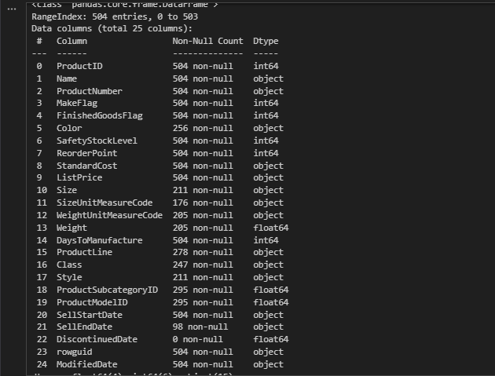

**Figure 3.2.** Product table Description (Source: Authors, 2025)

An overview description of the columns in the product table, including the number of non-null values in each column and the data type of each column.

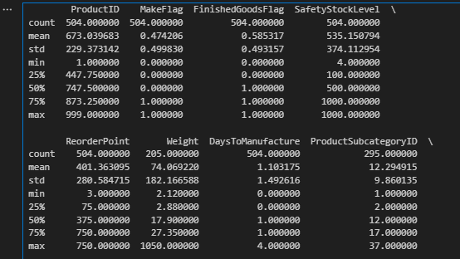

**Figure 3.3.** Product Statistical tables (Source: Authors, 2025)

From the above data of the product table, we can visualize it to reveal important information. The image displays a series of visualizations summarizing key product attributes such as manufacturing status, stock levels, costs, prices, and weights. It includes bar charts and a box plot to highlight data distribution, frequency, and outliers. These visuals provide a quick understanding of the dataset's structure and help identify potential issues like data skewness or missing values.

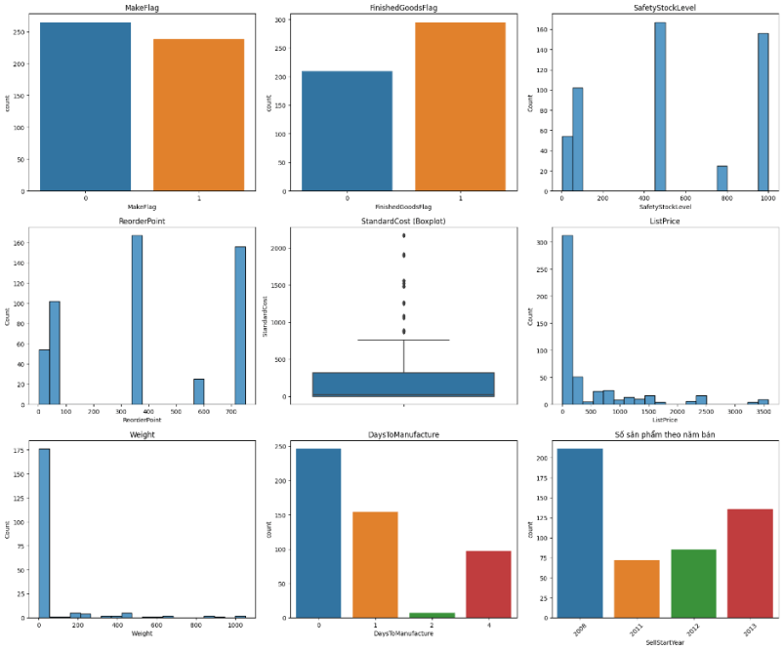

**Figure 3.4.** Summary charts of product attributes and manufacturing statistics. (Source: Authors, 2025)

*Product Inventory Table*

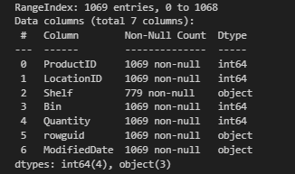

**Figure 3.5.** Product Inventory table Description (Source: Authors, 2025)

The Product Inventory table is extracted from the source table Production.ProductInventory, consists of 1069 rows and 7 columns, with specific details outlined as depicted in the figure above.

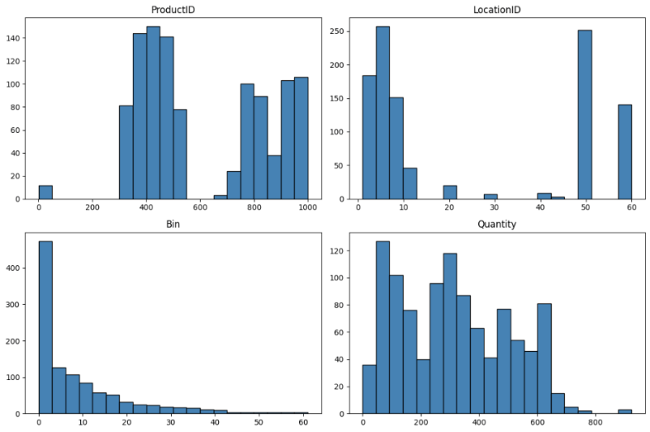

**Figure 3.6.** The data distribution of the ProductInventory table (Source: Authors, 2025)

*Product Subcategory*

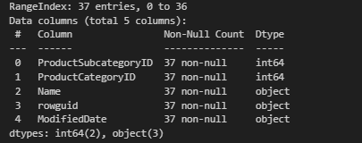

**Figure 3.7.** Product Subcategory table Description (Source: Authors, 2025)

The Product Subcategory table, sourced from Production.ProductSubcategory, contains 5 columns, as detailed in figure above.

*Product Category*

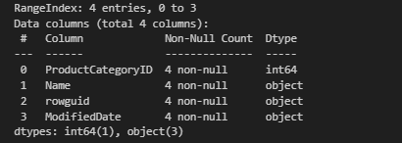

**Figure 3.8.** Product Category table Description (Source: Authors, 2025)

The Product Category table, sourced from ProductCategory, consists of 4 columns, with specific details shown in figure above.

*Product Vendor*

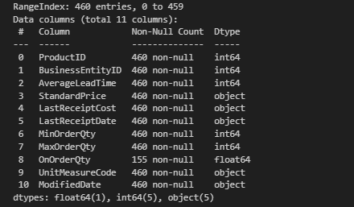

**Figure 3.9.** ProductVendor table Description (Source: Authors, 2025)

The Purchasing.ProductVendor table is a crucial component of the procurement system, extracted from the Purchasing.ProductVendor source table. It provides detailed information on the vendors supplying products to the organization. This table consists of 460 rows and 11 columns, each representing specific data points essential for managing vendor relationships and procurement processes.

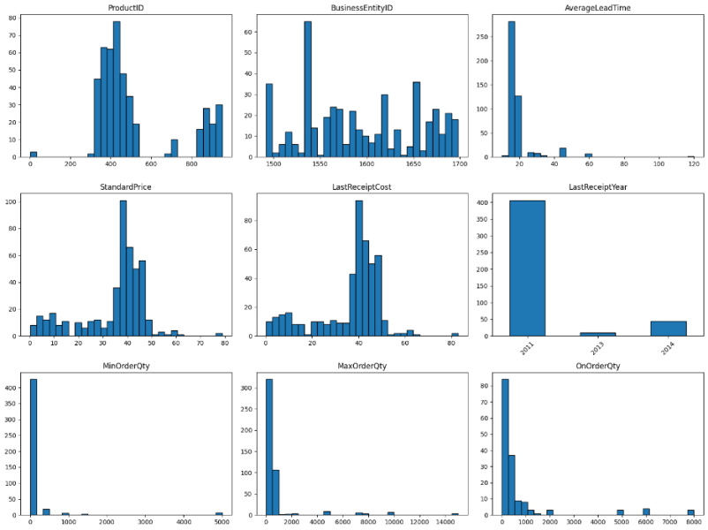 **Figure 3.10**. The data distribution of the UnitMeasure table (Source: Authors, 2025)

*Location table*

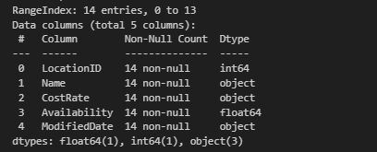

**Figure 3.11.** Location table Description (Source: Authors, 2025)

The Location table, derived from Production.Location, comprises 14 rows and 5 columns, as illustrated in Figure above.

*Purchase Order Header Table*

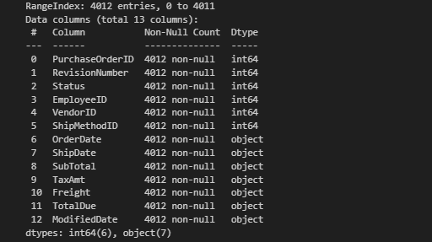

**Figure 3.12.** PurchaseOrderHeader table Description (Source: Author 2025)

The Purchase Order Header table, sourced from PurchaseOrderHeader, consists of 4012 rows and 13 columns, with specific details shown in Figure below.

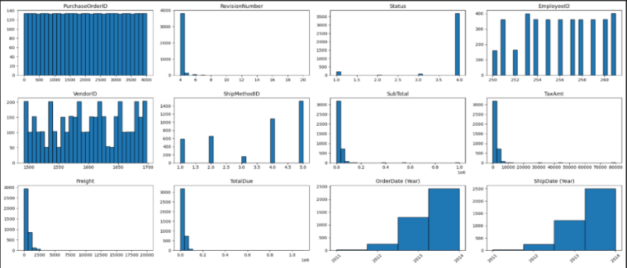

**Figure 3.13.** The data distribution of the ProductOrderHeader table (Source: Author 2025)

*Purchase order detail*

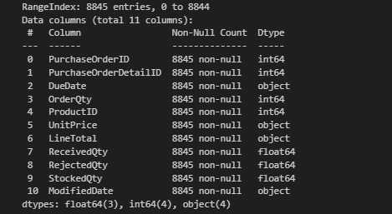

**Figure 3.14.** PurchaseOderDetail table Description (Source: Author 2025)

The Purchase Order Detail table, sourced from PurchaseOrderDetails, includes 8845 rows and 11 columns. Specific details are illustrated in the figure above.

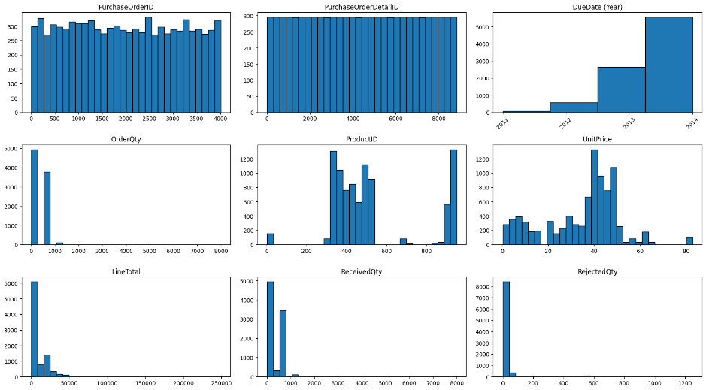

**Figure 3.15.** The data distribution of the ProductOrderDetail table (Source: Authors, 2025)

*Employee table*

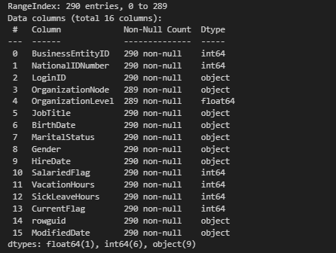

**Figure 3.16.** Employee table Description (Source: Authors, 2025)

The Employee table, derived from the Employee source table, comprises 290 rows and 16 columns.

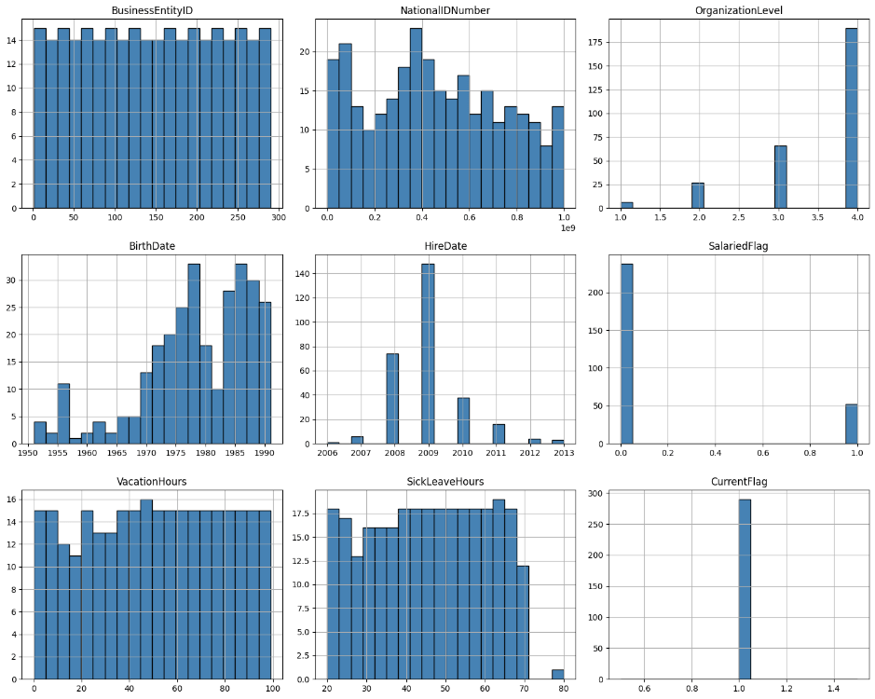

**Figure 3.17.** The data distribution of the Employee table (Source: Authors, 2025)

# CHAPTER 4: BUILDING DATA WAREHOUSE AND INTEGRATING DATA

## 4.1. Design Data Warehouse

### 4.1.1. Bus Matrix

**Table 4.1.** Bus matrix

|  |  |  |  |  |  |
| --- | --- | --- | --- | --- | --- |
| **Business Processes** | **Dimensions** | | | | |
| Product | Employee | Vendor | Ship Method | Time |
| Purchase Order Management | X | X | X | X | X |
| Product Tracking | X |  |  |  | X |
| Supplier Performance Evaluation | X |  | X |  | X |
| Inventory Monitoring | X |  | X |  | X |
| Shipping Efficiency Analysis |  |  |  | X | X |

The bus matrix of the Purchasing Department at AdventureWorks connects key business processes with relevant dimension tables, enabling consistent and efficient data analysis. The use of conformed dimensions within a unified data warehouse architecture supports accurate reporting and enhances decision-making capabilities. Below is a summary of business processes related to purchasing activities represented in the matrix:

* Purchase Order Management: Supports detailed order tracking. Tracked by: time, vendor, product, employee, shipping method.
* Product Tracking: Ensures accurate delivery and effective inventory control. Tracked by: time, product.
* Supplier Performance Evaluation: Helps assess and maintain supplier quality. Tracked by: time, vendor, product.
* Inventory Monitoring: Ensures optimal stock levels and effective warehouse control. Tracked by: time, vendor, product.
* Shipping Efficiency Analysis: Aims to optimize shipping strategies and minimize delivery costs. Tracked by: time, shipping method.

### 4.1.2. Master Data and Transaction Data

In modern data warehouse architecture, classifying and thoroughly understanding different types of data is a prerequisite for building an effective analytical system. Two core categories of data in this process are master data and transaction data—each with its distinct roles and structures that complement one another to provide a comprehensive view of organizational operations.

Master data refers to the fundamental information that defines long-term business entities such as products, suppliers, customers, or employees. These entities typically do not change frequently and are reused across various business processes. Therefore, master data forms the foundation of dimension tables in the data warehouse—where attributes are organized to support multidimensional queries and analysis.

**Table 4.2**. Master data

|  |  |
| --- | --- |
| **Master data** | **Description** |
| Product | Contains detailed information about the company’s products, including attributes such as name, category, and cost. |
| Vendor | Includes essential information about suppliers, such as name, address. |
| Employee | Information about the staff responsible for placing orders, including employee ID, full name, and position. |
| Warehouse | Details about the warehouse, such as product quantity, storage compartments, and storage containers. |
| Ship Method | Contains information on delivery methods, including method name and associated costs. |

In contrast, transaction data is dynamic and is generated whenever a business activity occurs, such as placing an order, making a purchase, processing a payment, or executing a shipment. This data captures the specifics of each action: who performed it, what was done, when, where, and at what value. It serves as the primary source for building fact tables, which aggregate quantitative metrics for reporting, KPIs, and trend modeling.

**Table 4.3.** Transaction data

|  |  |
| --- | --- |
| **Description** | **Description** |
| Date | The date when the purchase order is created or completed. |
| Purchasing.PurchaseOrderHeader | Provides an overview of each purchase order, including supplier information, order date, status, and related details. |
| Purchasing.PurchaseOrderDetail | Contains detailed information about individual products associated with specific purchase orders. |
| Production.ProductInventory | Contains inventory information of products at a specific point in time, including quantity, shelf, bin, and warehouse location. |

Master data provides the "context" needed to interpret and analyze transaction data. While transaction data delivers concrete evidence of business events that have taken place, master data ensures consistency and meaning. Both types of data are essential for developing a complete and reliable data warehouse system, capable of effectively supporting Business Intelligence (BI) tools and enabling data-driven decision-making.

### 4.1.3. Data Model

#### 4.1.3.1 Data Model overview

To meet the analytical requirements of the Purchasing Department at AdventureWorks, this project adopts a Galaxy Schema—also known as a Fact Constellation Schema—as the foundational structure of the data warehouse. This schema is specifically designed to support complex analytical environments where multiple processes, such as purchasing and inventory management, need to be examined in parallel through shared analytical dimensions.

The Galaxy Schema consists of multiple fact tables—each capturing distinct types of transactional or quantitative data—connected to a set of common dimension tables that provide business context. In our implementation, the model centers around two primary fact tables:

* FactPurchaseOrders, which records transactional data such as order quantities, unit prices, received and rejected quantities, vendor associations, and purchase dates.
* FactInventory, which contains periodic snapshots of inventory levels, including available quantity, storage location, shelf ID, and product references.

These fact tables are linked to shared dimensions such as DimProduct, DimVendor, DimEmployee, DimTime, and DimShipMethod. This structure enables analysts to conduct integrated queries across business domains. For example, users can examine vendor performance by comparing purchase volume and rejection rates, while also evaluating inventory availability for the same set of products and time periods.

The Galaxy Schema offers several key advantages in this context:

* Integrated Multi-Process Analysis: By modeling different operational areas through dedicated fact tables, the schema allows for both isolated and cross-functional analysis. Analysts can study purchasing trends independently, or relate them to inventory behavior across time and categories.
* Data Consistency Across Facts: Shared dimension tables ensure consistent definitions and classifications—such as product categories or time hierarchies—across all analytical scenarios, avoiding redundancy and promoting a single version of truth.
* Historical Context and Data Evolution: Dimensions such as DimVendor and DimProduct are implemented with Slowly Changing Dimension (SCD) techniques to preserve historical changes over time. This enables accurate reporting and trend analysis, even as business entities evolve.
* Scalability and Maintainability: The schema’s modular structure supports easy addition of new fact tables or dimensions. For example, incorporating a sales fact table in the future would only require linking to existing dimensions, minimizing redesign efforts.
* Compatibility with Modern BI Tools: Platforms like Power BI and SQL Server Analysis Services (SSAS) are highly compatible with Galaxy Schema architectures. The shared-dimension approach simplifies OLAP cube development, enhances reusability of measures and hierarchies, and supports efficient drill-down and roll-up analysis.

In practice, this data model empowers users to explore complex business questions with flexibility and speed. Whether comparing vendor delivery performance over time, tracking inventory stockouts by product category, or correlating purchase orders with warehouse availability, the Galaxy Schema provides the structure and depth needed for advanced business intelligence in the procurement domain.

**Table 4.4.** Description of Galaxy data warehouse model

|  |  |  |  |
| --- | --- | --- | --- |
| **No.** | **Relationship** | **Type** | **Description** |
| 1 | DimVendor – FactPurchaseOrders | 1-n | One vendor can have one or more records in FactPurchaseOrders; each record in FactPurchaseOrders references only one vendor. |
| 2 | DimEmployee - FactPurchaseOrders | 1-n | One employee can have one or more records in FactPurchaseOrders; each record references only one employee. |
| 3 | DimProduct - FactPurchaseOrders | 1-n | One product can have one or more records in FactPurchaseOrders; each record references only one product. |
| 4 | DimTime - FactPurchaseOrders | 1-n | One datetime can have one or more records in FactPurchaseOrders; each record references only one datetime. |
| 5 | DimShipMethod - FactPurchaseOrders | 1-n | One shipping method can have one or more records in FactPurchaseOrders; each record references only one shipping method. |
| 7 | DimProduct – FactInventory | 1-n | One product may be present in multiple inventory snapshots; each record in FactInventory references one product. |

#### 4.1.3.2. Fact and Dimension tables

**Table 4.5.** Data Warehouse Table Descriptions

| **No.** | **Table Name** | **Description** |
| --- | --- | --- |
| 1 | DimVendor | Information about vendors collaborating with the company. |
| 2 | DimEmployee | Employee information. |
| 3 | DimProduct | Product information, including inventory quantity and purchasing status. |
| 4 | DimTime | Time information. |
| 5 | DimShipMethod | Shipping method information. |
| 6 | FactPurchaseOrders | Aggregated data about vendors, products, employees, and purchasing activities over time. |
| 7 | FactInventory | Stores periodic inventory data, including stock levels and associated product IDs. |

*Table Structure Details*

DimVendor  
Data Source: Purchasing.Vendor, Purchasing.ProductVendor

**Table 4.6.** DimVendor table

|  |  |  |  |  |
| --- | --- | --- | --- | --- |
| **Column Name** | **Data Type** | **SCD Type** | **Source** | **Description** |
| VendorKey (PK) | int | 0 | - | Primary key. |
| BusinessEntityID (NK) | int | 0 | Purchasing.Vendor | Business entity identifier. |
| VendorName | nvarchar(50) | 1 | Purchasing.Vendor.Name | Vendor name. |
| CreditRating | tinyint | 2 | Purchasing.Vendor | Credit rating. |
| PreferredVendorStatus | bit | 2 | Purchasing.Vendor | Preferred vendor status. |
| ActiveFlag | bit | 0 | Purchasing.Vendor | Active flag. |
| AverageLeadTime | int | 2 | Purchasing.ProductVendor | Average delivery time. |
| StandardPrice | money | 2 | Purchasing.ProductVendor | Standard price. |
| LastReceiptCost | money | 2 | Purchasing.ProductVendor | Last receipt cost. |
| StartDate | datetime | 0 | - | Start date. |
| EndDate | datetime | 0 | - | End date. |

DimProduct  
DataSource: Production.Product, Production.ProductCategory,  Production.ProductSubCategory

**Table 4.7.** DimProduct table

|  |  |  |  |  |
| --- | --- | --- | --- | --- |
| **Column Name** | **Data Type** | **SCD Type** | **Source** | **Description** |
| ProductKey (PK) | int | 0 | - | Primary key. |
| ProductID (NK) | int | 0 | Production.Product | Product ID. |
| ProductName | nvarchar(50) | 1 | Production.Product.Name | Product name. |
| ProductNumber | nvarchar(25) | 1 | Production.Product | Product number. |
| MakeFlag | bit | 1 | Production.Product | Manufacturing flag. |
| FinishedGoodFlag | bit | 1 | Production.Product | Finished goods flag. |
| SafetyStockLevel | smallint | 2 | Production.Product | Safety stock level. |
| ReorderPoint | smallint | 2 | Production.Product | Reorder point. |
| ProductCategoryName | nvarchar(50) | 1 | Production.ProductCategory.Name | Product category name. |
| ProductSubCategoryName | nvarchar(50) | 1 | Production.ProductSubCategory.Name | Product subcategory name. |
| StartDate | datetime | 0 | - | Start date. |
| EndDate | datetime | 0 | - | End date. |

DimEmployee  
Data Source: HumanResources.Employee, Person.Person

**Table 4.8.** DimEmployee table

|  |  |  |  |  |
| --- | --- | --- | --- | --- |
| **Column Name** | **Data Type** | **SCD Type** | **Source** | **Description** |
| EmployeeKey (PK) | int | 0 | - | Primary key. |
| BusinessEntityID (NK) | int | 0 | HumanResources.Employee | Business entity identifier. |
| Gender | nchar(1) | 1 | HumanResources.Employee | Gender. |
| BirthDate | date | 1 | HumanResources.Employee | Date of birth. |
| HireDate | date | 1 | HumanResources.Employee | Hire date. |
| JobTitle | nvarchar(50) | 2 | HumanResources.Employee | Job title. |
| SalariedFlag | bit | 1 | HumanResources.Employee | Salaried flag. |
| ActiveFlag | bit | 0 | HumanResources.Employee.CurrentFlag | Active flag. |
| FirstName | nvarchar(50) | 1 | Person.Person | First name. |
| MiddleName | nvarchar(50) | 1 | Person.Person | Middle name. |
| LastName | nvarchar(50) | 1 | Person.Person | Last name. |
| StartDate | datetime | 0 | - | Start date. |
| EndDate | datetime | 0 | - | End date. |

DimTime  
Data Source: Generated dimension

**Table 4.9.** DimTime table

|  |  |  |  |
| --- | --- | --- | --- |
| **Column Name** | **Data Type** | **SCD Type** | **Description** |
| DateKey (PK) | datetime | 0 | Primary key. |
| DateFull | date | 0 | Full date. |
| TheDay | int | 0 | Day of the month. |
| TheDayName | nvarchar(30) | 0 | Day name (e.g., Monday). |
| TheWeek | int | 0 | Week of the year. |
| TheISOWeek | int | 0 | ISO week. |
| TheDayOfWeek | int | 0 | Day of week (numeric). |
| TheMonth | int | 0 | Month. |
| TheMonthName | nvarchar(30) | 0 | Month name. |
| TheQuarter | int | 0 | Quarter. |
| TheYear | int | 0 | Year. |
| TheFirstOfMonth | date | 0 | First day of the month. |
| TheLastOfYear | date | 0 | Last day of the year. |

DimShipMethod  
Data Source: Purchasing.ShipMethod

**Table 4.10.** DimShipMethod table

|  |  |  |  |  |
| --- | --- | --- | --- | --- |
| **Column Name** | **Data Type** | **SCD Type** | **Source** | **Description** |
| ShipMethodKey (PK) | int | 0 | - | Primary key. |
| ShipMethodID (NK) | int | 0 | Purchasing.ShipMethod | Shipping method ID. |
| Name | nvarchar(50) | 1 | Purchasing.ShipMethod | Method name. |
| ShipBase | money | 0 | Purchasing.ShipMethod | Base shipping cost. |
| ShipRate | money | 0 | Purchasing.ShipMethod | Shipping rate. |

FactPurchaseOrders  
Data Source: Purchasing.PurchaseOrderHeader, Purchasing.PurchaseOrderDetail

**Table 4.11.** FactPurchaseOrders table

|  |  |  |  |  |
| --- | --- | --- | --- | --- |
| **Column** | **Data Type** | **SCD Type** | **Source** | **Description** |
| PurchaseOrderID | int | 0 | - |  |
| PurchaseOrderDetailID | int | 0 | - |  |
| RevisionNumber | tinyint | 0 | Purchasing.PurchaseOrderHeader | Revision number. |
| Status | tinyint | 0 | Purchasing.PurchaseOrderHeader | Status. |
| OrderDate | datetime | 0 | Purchasing.PurchaseOrderHeader | Order date. |
| ShipDate | datetime | 0 | Purchasing.PurchaseOrderHeader | Ship date. |
| Freight | money | 0 | Purchasing.PurchaseOrderHeader | Freight |
| ProductKey (FK) | int | 0 | - | Foreign key to DimProduct. |
| EmployeeKey (FK) | int | 0 | - | Foreign key to DimEmployee. |
| VendorKey (FK) | int | 0 | - | Foreign key to DimVendor. |
| ShipMethodKey (FK) | int | 0 | - | Foreign key to DimShipMethod. |
| OrderQty | smallint | 0 | Purchasing.PurchaseOrderDetail | Order quantity. |
| UnitPrice | money | 0 | Purchasing.PurchaseOrderDetail | Unit price. |
| LineTotal | money | 0 | Purchasing.PurchaseOrderDetail | Line total amount. |
| ReceivedQty | decimal(8,2) | 0 | Purchasing.PurchaseOrderDetail | Received quantity. |
| RejectedQty | c(8,2) | 0 | Purchasing.PurchaseOrderDetail | Rejected quantity. |
| StockedQty | decimal(9,2) | 0 | Purchasing.PurchaseOrderDetail | Stocked quantity. |

FactInventory  
Data Source: Production.ProductInventory, Production.Location, DimTime

**Table 4.12.** FactInventory table

|  |  |  |  |  |
| --- | --- | --- | --- | --- |
| **Column** | **Data Type** | **SCD Type** | **Source** | **Description** |
| ProductID (FK) | int | 0 | Production.ProductInventory | Product ID. |
| LocationID (FK) | smallint | 0 | Production.ProductInventory | Location ID. |
| ProductKey | int | 0 | - | Foreign key to DimProduct. |
| Shelf | nvarchar(10) | 0 | Production.ProductInventory | Shelf location. |
| Bin | tinyint | 0 | Production.ProductInventory | Bin number. |
| Quantity | tinyint | 0 | Production.ProductInventory | Quantity. |
| Availability | decimal(8,2) | 0 | Production.Location | Availability status. |
| InventoryDate | datetime | 0 | DimTime |  |
| ProductID (FK) | int | 0 | Production.ProductInventory | Product ID. |

### 4.1.4. Data Warehouse building

After selecting the tables to use in the dataset and filtering the necessary columns, the team decided to build a data warehouse as shown below.

**Figure 4.1.** Purchasing data warehouse model

## 4.2. ETL Process

### 4.2.1. Rationale for Selecting the ETL Strategy and Data Integration Framework

During the development of the Data Mart for the Purchasing subsystem, the project team selected the ETL (Extract, Transform, Load) approach as the core data integration strategy. This decision was driven by the need to process dispersed data originating from multiple systems and tables, requiring a robust yet flexible mechanism to consolidate and standardize the data architecture.

ETL proved to be a suitable choice in this context due to its ability to manage and streamline the flow of data from source systems to the data warehouse, ensuring that the data is accurate, reliable, and ready for querying, analysis, and long-term monitoring.

The key reasons for adopting the ETL strategy are as follows:

* *Integration from heterogeneous systems:* The Purchasing subsystem receives data from various independent sources, each with distinct formats and structures. ETL facilitates the consolidation of this information by standardizing and unifying it into a common schema, thus simplifying downstream analytics and reporting.
* *Efficient handling of complex and high-volume data:* Purchasing data typically involves large datasets and intricate relationships among entities such as orders, products, and suppliers. ETL offers a structured and sequential process that ensures smooth data processing and management in such complex environments.
* *Support for historical tracking and versioning:* As purchasing data evolves—such as price adjustments, product updates, or changes in supplier information—it is essential to retain historical versions of the data. ETL enables the design of processing flows that preserve and track historical records, which is critical for time-series analysis and traceability.
* *Automation and scalability:* One of ETL’s main advantages lies in its ability to automate data processing tasks, reducing reliance on manual operations and minimizing human error. Furthermore, ETL pipelines can be adapted and scaled with relative ease when there is a need to adjust data structures, incorporate new business logic, or expand the system.

**Data Integration Framework Using ETL**

*Extract*

In the initial phase, data is extracted from key tables within the Purchasing subsystem, including:

* HumanResources.Employee
* Purchasing.Vendor
* Person.Person
* Purchasing.ProductVendor
* Production.Product
* Production.ProductInventory
* Production.ProductCategory
* Production.ProductSubCategory
* Production.Location
* Purchasing.ShipMethod
* PurchaseOrderDetails
* PurchaseOrderHeader

The extraction focuses on collecting essential information such as purchase order details, product data, supplier records, and ordered items. Once retrieved, the data is reorganized into structured tabular formats suitable for further SQL-based transformation steps within the ETL pipeline.

*Transform*

After extraction, the next step involves refining and standardizing the data to ensure consistency and usability. This phase includes tasks such as reformatting values, cleansing inconsistencies, filtering out invalid entries, and integrating records from multiple sources. Special attention is given to time-sensitive data, such as historical orders or price fluctuations, which are processed in a way that retains previous states while accurately representing the current status. This approach supports not only real-time reporting but also long-term trend analysis and forecasting.

*Load*

The final phase involves loading the processed data into the data warehouse. This step incorporates validation procedures to ensure completeness, uniqueness, and accuracy. Tools such as SSIS are often used to automate this loading process while simultaneously tracking performance metrics, logging operations, and flagging anomalies. As a result, the warehouse remains consistently updated and ready to support analytical queries and business intelligence tasks.

### 4.2.2 Detailed Operational Process of the System

The end-to-end integration model is a structured approach for integrating data in Business Intelligence (BI) projects, specifically within the ETL (Extract, Transform, Load) process.

This technique ensures more effective integration and maintenance of data in BI systems. It clarifies the detailed ETL process, explains how changing data is handled, ensures data integrity and accuracy, illustrates the complexity of the system, and provides a comprehensive view of the BI system's backend.

The operation of the end-to-end integration model is as follows:

* First, data is extracted from the OLTP database by focusing on specified data fields.
* After extraction, the data is searched in the data warehouse to determine appropriate storage and transformation methods.
* If the data is not found in the warehouse due to ID conflicts, it will be inserted directly into the warehouse.
* When duplicate data is encountered, it is classified according to the Slowly Changing Dimension (SCD) type.
* Type 1 SCD data will be updated, meaning the existing record is overwritten with new data without preserving historical changes.
* Type 2 SCD data will be inserted, typically by creating a new record for the changed data and updating the EndDate attribute of the old record to reflect its historical status.  
  Modified data is compared with the current data in the warehouse and updated if necessary.
* When new information is added to a table, the EndDate attribute in the warehouse is also updated, and new records are added to the database.

→ This entire technique - including extraction, transformation, and loading, with specific handling for new, updated, and historical data - aims to ensure more effective data integration and maintenance in the BI system

The research team applied the SCD method to handle changing data across all dimension tables. The specific SCD type applied depends on the inherent characteristics of each attribute in the table.

The use of different SCD types (0, 1, and 2) for individual attributes within the same dimension table demonstrates a deep understanding of historical data management. For example, JobTitle is a Type 2 SCD, while FirstName is a Type 1 SCD in the DimEmployee table. This detailed approach ensures that significant historical changes that affect business analysis are retained for auditing and trend analysis. Meanwhile, less important or descriptive changes only update the current record to optimize storage and performance. This careful balance optimizes storage and query performance while preserving necessary historical accuracy for robust BI reporting.

### 4.2.3. Practical execution of SSIS process

*Logging in the ETL Process*

During the development of ETL packages using SSIS, the team incorporated both system-defined and user-defined variables to support monitoring, logging, and error-handling throughout the data loading process. This approach is considered a best practice in enterprise environments, enabling better traceability, error tracking, and diagnostics.

The figure below presents a list of variables configured within the package responsible for processing the DimEmployee table:

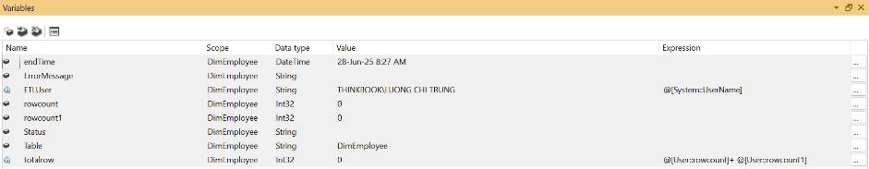

**Figure 4.2.** System and Custom Variables in the ETL Package – DimEmployee

**Table 4.13.** Description of Variables Used in the ETL Package

|  |  |  |
| --- | --- | --- |
| **Variable** | **Data Type** | **Description** |
| endTime | DateTime | Marks the end time of the package execution; used for logging or performance comparison. |
| ErrorMessage | String | Captures error messages if any issues occur during execution (for enhanced error handling). |
| ETLUser | String | Automatically retrieves the user executing the package via the expression @[System::UserName]. |
| rowcount | Int32 | Stores the number of rows successfully loaded in the NewOutput and Historical Attribute Inserts Output branches. |
| rowcount1 | Int32 | Stores the number of rows successfully loaded in the Changing Attribute Updates Output branch |
| totalrow | Int32 | Total number of rows loaded into the dimension |
| Status | String | Indicates execution status (e.g., Success, Failed); helps with overall job verification. |
| Table | String | Records the target table name—in this case, DimEmployee. |

Utilizing these variables allows the ETL process to be more transparent, easier to troubleshoot, and more scalable. It is particularly useful when implementing centralized logging mechanisms such as writing execution metadata to a table like ETL_Load_Log.

*Standard Control Flow for Dimension Table ETL*

The ETL process for each dimension table in the system follows a standardized control flow pattern. This design ensures better monitoring and logging after each execution, making the overall process more reliable and maintainable.

The following figure illustrates the typical control flow structure used for dimension tables such as DimEmployee, DimVendor, DimProduct, and others:

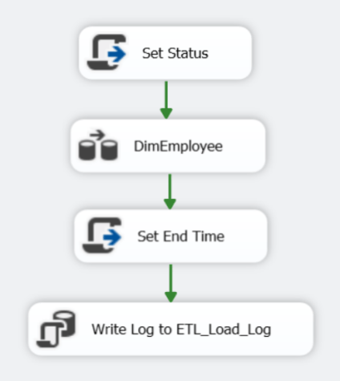

**Figure 4.3.** Standard Control Flow for ETL of Dimension Tables

The control flow consists of four main steps:

* *Set Status:* Before the main data flow is executed, the variable Status is initialized—commonly with a value like "Running"—to mark the beginning of the process. This setup helps differentiate the state of execution and supports log tracking or error handling in case of failures during the ETL process.
* *Execute Data Flow (e.g., DimEmployee):* This is the core of the package, responsible for extracting data from OLTP sources, applying necessary transformations (e.g., Derived Column, Lookup, Data Conversion), and loading the processed data into the corresponding dimension table in the Data Warehouse.
* *Set End Time:* Upon completion, the system assigns the current timestamp (GETDATE()) to the variable endTime. This allows accurate measurement of execution time for each individual table—especially useful for performance analysis or historical monitoring.
* *Write Log to ETL_Load_Log Table:* In the final step, a logging task is triggered to store metadata such as the table name, executing user (ETLUser), status (Status), number of rows processed (rowcount), end time (endTime), and any error messages if applicable. This information is saved to a centralized log table (ETL_Load_Log) used for auditing ETL processes across the entire project.

By adopting this structured control flow, the ETL becomes clear, sequential, and easy to test or rerun when needed. Moreover, it supports future automation via scheduling tools like SQL Server Agent.

Our team found that having predefined variables for logging—such as rowcount, ETLUser, and Status—combined with centralized logging significantly reduced testing time, especially when handling multiple dimension tables concurrently.

*Error Logging and Failure Status Recording in Dimension Table ETL*

In addition to logging successful executions, the ETL system is also designed to capture detailed information when a failure occurs during the data loading process. This enables the operations team to quickly pinpoint the root cause and location of the error, enhancing overall monitoring and recovery capabilities.

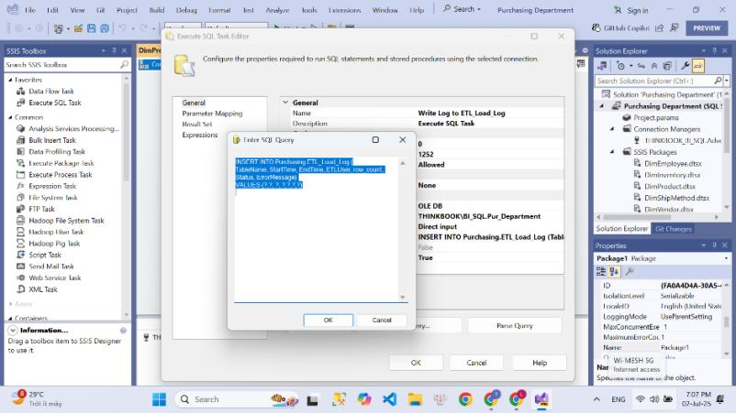

**Figure 4.4.** Task for Logging ETL Status

The Execute SQL Task window contains an INSERT INTO Purchasing.ETL_Load_Log statement, which records the following:

* The name of the dimension table being processed
* The user executing the ETL process (retrieved from the ETLUser variable)
* The number of rows processed (row_count)
* The completion time (EndTime)
* The execution status (e.g., "Success")
* Any error message, if applicable (ErrorMessage — typically left blank on success)

This SQL command uses dynamic SSIS variables, making it reusable across multiple dimension tables with minimal configuration changes.

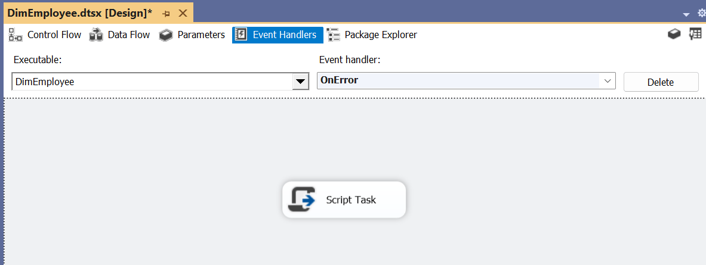

**Figure 4.5.** OnError Event – DimEmployee

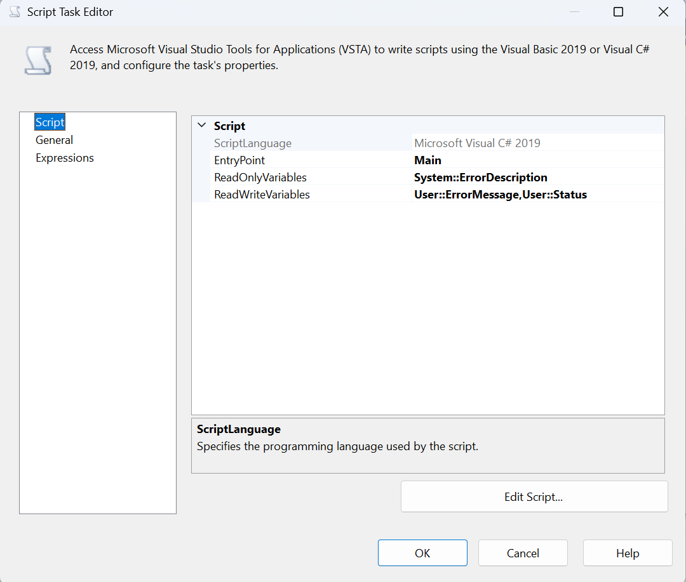

**Figure 4.6.** Script Task – Log Error & Failure Status

Additionally, an Event Handler with a Script Task is configured for the OnError event of the package. If any task fails during execution, the handler will:

* Retrieve the system-generated error description via the System::ErrorDescription variable
* Assign this error message to the user-defined variable User::ErrorMessage
* Set the Status variable to "Failed"

The script inside this task is written in Microsoft Visual C# 2019, allowing for flexible and clear error-handling logic within the control flow.

*Data Flow Task – ETL for DimEmployee Table*

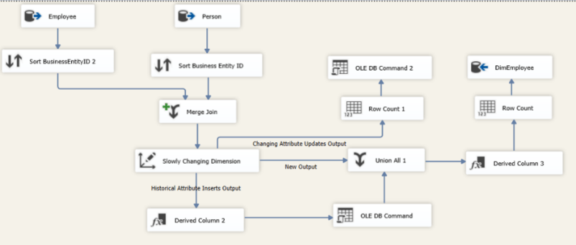

**Figure 4.7.** Data Flow for ETL of DimEmployee using SCD Techniques

The ETL process for the DimEmployee table begins by sourcing data from two operational tables: Employee and Person. After sorting each dataset by BusinessEntityID, the two streams are merged using a Merge Join, producing a comprehensive record that includes both personal and employment-related details.

Once joined, the data flows through the Slowly Changing Dimension (SCD) transformation. This component determines the appropriate handling strategy based on how attribute values have changed.

Based on the configuration used in this project, the attributes in the DimEmployee table are categorized as follows:

* SCD Type 2: Applied to the JobTitle attribute. When the job title changes, a new record is inserted, while the previous record is updated with an EndDate. This approach preserves the full history of role changes over time.
* SCD Type 1: Used for fields like FirstName, MiddleName, LastName, Gender, and SalariedFlag. These attributes are overwritten upon change—no historical values are retained.
* SCD Type 0: Applied to stable attributes such as BusinessEntityID, StartDate, EndDate, and CurrentFlag. These fields remain constant and are never updated once inserted.

Based on the SCD logic:

* Records identified as new or Type 2 changes are routed through the New Output or Historical Attribute Inserts Output branches. Additional system fields are appended via a Derived Column transformation before being inserted into the target table.
* Records requiring Type 1 updates are processed using an OLE DB Command to apply in-place updates.

All resulting rows—whether inserted or updated—are consolidated using a Union All transformation. System metadata such as LoadDate is added, the number of rows processed is counted via Row Count, and the final dataset is loaded into the DimEmployee table.

This multi-type SCD setup enables the system to not only reflect the most current employee data but also maintain a traceable history of job title changes. This design supports both point-in-time reporting and longitudinal workforce analysis.

*Data Flow Task – ETL for the DimProduct Table*

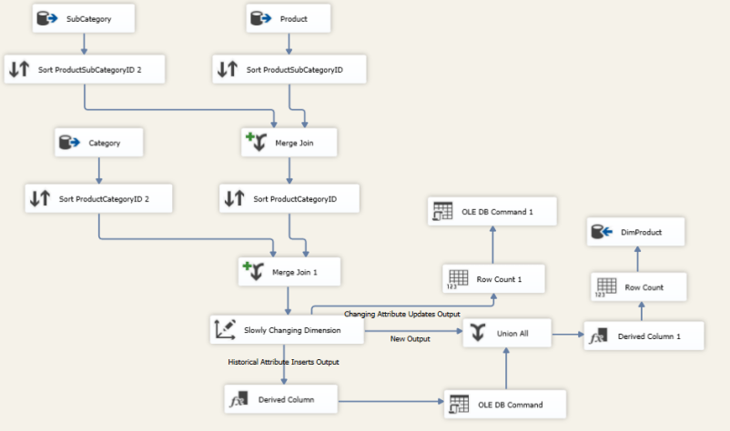

**Figure 4.8.** Detailed Data Flow for ETL of DimProduct Using SCD

The ETL process for the DimProduct table begins by integrating data from three primary source tables: Product, ProductSubcategory, and ProductCategory. Each table is first sorted by its corresponding foreign key (ProductSubcategoryID, ProductCategoryID) before being merged through two sequential Merge Join steps. This produces a complete product record that includes classification, category, and descriptive information.

Once combined, the data passes through a Slowly Changing Dimension (SCD) transformation, which categorizes each record based on the type and scope of attribute changes to determine the appropriate update strategy.

The attributes in DimProduct are categorized as follows:

* SCD Type 2: Applied to the StandardCost attribute, which tracks changes in product cost over time. When this value changes, a new record is inserted, and the previous one is updated with an EndDate to maintain historical accuracy.
* SCD Type 1: Used for attributes such as ProductName, ProductNumber, Color, Size, and Weight. These fields are updated in place whenever changes occur, and prior values are not retained.
* SCD Type 0: Assigned to static or identifying fields including ProductKey, ProductID, StartDate, EndDate, ProductCategory, and ProductSubcategory. These fields remain unchanged throughout the record’s lifetime.

Based on this classification:

* New records and those with Type 2 changes are routed through the New Output or Historical Attribute Inserts Output, followed by a Derived Column step to add system fields before being inserted into the destination table.
* Records with Type 1 changes are handled via an OLE DB Command, which performs in-place updates to the existing records.

All processed rows—whether inserted or updated—are merged using a Union All transformation. System metadata is appended through a Derived Column, and the number of processed rows is counted using a Row Count transformation before loading the final dataset into the DimProduct table.

This approach ensures the system maintains up-to-date product data while also preserving historical changes in critical fields such as cost—supporting more robust business intelligence and analytical capabilities.

*Data Flow Task – ETL for the DimShipMethod Table*

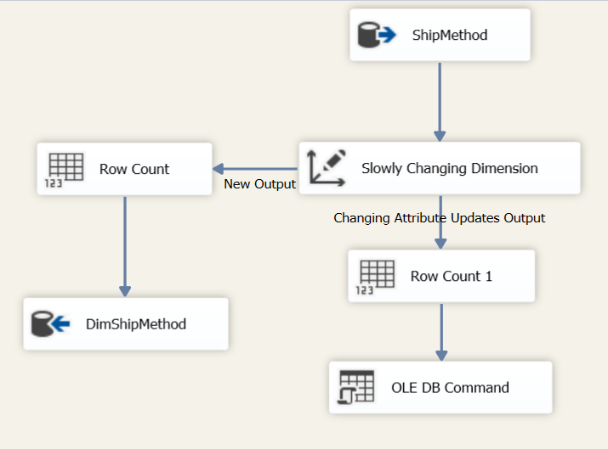

**Figure 4.9.** Detailed Data Flow for ETL of DimShipMethod Using SCD

The data for the DimShipMethod table is sourced directly from the ShipMethod table. The ETL process is managed through a Slowly Changing Dimension (SCD) component to ensure that the warehouse reflects current shipping information and handles changes appropriately.

In this flow, the attributes from ShipMethod are managed using two main SCD types:

* SCD Type 1: Applied to attributes that may change over time but do not require historical tracking—such as Name, ShipBase, and ShipRate. Updates to these fields are applied directly to the existing records via an OLE DB Command.
* SCD Type 0 (default): Used for identifier columns such as ShipMethodID, which remain constant and are not modified during the ETL process.

New records—those not previously found in the destination table—are routed through the New Output branch. These records are counted using the Row Count transformation and then inserted into the DimShipMethod table.

Overall, while this ETL flow is simpler compared to those of other dimension tables, it still ensures data accuracy, consistency, and efficient updates for shipping method information.

*Data Flow Task – ETL for the DimVendor Table*

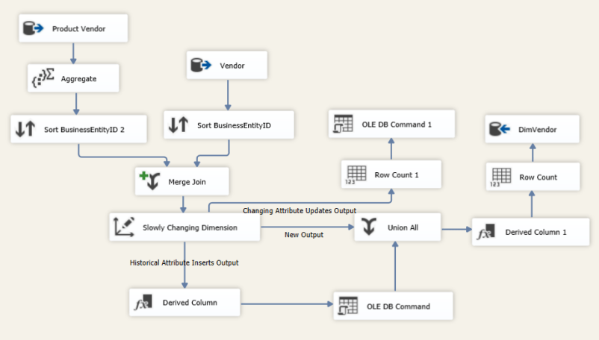

**Figure 4.10.** Detailed Data Flow for ETL of DimVendor Using SCD

The DimVendor table is constructed from two primary data sources: the Vendor and ProductVendor tables. The ProductVendor table is first processed through an Aggregate transformation to normalize and summarize the data. It is then merged with the Vendor table using a Merge Join on the BusinessEntityID key. This join enables the consolidation of detailed information on each vendor and the products they supply.

Following the join, the dataset flows into a Slowly Changing Dimension (SCD) component, which analyzes attribute changes and determines the appropriate handling for each record.

The SCD configuration for DimVendor includes:

* SCD Type 2: Applied to the CreditRating attribute to preserve the history of vendor credit changes. When this value changes, a new record is created while the old one is closed with an updated EndDate.
* SCD Type 1: Used for fields such as Name, ActiveFlag, and StandardPrice, where updates are made directly to the existing records without retaining previous values.
* SCD Type 0: Assigned to fixed or identifier fields such as VendorKey, VendorID, StartDate, and EndDate, which remain unchanged throughout the ETL process.

The processing logic is as follows:

* New records and Type 2 changes are routed through the New Output or Historical Attribute Inserts Output branches. After a Derived Column step adds necessary system fields, the data is inserted into the destination table.
* Type 1 updates are handled using an OLE DB Command, which directly updates the existing records.

Finally, all rows—whether inserted or updated—are consolidated using a Union All transformation, followed by Row Count and a Derived Column to append additional metadata, before being loaded into the DimVendor table.

This SCD-based implementation ensures that the system reflects the current vendor status while retaining the historical changes in credit rating and supply activity—supporting both operational accuracy and time-based vendor analysis.

*Control Flow – Loading Data into FactInventory*

**Figure 4.11.** Control Flow for Loading Data into FactInventory

The figure above illustrates the main control flow used to fully reload data into the FactInventory table. The process begins with a Script Task to update the initial load status. This is followed by a SQL Task to perform preparatory operations, such as truncating or staging necessary data.

Next, the data is fully loaded into the FactInventory table through a dedicated Data Flow task. Once the data load is complete, the system records the current timestamp using a Set EndTime task. Finally, the process concludes by writing execution metadata to the ETL_Load_Log table, ensuring traceability and enabling comprehensive monitoring of the ETL workflow.

*Data Flow – Loading Data into FactInventory*

**Figure 4.12.** Data Flow for Populating FactInventory

The FactInventory table is loaded using a full load approach, where all existing records are refreshed during each ETL run. The source data originates from the ProductInventory table in the transactional system and is processed through a series of transformations to ensure data integrity and consistency.

A key step involves the Lookup DimProduct transformation, which matches each product in the source data with its corresponding surrogate key in the dimension table. Only records with a successful match (Lookup Match Output) are passed forward, ensuring that referential integrity is preserved.

Subsequently, a Row Count transformation captures the number of records being inserted, enabling monitoring and audit logging. Finally, the cleansed and validated dataset is loaded into the FactInventory table via an OLE DB Destination.

This structured data flow ensures accurate foreign key resolution, consistent loading behavior, and reliable performance for downstream analytics.

*Control Flow – Loading Data into FactPurchaseOrders*

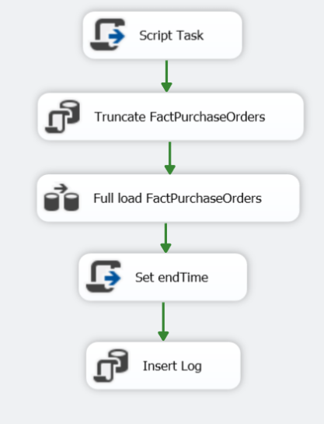

**Figure 4.13.** Control Flow for Loading Data into FactPurchaseOrders

The figure above illustrates the main control flow used to fully reload data into the FactPurchaseOrders table. The process begins with a Script Task to initialize system variables. Next, the fact table is cleared using a Truncate operation, followed by the execution of the detailed data loading workflow through a dedicated Data Flow task.

Once the loading process is completed, the system captures the current timestamp via a Set endTime task, and processing metadata is written to the log table through an Insert Log step. This control flow ensures clear traceability, structured execution, and ease of monitoring throughout the ETL process.

*Data Flow – Loading Data into FactPurchaseOrders*

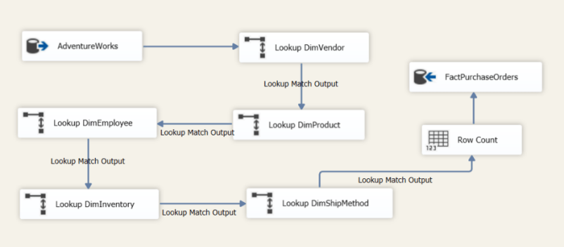

**Figure 4.14.** Data Flow for Populating FactPurchaseOrders

The FactPurchaseOrders table is loaded using a full load approach, meaning the table is completely refreshed with each ETL execution. Data is sourced from the transactional system (*AdventureWorks*) and passed through a series of Lookup transformations to resolve foreign keys with the corresponding dimension tables.

Specifically, the data is matched against the following dimensions:

* Lookup DimVendor: retrieves the supplier key
* Lookup DimProduct: maps the product identifier
* Lookup DimEmployee: resolves the employee handling the order
* Lookup DimShipMethod: assigns the shipping method key

Each lookup uses the Match Output path to ensure that only records with valid foreign key relationships are passed forward, maintaining referential integrity across the data warehouse.

After all lookups are completed, a Row Count transformation tallies the number of records loaded. The final dataset is then written to the FactPurchaseOrders table.

By resolving all dimension keys prior to insertion, this design enhances performance, ensures data consistency, and enables robust analytical querying downstream.

Once the data has been processed and loaded into the FactPurchaseOrders table, the overall ETL workflow continues with the execution of the master pipeline. This main pipeline is responsible for orchestrating the sequence of child packages, managing the flow of the entire ETL process. Such an architecture ensures that all tables are updated completely and in the correct logical order, resulting in a fully automated and end-to-end integrated data processing system.

**Figure 4.15.** ETL Completion

After the full ETL process has been completed, data has been successfully loaded into all relevant tables within the data warehouse, including both dimension and fact tables. The following section presents query results retrieved directly from these tables, reflecting the final output after successful deployment.

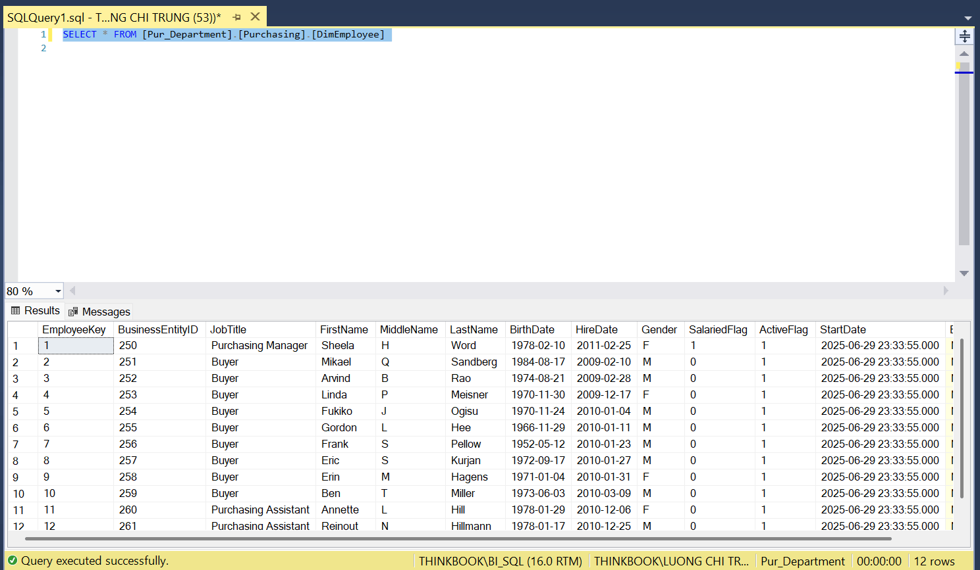

**Figure 4.16.** DimEmployee Result

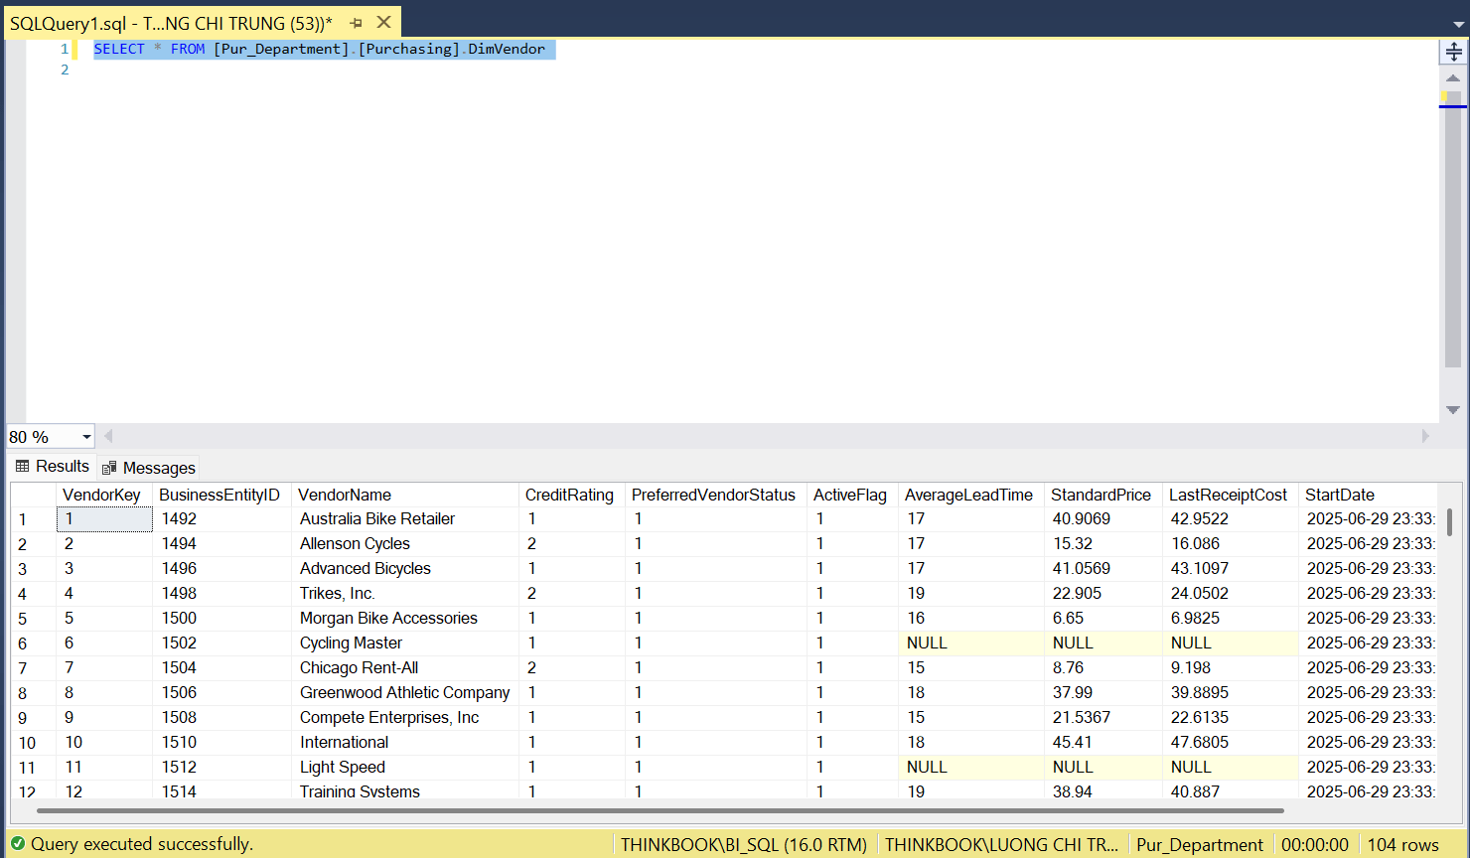**Figure 4.17.** DimVendor result

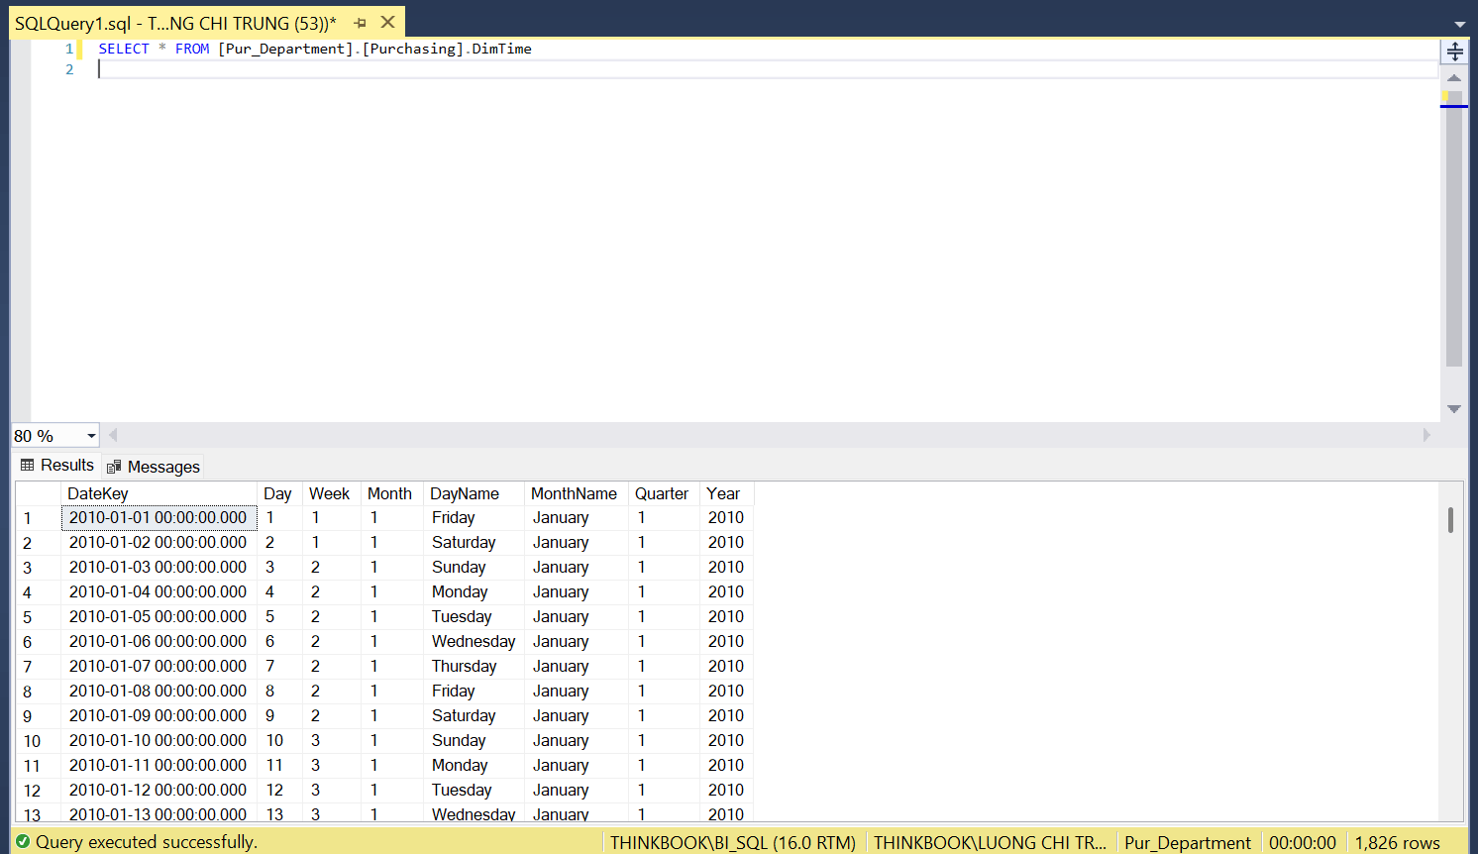**Figure 4.18.** DimTime result

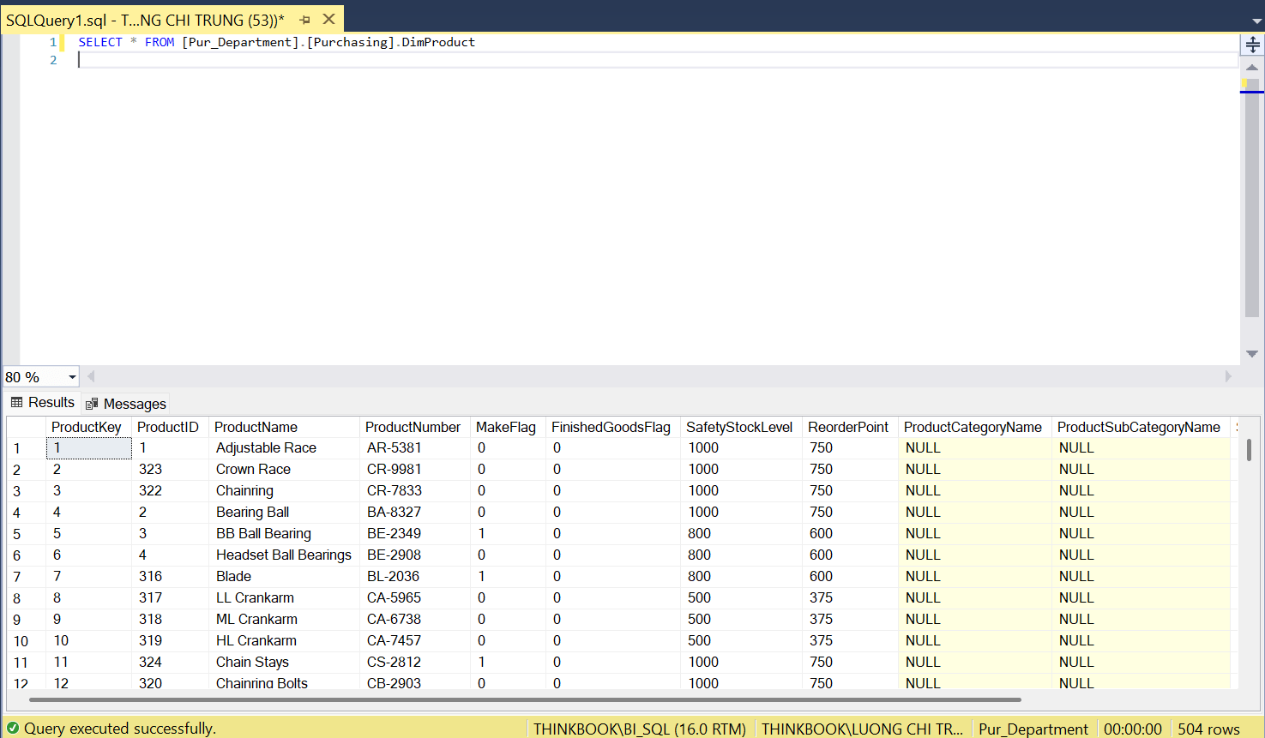

**Figure 4.19.** DimProduct result

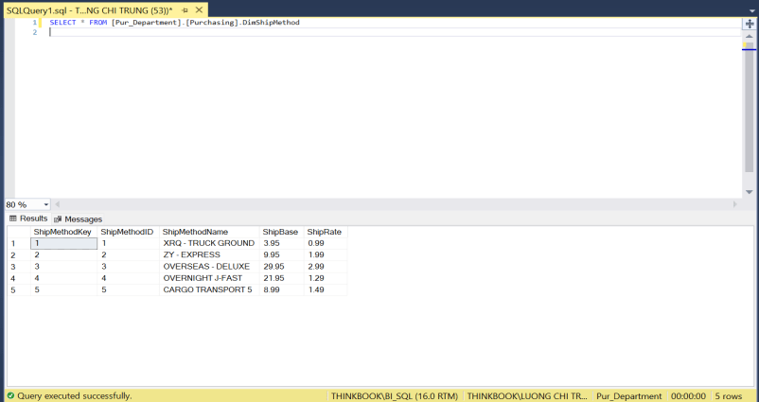

**Figure 4.20.** DimShipMethod result

**Figure 4.21** FactInventory result

**Figure 4.22.** FactPurchaseOrders result

**Figure 4.23.** ETL Load Log

*Deployment to Integration Services Catalogs*

**Figure 4.24.** Deployed ETL Packages in SSIS Catalog

After the ETL packages were fully designed and tested, all .dtsx packages corresponding to individual data tables were deployed to the Integration Services Catalogs within SQL Server. Specifically, the packages were deployed under the path: SSISDB > SSIS > Projects > Purchasing Department, including all relevant dimension tables (DimEmployee, DimProduct, DimShipMethod, DimVendor) as well as the fact table (FactPurchaseOrders). In addition, a centralized package named Master Pipeline.dtsx was deployed to coordinate the sequential execution of all child packages.

Deploying through Integration Services Catalogs provides a robust foundation for managing, monitoring, and automating the ETL process in a production environment. It also enables seamless integration with SQL Server Agent for scheduling and running ETL jobs as needed.

**Figure 4.25.** Purchasing_DW Job Configuration in SSMS

To streamline and automate the ETL process, the team configured a job using SQL Server Agent. A job named Purchasing_DW was created to trigger the Master Pipeline.dtsx package previously deployed to the Integration Services Catalogs. This master package is responsible for orchestrating the execution of all individual ETL packages corresponding to each table.

Within the job’s step configuration, the task type was set to SQL Server Integration Services Package, and the job was run under the SQL Server Agent Service Account. The package source was defined as the SSIS Catalog, accessed via Windows Authentication. Once scheduled, this job enables the ETL pipeline to run automatically at predefined intervals, ensuring the data warehouse remains current and consistent.

The screenshot below confirms that the job executed successfully. All child packages ran with a SUCCESS status, and detailed metadata—such as start time, end time, row counts, execution user, and status—was recorded in the centralized ETL log table for monitoring and audit purposes.

**Figure 4.26.** Purchasing_DW Job Execution Success Log

**Figure 4.27.** ETL Result Log

# CHAPTER 5. DATA ANALYSIS AND VISUALIZATION

## 5.1. Data analytics with SSAS technology

### 5.1.1. Building the cube

To install and analyze data using SQL Server Analysis Services (SSAS), we will set up a project called Final in SSAS. This will involve building a cube and conducting data analysis within the project. The process will include the following steps:

*Step 1:* Set up a new user account and assign administrative privileges on SQL Server

*Step 2:* Launch Visual Studio and start a new SSAS project titled FinalProject. Connect this project to the data warehouse, which includes dimension and fact tables, using the newly created login credentials.

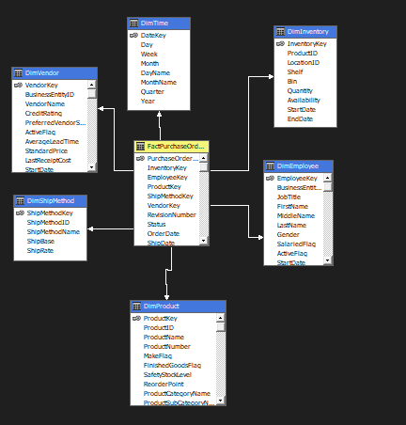

**Figure 5.1**. SSAS cube

### 5.1.2. Analysis with SSAS

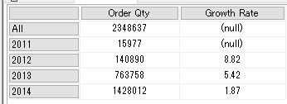

**Figure 5.2.** GrowthRate of Order Quantity 2011- 2014

The table presents the Growth Rate of Order Quantity from 2011 to 2014. In 2011, the recorded order quantity was 15,977, and no growth rate was calculated as it serves as the base year. In 2012, order quantity sharply increased to 140,890, showing a remarkable growth rate of 8.82, indicating a strong upward trend. This growth continued in 2013, with the order quantity reaching 763,758, though the growth rate slightly declined to 5.42, suggesting a deceleration in growth momentum. By 2014, the order quantity peaked at 1,428,012; however, the growth rate further decreased to 1.87, implying that although orders continued to increase, the pace of growth had significantly slowed. Overall, the period reflects a rapid initial expansion followed by a gradual stabilization in order of growth.

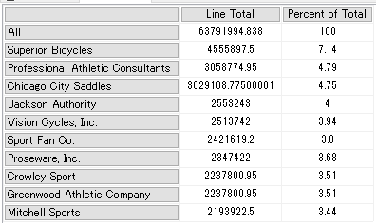

**Figure 5.3.** Top 10 Vendor by Line Total

The table displays the Line Total revenue and its corresponding percentage contribution by customer or organization. The overall revenue generated amounts to approximately $637.92 million. Among the listed entities, Superior Bicycles contributes the highest share, accounting for 7.14% of the total, followed by Professional Athletic Consultants with 4.79%, and Chicago City Saddles close behind at 4.75%. Other notable contributors include Jackson Authority (4%), Vision Cycles, Inc. (3.94%), and Sport Fan Co. (3.8%). At the lower end of the top contributors, Mitchell Sports represents 3.44% of the total revenue. These top ten customers collectively contribute a significant portion of the overall line total, indicating a relatively concentrated revenue base, with a few key accounts driving a large share of the business.

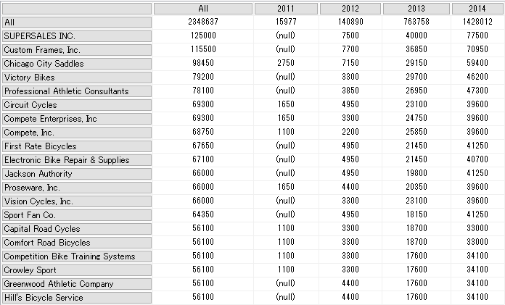

**Figure 5.4.** Annual Top 20 Vendors by OrderQty

The table shows the annual order quantity from 2011 to 2014 for the top 20 vendors. The overall order volume across all vendors totaled 2,348,637 units during this period. Among the vendors, SUPERSALES INC. leads with the highest cumulative order quantity of 125,000, demonstrating consistent annual performance with steady increases, peaking at 77,500 units in 2014. Other major contributors include Custom Frames, Inc. (115,600 units), Chicago City Saddles (98,450 units), and Victory Bikes (79,200 units).

The majority of vendors show growth in order quantities over the years, particularly from 2012 to 2014, with 2014 being the peak year for most vendors. For instance, Professional Athletic Consultants and Circuit Cycles both saw significant growth in 2014, reaching 47,300 and 39,600 units respectively.

Interestingly, many vendors had no recorded orders in 2011, indicating that business relationships or data tracking may have begun from 2012 onward. Overall, the data reflects a strong upward trend in order volume across vendors, highlighting expanding operations or increasing demand year over year.

## 5.2. Building the KPIs system

After completing the construction of the cube, the team proceeded to create calculations to accurately measure the indicators serving the KPI system. An illustrative example is presented below, showing how the team dragged and dropped attributes from the Measure group, named the calculation, and adjusted the format in the Additional Properties section. This approach was consistently applied to all remaining calculations.

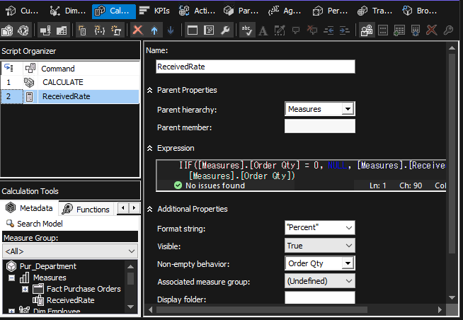

**Figure 5.5.** ReceivedRate Calculation in SSAS

The ReceivedRate KPI is established to evaluate the effectiveness of suppliers in delivering orders as requested. This indicator reflects the ratio between the quantity of goods received and the quantity of goods ordered, thereby helping the Purchasing Department monitor the reliability and performance of each supplier.

Value Expression: [Measures].[ReceivedRate] – The value is calculated based on the ratio of received quantity to total ordered quantity, as previously defined in the cube using the formula: IIF([Measures].[Order Qty] = 0, NULL, [Measures].[Received Qty] / [Measures].[Order Qty]).

Goal Expression: 0.99 – The target is set at 99%, meaning that at least 99% of the ordered quantity is expected to be received.

Status Indicator: Shows the KPI achievement level, where green indicates the goal is met, red indicates it is not met, and yellow represents a warning or borderline status.

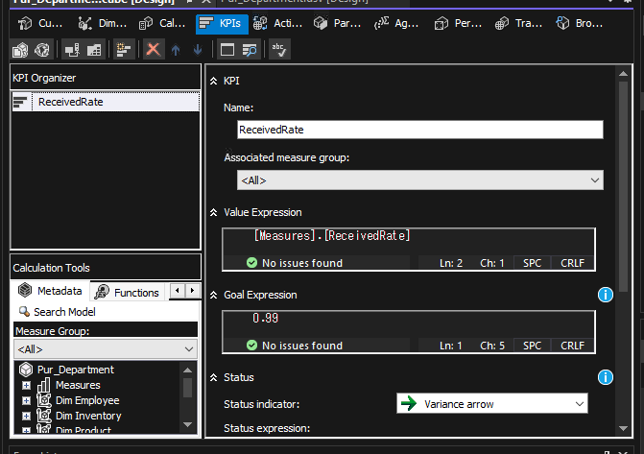

**Figure 5.6.** Setting up the ReceivedRate KPI in SSAS

After deploying and setting up the ReceivedRate KPI in SSAS, the data is connected and visually presented using a Pivot Table in Excel. The use of Pivot Tables allows for the aggregation, analysis, and comparison of the received rate by supplier and by year, while also incorporating the goal target and KPI status indicator to assess performance effectiveness.

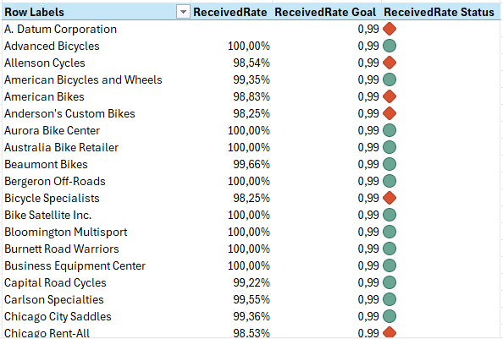

**Figure 5.7.** ReceivedRate KPI by Supplier

This table presents the ReceivedRate of suppliers in the system, compared against the established target. The ReceivedRate Status column uses KPI indicators to reflect performance levels:

* A green circle icon indicates that the supplier has a received rate ≥ 99%, meeting the KPI.
* A red diamond icon indicates a received rate < 99%, failing to meet the KPI.

For example, suppliers such as Advanced Bicycles, Aurora Bike Center, and Bergeron Off-Roads all have a 100% rate, while Allenson Cycles (98.54%) and American Bikes (98.83%) do not meet the requirement.

The ReceivedRate KPI by supplier helps the company identify reliable suppliers with consistent delivery performance to maintain partnerships, while also highlighting underperforming vendors for potential adjustment or replacement.

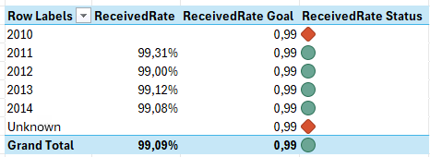

**Figure 5.8.** ReceivedRate KPI by Year

The ReceivedRate KPI by year reflects fluctuations in the company’s inbound delivery performance from 2010 to 2014. From 2011 onward, the ReceivedRate consistently remained above 99%, indicating a significant improvement and stabilization in delivery performance over time. Overall, the average rate across the period reached 99.09%, successfully meeting the established KPI target. This table enables management to monitor operational trends, assess the effectiveness of procurement policies, and make appropriate adjustments for each period.

In addition to the ReceivedRate used to evaluate delivery efficiency, the team also developed the ReturnRate KPI to track the proportion of goods returned due to not meeting quality standards. This is an important KPI that reflects the quality of incoming goods and serves as a basis for assessing supplier reliability. By combining both KPIs, the Purchasing Department can not only measure whether goods are delivered as ordered, but also evaluate whether those goods meet the required technical and quality standards.

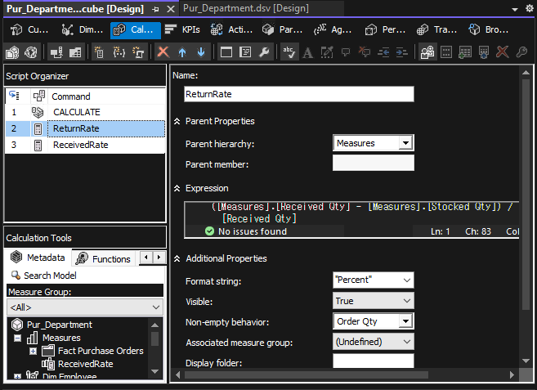

**Figure 5.9.** ReturnRate Calculation in SSAS

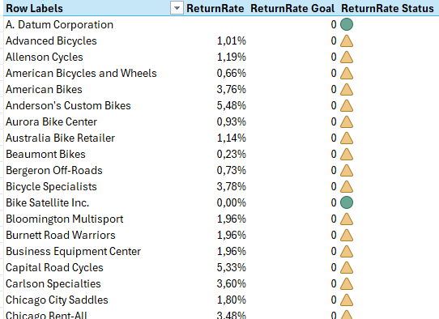

**Figure 5.10.** ReturnRate KPI by Supplier

The table shows the ReturnRate KPI — the percentage of goods returned after receipt - for each supplier, compared against the target of 0%. The icon in the ReturnRate Status column indicates KPI performance: green represents suppliers who meet the KPI (ReturnRate = 0%), while yellow indicates those who do not (ReturnRate > 0%).

Notably:

* Bike Satellite is the only supplier with a green icon, indicating a return rate of 0%.
* Meanwhile, suppliers such as Anderson’s Custom Bikes (5.48%) and Capital Road Cycles (5.33%) have significantly higher return rates and should be flagged for monitoring, contract review, or quality improvement requirements.

The ReturnRate KPI helps the Purchasing Department identify suppliers with high quality risks. It serves as a basis for decisions regarding continued partnerships, adjustments to vendor evaluation policies, or enhancements to incoming goods inspection processes.

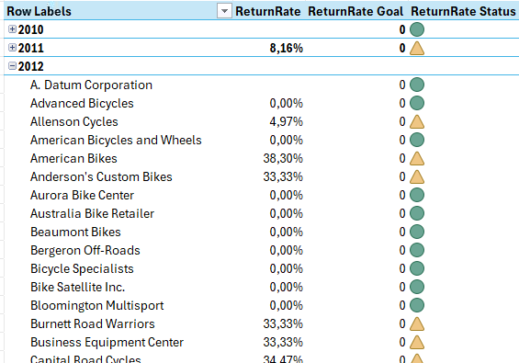

**Figure 5.11.** ReturnRate KPI by Supplier and by Year

The ReturnRate of each supplier is broken down by year, allowing the company to monitor the quality performance of incoming goods over time. The data reveals a significant spike in return rates in 2011 (8.16%), indicating a potential issue or decline in quality control during that period. In contrast, years like 2010 and 2012 show multiple suppliers maintaining a return rate of 0%, demonstrating high reliability.

This table supports the Purchasing Department in identifying high-risk periods, evaluating the consistency of each supplier, and making informed decisions on whether to maintain, improve, or replace suppliers based on actual performance data.

## 5.3. Introduction to the structure of the reporting system

### 5.3.1. Report highlights

* Cover Page
* Dashboard 1: Purchasing Overview
* Dashboard 2: Inventory Dashboard
* Dashboard 3: Vendor Performance
* Dashboard 4: Delivery Dashboard
* Dashboard 5: Employee Dashboard
* Dashboard 6: Product Dashboard
* Solution

### 5.3.2. Overall insight of dashboards

Using the ETL process, the team extracted and transformed data from the data warehouse to develop six interactive dashboards. These dashboards are designed to support business decision-making through targeted insights:

* *Dashboard 1: Purchasing Overview.* This dashboard provides a high-level snapshot of purchasing operations, including total orders, procurement expenses, and receipt completion rates. It offers stakeholders a quick grasp of purchasing performance without delving into specific suppliers or products.
* *Dashboard 2: Inventory Dashboard.* Presents both summary and detailed views of current inventory levels, product stock statuses, and reorder needs. This aids in inventory optimization and strategic purchasing decisions.
* *Dashboard 3: Vendor Performance.* Offers a comprehensive evaluation of suppliers based on order fulfillment, delivery times, and cost effectiveness. This enables supplier performance tracking and relationship optimization.
* *Dashboard 4: Delivery Dashboard.* Focuses on logistics efficiency, showcasing delivery lead times, shipment statuses, and any delivery-related issues. It supports continuous improvement in distribution processes.
* *Dashboard 5: Employee Dashboard.* Highlights key employee metrics related to purchasing and logistics operations. This includes staff performance (e.g., number of orders processed), workload distribution, approval times, and involvement in procurement or inventory tasks. The dashboard helps management assess team effectiveness, identify training needs, and ensure resource allocation aligns with operational demands.
* *Dashboard 6: Product Dashboard.* Displays product-level data, such as purchase volume, cost trends, and inventory turnover rates. This facilitates effective portfolio management and demand planning.

## 5.4. Analyze and visualize data with Power BI

### 5.4.1. Transform and load data

After the data is prepared from the Data Warehouse, the next step is to transform and load it into Power BI to support data visualization and analysis. The team chose to use Import mode to retrieve data from the database instead of Direct Query. With Import mode, the data is stored locally within Power BI, and preloading it significantly improves performance, providing users with faster and smoother report interactions, while also enabling offline analysis without relying on a direct connection to the data source.

Unlike Direct Query, which requires a continuous connection to the data source—resulting in query latency and dependence on the performance of the underlying database system—Import mode helps reduce latency and lessen the load on the data source. This ensures that the analysis process is not interrupted and is especially beneficial in scenarios where internet connectivity is unstable or limited.

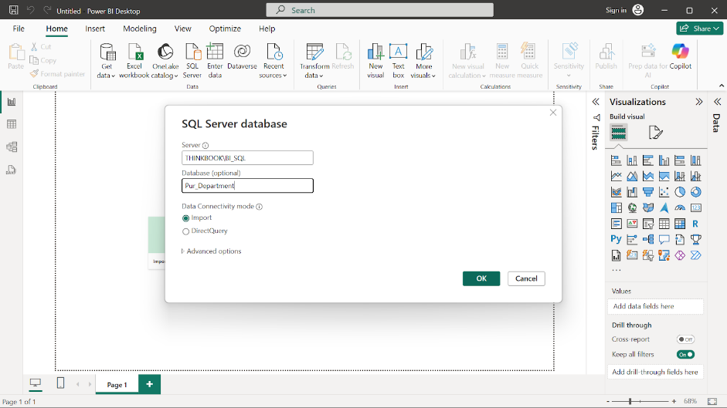

**Figure 5.12:** Import SQL Server database

After loading the data using Import mode, the team performed several data transformation steps before proceeding with analysis. Key transformation tasks included:

* Merging columns to better align with analytical objectives. For example, combining the FirstName, MiddleName, and LastName columns into a single FullName column.
* Creating new tables and measures to support more in-depth analysis.
* Generating calculated columns such as Line Total, Lead Time, Received Rate, and Return Rate to facilitate KPI measurement.
* Establishing relationships between tables to ensure the relational data model accurately reflects the underlying business structure.

This transformation and loading process plays a foundational role in ensuring the quality of the reporting system, guaranteeing that the data is complete, accurate, consistent, and ready for analysis. As a result, Power BI can operate at its full potential in supporting data-driven analysis and decision-making.

### 5.4.2. Creating model relationship

Figure 5.13 illustrates the data model designed in Power BI, which follows a galaxy schema structure. At the center of the model is the FactPurchaseOrders table, which serves as the main fact table. Surrounding it are six dimension tables: DimProduct, DimVendor, DimShipMethod, DimEmployee, and DimTime. Each of these dimension tables is connected to the fact table through one-to-many relationships, where the dimension table represents the "one" side and the FactPurchaseOrders table represents the "many" side, enabling efficient filtering and slicing across different analytical perspectives.

**Figure 5.13.** Model relationship

### 5.4.3. Business analytics

#### 5.4.3.1. Home page

**

**Figure 5.14**. Home Page

#### 5.4.3.2. Overview Dashboard

**Figure 5.15.** Overview Dashboard

The Purchasing Overview dashboard provides a holistic view of the purchasing performance at AdventureWorks over the years 2011 to 2014. The dashboard is structured into key sections that highlight core procurement metrics such as total purchase orders, total spending, rejection rates, delivery timeliness, and average unit price. It further supports decision-making by presenting visualizations and detailed tables on employee activity, vendor performance, product distribution, and temporal trends.

*Key Metrics and Insights*

The total number of purchase orders recorded is 8,845, which reflects a high level of procurement activity throughout the observed period. The total purchasing expenditure amounts to $63.79 million, indicating the organization’s significant investment in raw materials and components. With an average unit price of $34.743, cost management appears to be stable. The rejection rate of 3.12%—while not alarming—suggests potential for improvement in quality control or supplier compliance. Notably, the on-time delivery rate is exceptionally high at 99.88%, emphasizing strong logistical coordination and vendor reliability.

*Visual Charts and Tables*

The dashboard incorporates several visual elements to illustrate procurement trends and performance distributions. A bar chart detailing Purchase Amount by Employee shows that procurement responsibilities are spread across key individuals, with Mikael Sandberg and Linda Meisner leading in total purchase value. This breakdown can help assess employee workload and procurement accountability.

The Purchase Amount by Time line chart tracks monthly spending from 2011 to 2014. Peaks observed in mid-year months (June–August) indicate seasonal procurement patterns, likely aligned with production cycles or promotional periods. This data is instrumental for strategic budgeting and planning.

The Product Category donut chart visualizes purchase distribution by product type. Components make up the largest share (41.47%), followed by Clothing (26.59%) and Accessories (19.2%). This insight emphasizes which categories require more rigorous supplier monitoring or cost-saving initiatives.

The Vendor Overview table lists suppliers along with metrics such as total received quantity, purchase amount, rejection rate, and vendor performance score. Vendors like American Bikes and Allenson Cycles stand out in both volume and value, but varying rejection rates (some over 3%) highlight inconsistencies in product quality or delivery standards.

The Purchase Orders by Year matrix presents product-level order history over the four-year period. Items such as Chainring, Classic Vest, and Cable Lock exhibit consistent ordering patterns, suggesting they are high-demand or frequently restocked products. Meanwhile, the Purchase Orders by Status chart reveals that the majority of orders (8.17K) are successfully processed, affirming overall process efficiency.

*Objectives and Recommendations*

Short-Term Objectives:

* Enhance order fulfillment by reducing the rejection rate. This involves working closely with suppliers to ensure product quality and accurate delivery.
* Implement cost optimization strategies during peak months. Analyzing high-expenditure periods may uncover opportunities for price negotiations or bulk purchase discounts.

Long-Term Objectives:

* Strengthen partnerships with high-performing suppliers who demonstrate timely and accurate deliveries. Simultaneously, contracts with underperforming vendors should be revisited.
* Leverage historical purchasing data for strategic planning. Forecasting future demand, managing inventory proactively, and preparing for seasonal spikes will contribute to more efficient operations and improved cost control.

#### 5.4.3.3. Inventory Dashboard

**Figure 5.16.** Inventory Dashboard

*Key Metrics and Insights*

The total inventory quantity currently stands at 307,000 units, reflecting the organization’s overall stock volume across all locations. Out of this, only 50,450 units are immediately available for use or sale, which may imply that a significant portion of stock is either reserved, in transit, or awaiting processing. The company manages 405 distinct products, a testament to the breadth of its offerings. Notably, only 4 products are out of stock, indicating a well-maintained supply chain with minimal service risk.

A key performance indicator featured in the dashboard is the Order Accuracy Rate, which tracks fulfillment reliability over time. From 2011 to 2014, this metric shows a consistent upward trend—from approximately 0.89 in 2011 to 0.946 in 2014—signifying improvements in inventory handling, order processing, and supplier coordination.

*Visual Charts and Tables*

The Order Accuracy Rate line chart illustrates a steady improvement in operational precision over the four-year span. Beginning below 0.89 in 2011 and rising to approximately 0.946 by 2014, this upward trend reflects ongoing enhancements in order fulfillment processes. Such progress may be attributed to better coordination between departments, improved inventory tracking systems, or stricter quality control mechanisms.

Complementing this is the Value by Category donut chart, which provides a clear picture of how inventory value is distributed across product lines. Components dominates the inventory value, accounting for 41.71%, followed by Others (34.97%), Accessories (19.94%), and Clothing (3.38%). This distribution indicates that strategic planning, budgeting, and risk mitigation efforts should prioritize the highest-value categories—particularly Clothing, given its substantial financial impact on overall inventory.

The Products table offers detailed insights into stock levels across individual products. Notably, items such as Hex Nut 7 (1911 units), Hex Nut 23 (1901 units), and Thin-Jam Hex Nut 3 (1901 units) appear to be highly stocked, which may reflect fast-moving items, core components, or deliberate buffer stock policies. Conversely, other items show significantly lower quantities, suggesting potential reorder requirements, limited demand, or recent stock depletion. This product-level visibility helps guide procurement and replenishment decisions.

Lastly, the Quantity by Shelf treemap visualizes the physical layout and concentration of inventory within warehouse space. Shelf labels such as "N/A", "G", "E", and "A" hold substantial stock volumes, while a large number of shelf identifiers contain little to no inventory. This uneven distribution highlights opportunities to optimize shelf utilization, streamline picking paths, and potentially redesign warehouse layout to improve operational efficiency and space management.

*Objectives and Recommendations*

Short-Term Objectives:

* Resolve the stockout of the 4 unavailable items to maintain product continuity.
* Redistribute items more evenly across shelves to balance space utilization and improve accessibility in warehouse operations.

Long-Term Objectives:

* Continue tracking and improving the Order Accuracy Rate by investing in better inventory control systems and employee training.
* Focus inventory monitoring efforts on high-value categories such as Clothing and Components, ensuring optimal stock levels and turnover.
* Conduct periodic audits of shelf usage and storage layout to streamline warehouse capacity and reduce underutilized areas.

#### 5.4.3.4. Vendor Dashboard

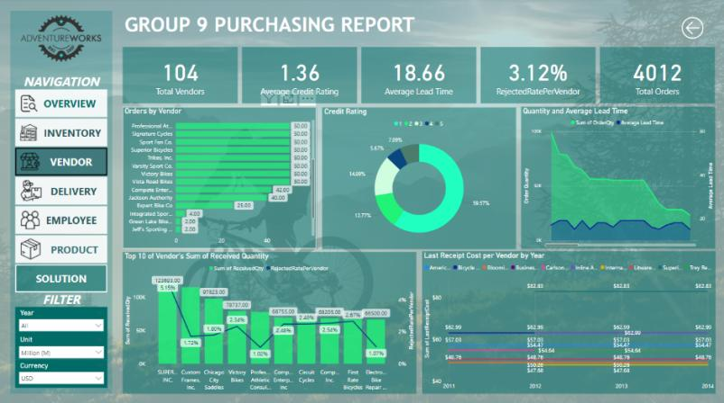

**Figure 5.17.** Vendor Dashboard Overview

The Vendor Dashboard is a critical element of Adventure Works Cycles’ purchasing analytics system. It provides a comprehensive overview of supplier performance, delivery quality, and procurement spending across the vendor network. By combining key performance indicators with intuitive visualizations, this dashboard enables the purchasing team to assess vendor reliability and efficiency for strategic supply chain decisions.

Users can explore the data through interactive filters such as year, unit of measure, and currency. These tools facilitate both high-level insights and detailed drill-downs, helping stakeholders monitor ordering trends, evaluate delivery reliability, track rejection rates, and analyze cost variations by vendor.

*Key Metrics and Analysis*

* Total Vendors: 104. Indicates the size of the current supplier network.
* Average Credit Rating: 1.36. Reflects the average financial trustworthiness and payment terms of vendors.
* Average Lead Time: 18.66 days. Measures how quickly vendors fulfill orders — shorter times indicate better supply responsiveness.
* Rejected Rate per Vendor: 3.12%. Represents the percentage of returned or rejected orders, typically due to quality or delivery issues.
* Total Orders: 4,012. Denotes total purchase activity over the reporting period.

*Visual Insights*

* Orders by Vendor (Horizontal Bar Chart): Displays order volume from each key vendor.
* Vendor Credit Rating Distribution (Donut Chart): Shows the proportion of vendors by credit rating, offering insight into financial risk.
* Order Quantity and Lead Time Trends (Area + Line Chart): Tracks how order volumes and lead times have changed over time.
* Top 10 Vendors by Received Quantity (Combo Column & Line Chart): Highlights high-volume suppliers alongside their rejection rates to assess consistency.
* Last Receipt Cost per Vendor by Year (Line Chart): Helps identify pricing trends for better negotiation and cost planning.

*Objectives*

Short-term:

* Lower rejection rates by improving inbound quality control.
* Prioritize fast and price-stable suppliers to ensure uninterrupted operations.

Long-term:

* Conduct regular supplier assessments based on credit score, rejection rate, and lead time.
* Optimize the vendor pool by removing underperformers and renegotiating with strategic partners.
* Use historical data to enhance procurement planning and match production needs.

*Role-Based Recommendations*

* Purchasing Manager: Should focus on delivery performance of high-volume vendors and track lead time variability to spot risks.
* Buyers: Must monitor high rejection vendors closely and prioritize reliable partners with steady pricing and short lead times.
* Purchasing Assistant: Should utilize dashboard filters to quickly detect outliers like cost spikes or rising defect rates and ensure supplier data is consistently maintained.

#### 5.4.3.5. Delivery Dashboard

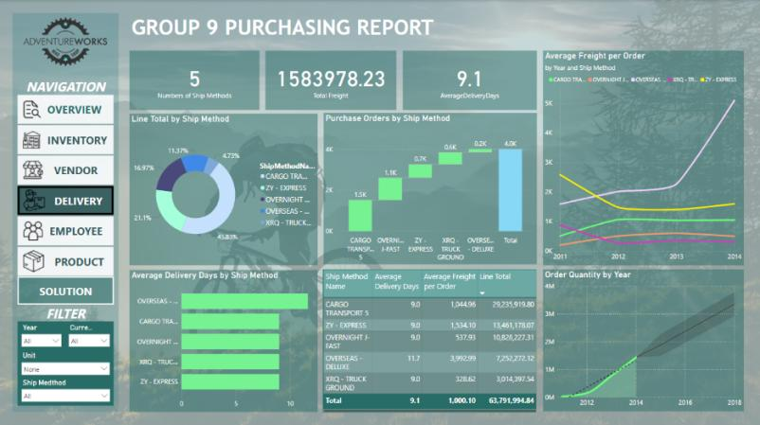

**Figure 5.18.** Delivery Dashboard

The Delivery Dashboard provides an overview and detailed insights into the purchasing and shipping operations of the business. Thanks to key indicators such as total number of orders, total revenue, number of shipping methods, and average shipping cost, this dashboard supports the management team in easily monitoring and evaluating the overall efficiency of the entire delivery process.

*Overall Performance*

Based on aggregated data from the "Group 9 Purchasing Report" system, the company's shipping system is currently operating with 5 main shipping methods. The total recorded shipping cost is 1,583,978.23 USD, with an average delivery time of 9.1 days, reflecting a relatively stable level of logistics activity. The Line Total revenue reached 63,791,994.84 USD, showing a large scale of operations and high transaction volume.

*Analysis by Shipping Method*

The chart “Line Total by Ship Method” shows that CARGO TRANSPORT 5 holds the dominant position, contributing 45.83% of total revenue, followed by ZY – EXPRESS (21.1%) and OVERNIGHT J-FAST (16.97%). This indicates that CARGO TRANSPORT 5 is currently the main pillar in the company's shipping network.

The distribution of orders by shipping method shows that CARGO TRANSPORT 5 also leads in order volume with approximately 4,000 orders, followed by OVERNIGHT J-FAST with around 1,500 orders and ZY – EXPRESS with about 1,100 orders. The consistency between revenue and usage frequency reflects the reliability and popularity of these methods in the supply chain.

The average shipping cost per order varies significantly across methods. Specifically:

* OVERSEAS – DELUXE has the highest cost, up to 1,534.10 USD/order.
* XRQ – TRUCK GROUND has the lowest cost, only 328.62 USD/order.

This difference suggests an opportunity to optimize costs by reconsidering the frequency of using expensive methods, especially in the context of increasing cost pressure.

The OVERSEAS – DELUXE method has the longest delivery time (11.7 days), while the other methods all remain under 10 days, showing a significant discrepancy in time efficiency among different shipping providers.

*Trends and Performance Evaluation*

The chart “Average Freight per Order by Year” shows that the average shipping cost of OVERSEAS – DELUXE increased sharply from 2012 to 2014. Meanwhile, other methods like CARGO TRANSPORT 5, XRQ – TRUCK GROUND, and OVERNIGHT J-FAST maintained stable or slightly declining costs over time. This trend reveals price instability and poor cost control from the OVERSEAS – DELUXE method, highlighting the need for reassessment and evaluation of its effectiveness.

The chart “Order Quantity by Year” shows a strong increase in the number of orders from 2011 to 2014, rising from about 0.9 million to nearly 1.5 million orders. This trend not only reflects market expansion and growing demand but also serves as a warning about the current shipping system’s capacity, requiring the company to plan for logistics capability expansion.

*Recommendations*

* Optimize transportation methods: CARGO TRANSPORT 5 plays a key role but is not cost-effective – renegotiation or route optimization is recommended. OVERSEAS – DELUXE has high cost and delivery time – it should be reserved for special orders only. XRQ – TRUCK GROUND offers low costs and should be utilized more if quality can be ensured.
* Control transportation costs: Monitor transportation expenses by year and by method, especially for OVERSEAS – DELUXE. Analyze reasons for cost increases and consider alternative suppliers with better pricing.
* Reduce delivery time: The current average delivery time of 9.1 days can be improved. Prioritize ZY – EXPRESS and OVERNIGHT J-FAST for urgent orders. Regularly assess on-time delivery rates.
* Expand logistics capacity: With a sharp rise in orders from 2011–2014, it's necessary to invest in warehouse expansion, implement technologies (ERP, tracking), and standardize processes to meet growing demand.
* Enhance monitoring tools: Introduce additional KPIs such as on-time delivery rate, defective orders, and transportation cost per 100 USD in revenue to comprehensively evaluate transportation performance.

#### 5.4.3.6. Employee Dashboard

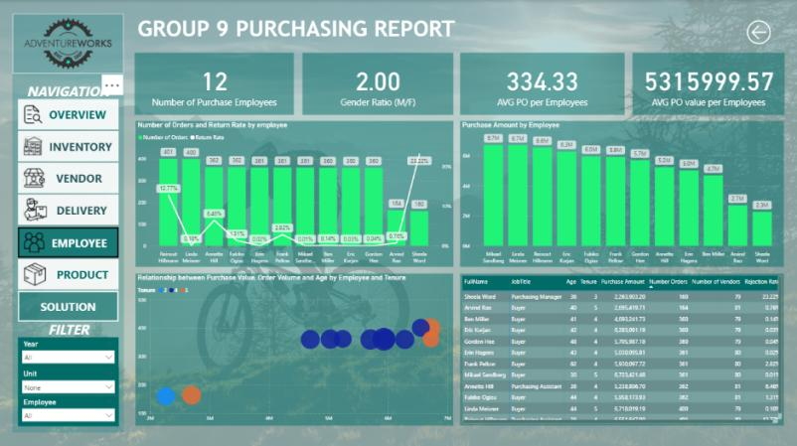

**Figure 5.19.** Employee Dashboard

*Key Metrics and Insights*

The procurement department comprises 12 employees, forming a moderately sized team responsible for managing vendor relationships and purchase orders. The gender ratio of 2.00 (M/F) reveals a male-dominant team structure, which could raise considerations for future gender diversity efforts. On average, each employee processes 334 purchase orders, with an average PO value of approximately $5.32 million, reflecting the substantial transactional responsibilities assigned to each member.

The role distribution within the team is skewed toward operational execution, with 75% designated as Buyers, 16.7% as Purchasing Assistants, and only 8.3% holding managerial positions. This suggests a lean oversight structure where Buyers must operate with high autonomy, requiring strong individual accountability.

From the performance perspective, Mikael Sandberg, Linda Meisner, and Eric Kurjan emerge as top contributors—each handling 360+ orders and managing over $6 million in purchases, with minimal rejection rates (0.01%–0.10%). In contrast, Sheela Word, the sole manager, processed only 160 orders and recorded a significantly high rejection rate of 23.22%, indicating potential concerns around vendor selection or oversight execution. These variances highlight the need for individualized performance tracking beyond role hierarchy.

*Visual Charts and Tables*

The bar and line chart displaying number of orders versus rejection rate emphasizes inconsistencies in quality among employees. While most Buyers maintain rejection rates below 1%, Reinout Hillmann (12.77%) and Sheela Word (23.22%) stand out with considerably higher return rates, signaling quality control issues that warrant deeper investigation.

The Purchase Amount by Employee bar chart aligns closely with order volume, reinforcing a positive relationship between quantity and financial impact. However, some employees—such as Ben Miller and Arvind Rao—handle a comparable number of orders but with noticeably lower total purchase values, suggesting differences in deal size, vendor category, or pricing tiers.

The updated scatter plot labeled “Relationship between Purchase Value, Order Volume and Age by Employee and Tenure” offers a multidimensional view. Positioned by age and tenure, each bubble reflects individual purchasing performance. The cluster of mid-tenure employees (4–5 years) managing high order volumes and values reinforces the notion that mid-experience employees are the most productive segment.

The employee table at the bottom further supports this, combining tenure, age, vendor coverage, and rejection rate into a holistic view. Most high-performing Buyers fall in the 40–45 age range with 4–5 years of tenure, guiding both retention strategies and leadership grooming.

*Objectives and Recommendations*

Short-Term Objectives:

* Investigate causes behind high return rates in specific employees, especially in managerial and assistant roles.
* Provide targeted support or coaching for individuals with high order volumes but suboptimal quality scores.

Long-Term Objectives:

* Implement a performance dashboard combining order count, value, rejection rate, and vendor diversity per employee.
* Rebalance the team structure by increasing assistant or analyst support to Buyers.
* Introduce diversity and inclusion initiatives to address the current gender imbalance.

With a clearer understanding of individual performance patterns, the organization is well-positioned to enhance operational efficiency, reinforce accountability, and build a more data-driven and inclusive procurement function.

#### 5.4.3.7. Product Dashboard

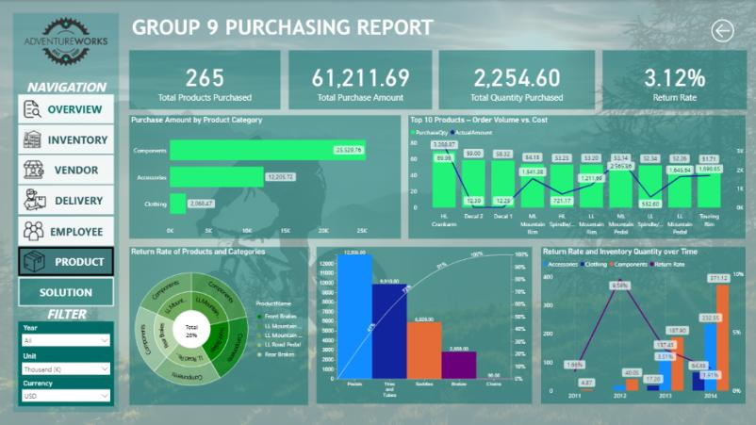

**Figure 5.20.** Product Dashboard

This dashboard, titled "Product", offers a detailed view of key metrics related to the purchasing activities of Adventure Works Cycles, with a specific focus on products. It helps purchasing personnel monitor product performance, track return trends, and analyze inventory levels efficiently. Users can interact with the report through filters such as year, unit, and currency to explore data from different perspectives. This flexibility allows purchasing teams to evaluate product effectiveness, supplier reliability, and order performance at both summary and detailed levels. To support strategic decision-making, insights and recommendations are provided for each of the following roles: Purchasing Manager, Buyer, and Purchasing Assistant.

*Key Metrics and Insights*

* Total Products Purchased: 265. Represents the number of distinct products that were purchased within the given period.
* Total Purchase Amount: $61,211.69K. Reflects the actual spending on product procurement.
* Total Quantity Purchased: 2,254.60K Indicates the overall number of units successfully acquired and stocked.
* Return Rate: 3.12%. Shows the percentage of purchased products that were returned, which may reflect issues in quality, packaging, or vendor performance.
* While the total quantity and cost of purchases are at a reasonable level, the return rate of 3.12% warrants further attention, especially in high-volume product categories.

*Visual Insights*

* Purchase Amount by Product Category. Components lead in terms of purchase value, followed by Accessories and Clothing. This indicates where the majority of procurement budgets are allocated.
* Top 10 Products by Order Quantity and Value. The chart shows which products dominate in terms of both volume and cost. HL Crankarm stands out as the most frequently ordered product with the highest associated cost.
* Return Rate by Product and Category. Products in the Components category exhibit the highest return rates, signaling the need for deeper investigation into potential defects or mismatches.
* Returned Quantity by Subcategory. Subcategories like *Pedals* and *Tires and Tubes* have the highest number of returned items, suggesting recurring quality or supplier issues.
* Return Rate and Inventory Quantity Over Time. A notable peak in return rate occurred in 2012 (9.59%), followed by a steady decline to 1.91% in 2014. Meanwhile, inventory quantities, particularly in Components, have grown — possibly indicating improved stock management but also a need to monitor overstocking.

*Objectives*

* Short Term: Improve the efficiency of product purchasing by reducing the frequency of returns to vendors due to defective items. Focus particularly on product categories like Components, where return rates are noticeably high. Strengthen inspection processes during receipt to detect quality issues early and reduce return processing time.
* Long Term: Maintain a high level of procurement accuracy while minimizing defective returns and the need for vendor compensation. Establish stronger vendor evaluation and quality assurance mechanisms to prevent recurring quality issues. Optimize inventory by aligning purchasing plans with historical return patterns and supplier reliability.

*Recommendations by Role*

* Purchasing Manager:The Purchasing Manager should regularly monitor net purchase trends to identify potential opportunities for cost reduction. It is also essential to assess fulfillment performance, especially in categories like *Components*, where low fulfillment rates may signal inefficiencies in the supply chain. Leveraging historical purchasing trends is critical for planning orders in advance of high-demand periods or anticipated price fluctuations, ensuring a proactive and stable procurement process.
* Buyers:For Buyers, enhancing quality control during the ordering process is vital to reduce the number of defective items returned to vendors. Maintaining high order accuracy is also necessary by carefully verifying order details before finalization. Additionally, Buyers should focus on replenishing products that are understocked or in high demand to maintain adequate inventory levels and avoid supply disruptions.
* Purchasing Assistant: Purchasing Assistants need to proactively monitor inventory levels to initiate timely reorders before stock reaches critical thresholds. Keeping purchasing records accurate and up to date—including order history and vendor performance—is crucial for supporting informed procurement decisions. Finally, they should use filtering tools to analyze past transactions and identify recurring patterns, helping improve the efficiency and effectiveness of future purchasing activities.

#### 5.4.3.8. Solution

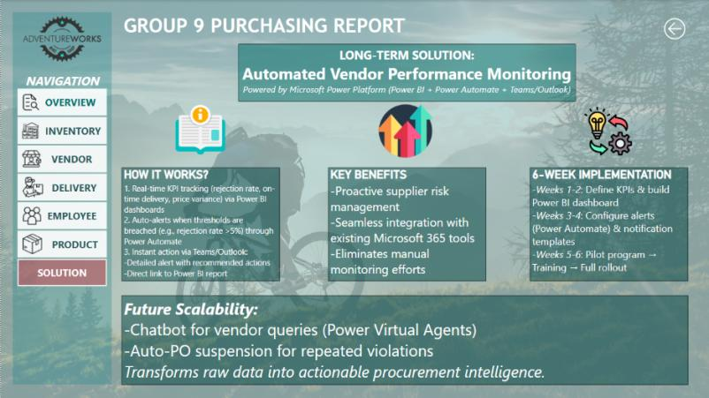

**Figure 5.21.** Solution Page

*Long-Term Solution: Integrated Vendor Performance Workflow Using Microsoft Power Platform*

To improve procurement effectiveness and ensure vendor performance is monitored and acted upon consistently, we propose implementing an integrated vendor performance workflow. This solution leverages existing enterprise tools—Power BI for analytics, Power Automate for alerts and workflows, and Microsoft Teams or Outlook for communication—to create a closed-loop system that supports timely, data-driven purchasing decisions.

The core of this solution is a live Vendor Performance Monitoring System. This system continuously evaluates suppliers using predefined KPIs, including rejection rate, delivery timeliness, and unit price variance. Power BI dashboards aggregate and visualize vendor performance data on a weekly basis. When any KPI exceeds a set threshold, Power Automate is triggered to send automated alerts to the procurement team. These alerts include a summary of the issue, links to relevant reports, and suggested actions, all delivered directly via Teams or email.

The workflow operates as follows. Data is pulled from existing sources such as SAP ERP, Excel, or SharePoint and updated daily. Power BI processes and visualizes this data in real time, highlighting key trends and anomalies. When an issue is detected—such as a vendor's rejection rate surpassing five percent—Power Automate generates an alert. This alert includes key details about the supplier, performance metrics, and direct links to the dashboard, enabling immediate review. Procurement staff receive this notification in Teams or Outlook and can take immediate action, such as contacting the supplier or flagging the issue for management. All follow-up actions can be tracked in a shared Excel file or Microsoft Planner.

For example, if Vendor X exceeds a rejection rate of 6.4% (above the 5% threshold), the system will automatically notify the responsible purchasing officer via Teams. The message includes the vendor’s name, a brief description of the issue, and buttons to open the report in Power BI or escalate to a procurement manager. This eliminates the need for manual report checking and ensures no critical issue goes unnoticed.

This integrated approach delivers significant value across four key areas. First, it enables real-time responses to supplier issues, preventing repeat problems. Second, it increases cross-tool visibility, ensuring insights reach stakeholders directly in the tools they use every day. Third, it enforces an action-oriented mindset, where every alert is tied to a response or escalation. Finally, it is easy to implement, leveraging familiar Microsoft 365 applications already in use by most businesses.

To deploy this system, we propose a six-week rollout plan:

* *Week 1:* Define KPIs, thresholds, and alert conditions in alignment with procurement goals.
* *Week 2:* Develop and configure the Power BI dashboard, integrating with existing data sources such as SAP or Excel.
* *Week 3:* Build and test Power Automate flows using sample data to validate logic and response behavior.
* *Week 4:* Design adaptive notification templates for Teams and Outlook, ensuring they are clear and actionable.
* *Week 5:* Pilot the system with two to three high-volume vendors, gather feedback, and refine as necessary.
* *Week 6:* Train the procurement team, finalize SOPs, and roll out the solution company-wide.

This solution is scalable and can be expanded in the future. For example, approval workflows can be added to pause vendor purchases automatically if thresholds are breached. A chatbot powered by Power Virtual Agents can allow staff to query vendor status by name. Additionally, Microsoft Forms can be used to collect post-delivery vendor feedback, enriching the performance dataset.

In summary, this is a practical, tool-supported, and action-driven solution that aligns closely with real-world procurement needs, minimizes risks, and turns Business Intelligence into real-time business impact.

## 5.5. Discuss and evaluate the results of data analysis and visualization

The project introduced a Business Intelligence (BI) solution designed to assist the purchasing department in monitoring and enhancing operational performance across several dimensions, including products, inventory, delivery timelines, and vendor reliability. Data was processed and organized within a dedicated data warehouse, where the central fact table, *FactPurchaseOrders*, served as the foundation. Based on this, a data cube was constructed using a galaxy schema to facilitate detailed analysis and flexible aggregation.

Reports and dashboards were developed using Power BI, offering dynamic visual representations of the data. The integration of Slicer tools allowed users to interact with the visualizations by applying filters—such as product categories, specific vendors, or delivery periods—tailoring the analysis to their specific needs.

The analytical results revealed that the BI system provided clear insights into key purchasing metrics, such as inventory fluctuations, supplier performance, and order efficiency. This enabled users to identify emerging trends, make timely adjustments to inventory levels to prevent shortages or excess, and make data-driven decisions when selecting suppliers based on historical performance.

In conclusion, the implemented BI solution proved to be a valuable asset in streamlining procurement operations and supporting strategic decision-making, ultimately contributing to improved efficiency and overall organizational growth.

## 5.6. Cloud-Based Deployment Model

During the deployment phase of the Business Intelligence system, the team connected SQL Server to Power BI Desktop using the Import mode, in which data is loaded into the report file and synchronized on a scheduled basis.

To ensure secure and automatic data updates between the on-premises environment and Power BI Service, an On-premises Data Gateway was configured, acting as a secure bridge between internal databases and cloud reports. Additionally, Schedule Refresh was set up to update data at regular intervals.

This Import-based approach provides stability and is suitable for the current data size. In later stages, the team may consider switching to DirectQuery to enable real-time data interaction without relying on scheduled updates.

Steps to Deploy Reports from Power BI Desktop to Power BI Service:

*Installing and Activating the On-premises Data Gateway*

The gateway was installed on the machine hosting the SQL Server database. It was configured as a Personal Gateway, allowing Power BI Service to access the internal source whenever the host is online.

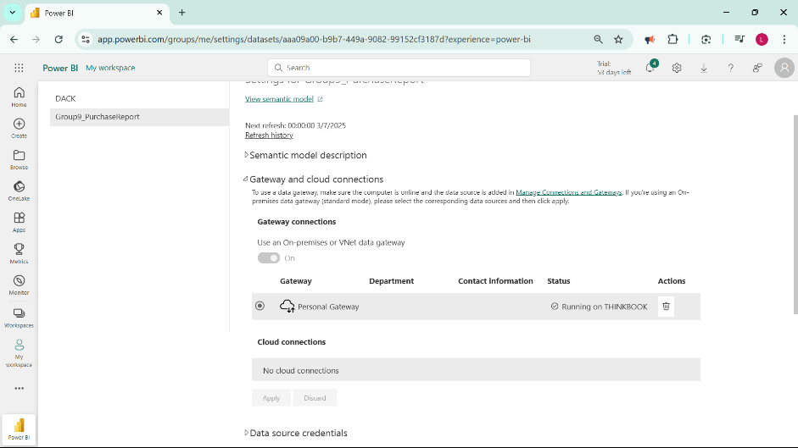

**Figure 5.22.** Activating a Personal Gateway in Power BI Service

*Publishing Reports from Power BI Desktop*

Once the report was finalized in Power BI Desktop, it was published to the designated workspace in Power BI Service, making it accessible for cloud-based collaboration and dashboards.

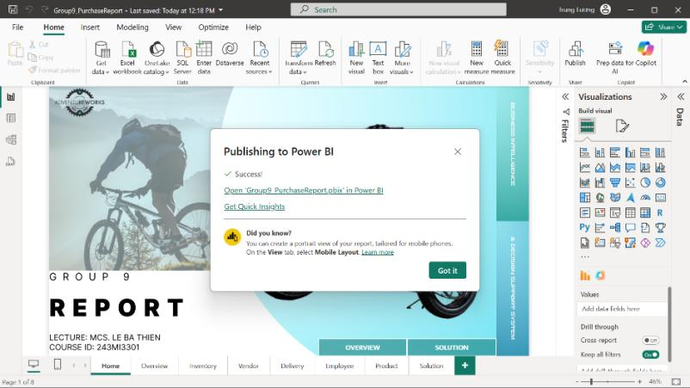

**Figure 5.23.** Successful publishing of a report from Power BI Desktop to Power BI Service

*Configuring the Data Source within the Gateway*

In Power BI Service, the team used the "Manage Gateways" section to register a new data source. The configuration included:

* Server and database names
* Authentication type (Basic or Windows)
* User credentials

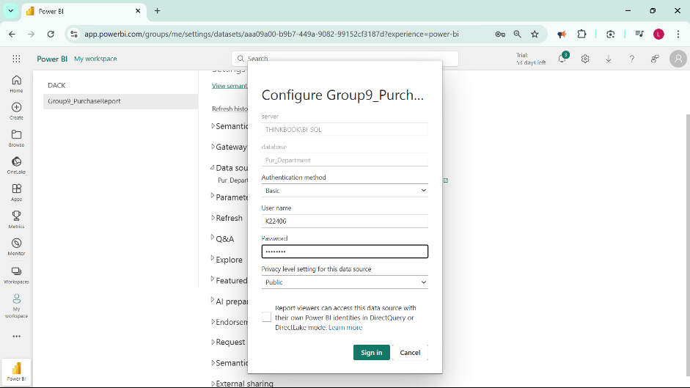

**Figure 5.24.** Data source configuration in the On-premises Gateway

*Setting up Scheduled Refresh*

Since the report is using Import mode, a Schedule Refresh was configured to automatically update the dataset daily. Users can also receive email alerts in case the refresh process fails.

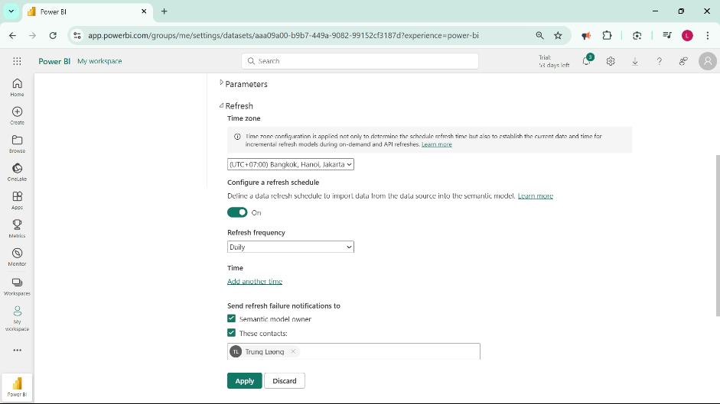

**Figure 5.25.** Schedule Refresh configuration in Power BI Service

# CHAPTER 6. CONCLUSION

## 6.1. Summary of findings

This project focused on developing a Business Intelligence (BI) system for the Purchasing Department at AdventureWorks, aiming to leverage data from the purchasing database to improve procurement strategies and optimize operations. The results revealed valuable insights into procurement activities. A galaxy schema model was applied, with the FactPurchaseOrders table at the center, enabling efficient data aggregation and analysis. Additionally, the implementation of a data cube allowed for multidimensional analysis, providing the purchasing team with a comprehensive view of operational performance.

Key performance indicators such as Received Rate, Return Rate, and Order Quantity were defined to assess purchasing efficiency. Power BI was utilized to create interactive dashboards that visually presented inventory status, vendor quality, delivery performance, and other essential procurement metrics, thereby supporting quicker and more accurate decision-making. Finally, the study emphasized that to maximize the effectiveness of the BI system, it is crucial to provide training and support for users—particularly purchasing staff—to ensure proper usage and data interpretation.

## 6.2. Limitations

Although the implementation of the Business Intelligence (BI) system produced promising initial results, the research process revealed several key limitations. First and foremost, the project was conducted using simulated data from the AdventureWorks sample database rather than real-world business data. This limitation reduces the representativeness of the analysis and may affect the accuracy and practical relevance of the insights generated, particularly when applied to real operational contexts.

Additionally, the study was restricted to the purchasing department, which limited the scope of evaluating how BI tools could be leveraged across other functional areas within AdventureWorks. Another significant challenge was the lack of experience and technical knowledge among some team members. Insufficient familiarity with data analysis principles and BI tools—such as SQL Server and Power BI—led to reduced efficiency and extended the time required for system development. Finally, the system's dependency on specific technologies may limit its flexibility and scalability, especially when adapting to evolving organizational requirements or emerging technological trends.

## 6.3. Future works

To advance beyond current limitations and amplify the impact of our findings, we propose a multi-faceted strategy for future development. First, integrating advanced analytics—specifically machine learning (both supervised and unsupervised models) and predictive analytics—will transform raw data into actionable intelligence. This shift will enable precise forecasting of purchasing trends, multidimensional evaluation of supplier risk/performance, and real-time anomaly detection in supply chain operations. Consequently, organizations can transition from reactive to predictive decision-making, optimizing inventory, reducing costs, and strengthening negotiation outcomes.

Furthermore, expanding the BI ecosystem to integrate seamlessly with core enterprise systems is critical. By bridging data silos between ERP (financials, inventory, procurement), CRM (sales pipelines, customer interactions), and external sources like market intelligence platforms, we create a unified 360-degree view of organizational performance. This holistic perspective reveals cross-functional insights—such as correlating procurement strategies with revenue impact—and drives alignment between operational efficiency and customer-centric outcomes.

Concurrently, establishing a structured user feedback mechanism ensures continuous solution refinement. Implementing digital feedback portals, periodic surveys, functional workshops, and power-user programs will capture granular insights into usability gaps and emerging needs. By systematically prioritizing and incorporating this input into development cycles, the BI solution evolves as a dynamic asset that remains tightly aligned with evolving user workflows, thereby maximizing adoption and ROI.

Finally, modernizing our data architecture via Microsoft Fabric will replace legacy SSIS/SSAS infrastructures with a fully cloud-native paradigm. Fabric’s integrated environment—featuring OneLake unified storage, serverless compute elasticity, and native Power BI interoperability—delivers transformative scalability and performance. Vectorized processing accelerates large-scale analytics, while automated resource scaling and pay-as-you-go economics reduce operational burdens. This transition future-proofs our analytics foundation, enhancing agility, governance, and cost-efficiency while unlocking advanced AI/ML capabilities across the data lifecycle.

Collectively, these initiatives will not only resolve existing constraints but also position the organization at the forefront of data-driven innovation, fostering a culture where strategic decisions are informed by integrated, real-time intelligence.

## 6.4. Conclusion

The project to build a Business Intelligence (BI) system for the Purchasing Department of AdventureWorks has achieved many positive outcomes, clearly demonstrated through the successful implementation of a data warehouse architecture and the effective application of analytical and visualization tools. Specifically, the system has supported the aggregation and analysis of data from multiple sources, facilitating the monitoring of purchasing performance, supplier evaluation, and inventory management. The development of appropriate Key Performance Indicators (KPIs) has also enabled the management team to make more accurate and timely decisions. Additionally, the analytical process was systematically implemented—from data extraction, transformation, and loading (ETL) to OLAP-based data exploration and the presentation of results through dynamic reports—contributing to overall operational efficiency.

However, the project still has certain limitations. The quality of input data in some tables remains inadequate, affecting the accuracy of analyses. Moreover, the system has so far only been deployed within the Purchasing Department, without integration into related departments such as Sales, Production, or Finance. Some advanced analytical features have not been fully developed due to time and resource constraints. Nevertheless, the results achieved have laid a solid foundation for the further development of a comprehensive BI system.

In the future, by expanding the BI system across the entire organization and continuing to address current challenges, AdventureWorks can fully leverage its data assets to enhance competitiveness and achieve sustainable growth in the dynamic bicycle industry. This project highlights the significant potential of BI in optimizing business processes and improving decision-making quality in today’s modern business environment.

# 

# REFERENCES

1. Intelligence, M. (n.d.-b). *Bicycle market*. <https://www.mordorintelligence.com/industry-reports/bicycle-market>

2. MashaMSFT. (n.d.). *AdventureWorks sample databases - SQL Server*. Microsoft Learn. <https://learn.microsoft.com/en-us/sql/samples/adventureworks-install-configure?view=sql-server-ver17&tabs=ssms>

3. Oracle. (2023, June 8). *What is a data warehouse?* Oracle Vietnam. <https://www.oracle.com/vn/database/what-is-a-data-warehouse/>

4. Twin, A. (2025, June 15). *KPIs: What are key performance indicators? types and examples*. Investopedia. <https://www.investopedia.com/terms/k/kpi.asp>

5. Wikipedia contributors. (2025, April 7). *Performance indicator*. Wikipedia. <https://en.wikipedia.org/wiki/Performance_indicator>

6. *Types of business intelligence*. (n.d.). <https://www.tutorialspoint.com/business-intelligence/types-of-business-intelligence.htm>

7. *AdventureWorks*. (n.d.). <https://dataedo.com/samples/html/AdventureWorks/>

8. Dastaffo. (n.d.). *Training for Power BI*. Microsoft Learn. <https://learn.microsoft.com/en-us/training/powerplatform/power-bi>

9. Devart. (n.d.). *Devart SSIS Data Flow Components for cloud and database integration*. Devart Software. <https://www.devart.com/ssis/what-is-ssis.html>

10. Tutorial Gateway. (2025, January 26). *SQL Server Analysis Services (SSAS) tutorial*. <https://www.tutorialgateway.org/ssas/>

11. Cofsky, A. (2019, January 3). Connecting to datasets in the Power BI service from Desktop. *Blog di Microsoft Power BI | Microsoft Power BI*. <https://powerbi.microsoft.com/it-ch/blog/connecting-to-datasets-in-the-power-bi-service-from-desktop/>

# APPENDIX: GROUP WORK ACTIVITY REPORT

|  |  |  |  |  |
| --- | --- | --- | --- | --- |
| **No.** | **CONTENT** | **TASK** | **MAIN RESPONSIBLE** | **EVALUATION** |
| **1** | **OVERVIEW OF THESIS** | Background | Trung Hieu | 100% |
| Project Objectives | Chi Trung | 100% |
| Research Subjects and Scope | Quy Hai | 100% |
| Technology Used |
| Research Significance |
| Report Structure | Chi Trung | 100% |
| **2** | **THEORETICAL BASIS** | Overview of BI | Duc Luong | 100% |
| Overview of ETL |
| Data Warehouse and Data Mart | Van Tai | 100% |
| KPIs | Quy Hai | 100% |
| MDX Language and OLAP Techniques |
| Power BI | Trung Hieu | 100% |
| **3** | **USER REQUIREMENTS ANALYSIS & DATA DESCRIPTION** | Purchasing Department | Duc Luong | 100% |
| KPI Indicators | Quy Hai | 100% |
| BI System Requirements | Trung Hieu | 100% |
| Data Preparation | Chi Trung, Van Tai | 100% |
| Data Warehouse Design | Quy Hai, Duc Luong | 100% |
| ETL Process | All Team | 100% |
| **4** | **DATA ANALYSIS AND VISUALIZATION** | Data Analytics with SSAS Technology | Van Tai | 100% |
| KPI System Development | Quy Hai | 100% |
| Introduction to Reporting System Structure | Duc Luong | 100% |
| Data Analysis and Visualization with Power BI | All Team | 100% |
| Discussion and Evaluation of Data Results | Trung Hieu | 100% |
| Report Implementation |
| **5** | **CONCLUSION** | Summary of Findings | Quy Hai | 100% |
| Limitations | Trung Hieu | 100% |
| Future Works | Duc Luong | 100% |
| Conclusion | Chi Trung | 100% |
| **6** | **REPORT COMPILATION AND EDITING** |  | All Team | 100% |
| **7** | **PRESENTATION SLIDES** |  |

Ảnh có chứa văn bản, ảnh chụp màn hình, phần mềm, Trang web

Nội dung do AI tạo ra có thể không chính xác.